The Battle of Hamburger Hill
10-20 May 1969
A Vietnam War Virtual Staff Ride

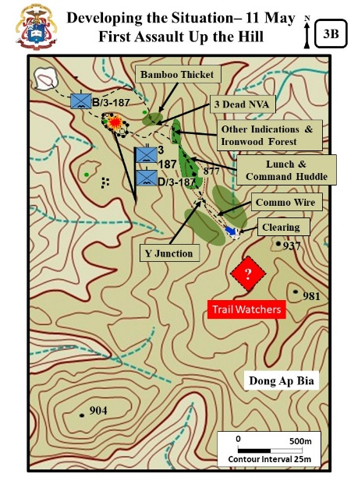
Combat Studies Institute
The Army University Press
Fort Leavenworth, Kansas 66027-6900
March 2020

Significant Sources Used

- Gov’t Documents and Books
  - Battle of Dong Ap Bia, Summary of Actions and Results, Headquarters 101st Airborne Division, 24 May 1969.
  - Boian, Kelly. Major General Melvin Zais and Hamburger Hill, SAMs Monograph, Fort Leavenworth, KS: U.S. Army, 2012)
  - McGrath, John. The Brigade: A History, Its Organization and Employment in the US Army. Fort Leavenworth, KS: Combat Studies Institute Press, 2004.
  - Narrative of Operation Apache Snow, prepared by the 22d Military History Detachment. (No date found, During the time of MG Wright commanding)
  - Scalard, Douglas (LTC). “The Battle of Hamburger Hill: Battle Command in Difficult Terrain Against a Determined Enemy.” Studies in Battle Command, by the Faculty of Combat Studies Institute, Combat Studies Institute Press, 1996, pp. 165-175.
  - Trass, Adrian. CMH PUB 76 -6, The U.S. Army Campaigns of the Vietnam War – Transition Nov 1968-Dec 1969. Washington, DC: Center for Military History, 2018.
  - Vietnam War: After Action Reports, Lessons Learned Documents, and Battle Assessments. Beverly Hills, CA: by BACAM Research, 2009.
  - Villard, Erik. STAYING THE COURSE October 1967 to September 1968. Washington, DC: Center for Military History, 2017
  - West Point Center for Oral History, Hamburger Hill reunion May 2017. http ://www.westpointcoh.org/search?authenticity_token=nxQ5SiZtFUZn3dMNNpOvKbs9NxlCyqGalv3SeP4bM7E%3D&search=hamburger+hill&utf8=%E2%9C%93
  - XXIV Corps Historical Summary of the Battle of AT Dong Ap Bia (Hamburger Hill) 10 – 20 May 1969. [N-12975.17, Library, USA CGSC Fort Leavenworth, KS]

- Books and Articles
  - Boccia, Frank. The Crouching Beast. Jefferson, NC: McFarland & Company, 2013
  - Diconsiglio, John. Vietnam: Blood Bath at Hamburger Hill. NY, NY: Franklin Watts, 2009.
  - Willbanks, James. Hell on Hamburger Hill, History Net. https://www.historynet.com/hell-on-hamburger-hill.htm
  - Zaffiri, Samuel, Hamburger Hill, May 11-20, 1968. Novato CA: Pesido Press, 1988

TABLE OF CONTENTS
- STAND 1: OPERATION APACHE SNOW
1A: Background
1B: The A Shau Valley
1C: Third Brigade, 101st Airborne Division

- STAND 2: INITIAL CONTACT - MAY 10
2A: Dong Ap Bia
2B: Reconnaissance In Force

- STAND 3: 11 MAY– DEVELOPING THE SITUATION
3A: Disconcerting Discoveries
3B: First Assault Up Hill 397
3C: Plan For 12 May

- STAND 4: 12 MAY – FRUSTRATION
4A: Second Assault Up Hill 397
4B: Firebase Airborne – Night Of 12 May

- STAND 5: THIRD ASSAULT UP HILL 397 - 13- MAY

- STAND 6: COORDINATED ATTACK - 14 MAY
6A: Fourth Assault Up Hill 397
6B: Lieutenant Boccia’s Mission
6C: The Third Brigade, 101st Airborne Division Plan

- STAND 7: THE SECOND COORDINATED ATTACK - 15 May
7A:Delimma and Decision
7B:Fifth Assault Up Hill 397

- STAND 8: WAITING FOR THE CURRAHEES - 16 AND 17 MAY
8A: Waiting for the Currahees – 16 May
8B: Setting The Conditions – 17 May

- STAND 9: BRIGADE ATTACK - 18 MAY
9A: The Brigade Plan
9B: Sixth Assault Up Hill 397 – Morning
9C: Sixth Assault Up Hill 397 – Afternoon

- STAND 10: HAMBURGER HILL - 19 AND 20 MAY
10A: Setting the Conditions for Success – 19 May
10B: The Seventh Assault Up Hill 397 -20 May

- STAND 11: WAS IT WORTH IT

Page not used (formatted for two sided printing)
STAND 1: OPERATION APACHE SNOW
VISUALS

1A: BACKGROUND
1B: THE A SHAU VALLEY
1C: THIRD BRIGADE, 101ST AIRBORNE DIVISION

ORIENTATION

Virtual View: From above Hill 859 (marked with purple smoke - see Visual 3A) assume a helicopter view of Dong Ap Bia to the North.

Orientation: Currently looking north and overlooking Dong Ap Bia. Loosely translated as “The Mountain of the Crouching Beast.” Later it would come to be known as “Hamburger Hill.” The Hill was in the north portion of what was South Vietnam. Later in the field study there will be a more detailed orientation of the ground.

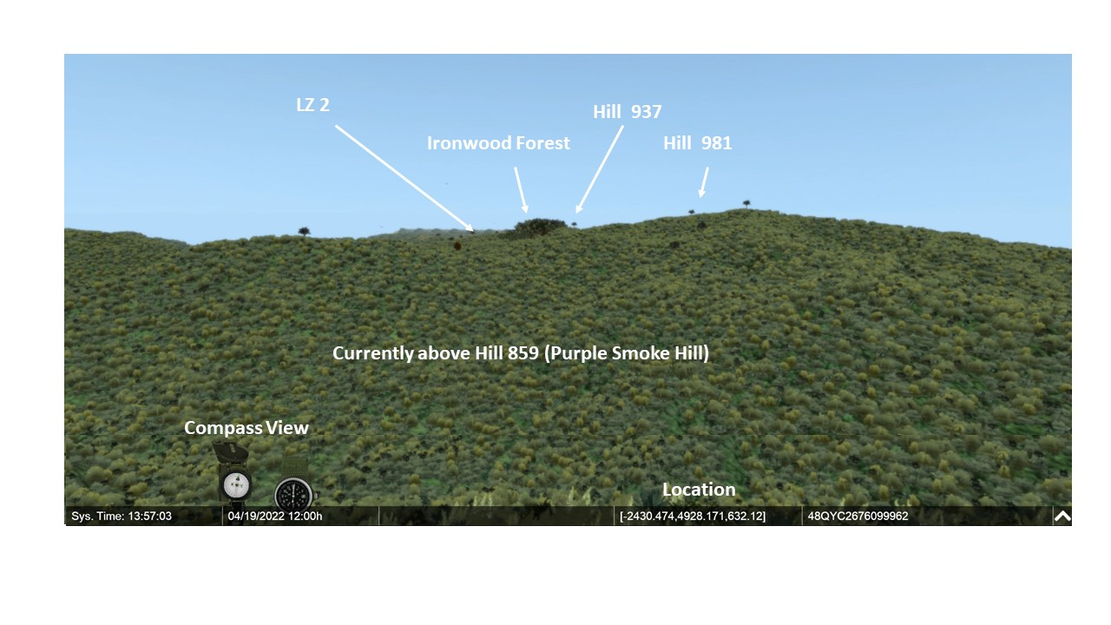

DESCRIPTION

Virtual Movement: None

VISUAL 1A: BACKGROUND [Excerpt from The Brigade: A History, Its Organization and Employment in the US Army by John McGrath. Combat Studies Institute Press, Fort Leavenworth, Kansas, 2004, 69-71] Additional details from CMH PUB 76 -6, The U.S. Army Campaigns of the Vietnam War – Transition Nov 1968-Dec 1969] [There are no PPT builds on the Visual 1A]
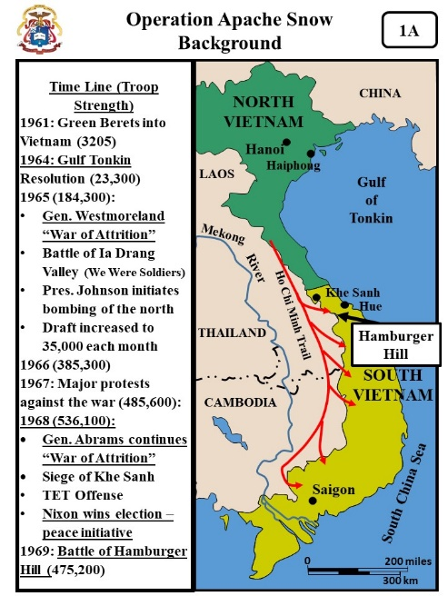
- By 1969, the US had been directly involved in the Vietnam War for 4 years. US troop strength had peaked in 1968 at 536,100.

- From 1965 to 1968, General William Westmoreland led the U.S. military effort in Vietnam. He believed that the Vietnamese communists could be destroyed by fighting a war of attrition.

  - His war strategy depended upon heavy use of artillery and airpower.
  - His goal was to engage the communists in large-unit battles to exploit the US's vastly superior firepower and technology.

- In June 1968, General Creighton Abrams succeeded Westmoreland as the commander in Vietnam.
  - With peace talks under way in Paris, Abrams believed success on the battlefield offered the U.S. the opportunity to negotiate from a position of strength.
  - He saw no need to change in U.S. strategy and U.S. forces continued large-scale operations to engage People's Army of Vietnam (PAVN).

- However, the Nixon administration had come into office in January 1969 promising peace, and to many people that meant avoiding bloody fights with the enemy.

- The stage was set for what would become one of the most controversial battles in the Vietnam War.

Virtual View: Continue with the helicopter view of Dong Ap Bia. No movement required.

Orientation: Dong Ap Bia is part of a range of hills on the west side of the A Shau Valley. The valley floor is 5k’s to the NE. The small river visible on the left side (west) is the border between Vietnam and Laos.

VISUAL 1B: THE A SHAU VALLEY [McGarth’s, Brigade, 69-71. Additional details from CMH PUB 76 -6.[There are no PPT builds on the Visual 1B]

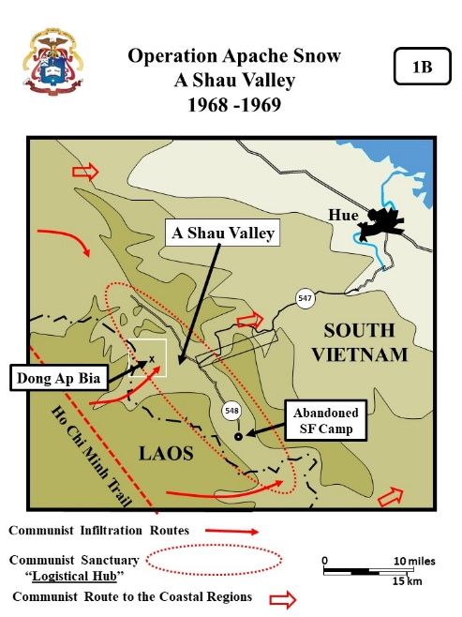
- The narrow A Shau Valley was 30-miles long. It was located on the Laotian border about 25 miles southwest of Hue, had been a North Vietnamese-controlled sanctuary since a Special Forces camp had been driven out of the valley in 1966.

- Since then, the valley and its adjoining jungle-covered ridgelines had become a major Communist base area along Ho Chi Minh Trail and supply route into the coastal regions.

- The enemy forces that attacked Hue city during the Tet Offensive in 1968 had assembled in the A Shau Valley and infiltrated out of there. The valley’s location next to the safe haven of Laos and the Ho Chi Minh Trail made it of great importance to the North Vietnamese.

- The Communists infrastructure in the valley included a main supply route running down the middle of the valley on an improved road (Hwy 548). Jungle-covered mountains surrounded the valley itself. (additional details from Villard, Staying the Course, 36)

  - The Communists depended on logistical hubs to sustain their forces in Vietnam.
  - Logistical installations were usually located in areas well shielded by mountains, swamps, or heavily canopied jungle. The A Shua valley was one of these locations.
  - These installations contained everything the troops needed to wage war: headquarters, training facilities, ammunition and supply depots, repair shops, hospitals, barracks, and even rest areas.
  - Communist commanders drew upon them well ahead of attacks to stockpile food, ammunition, and whatever other supplies they would need in small caches near their targets. They called the process “preparing the battlefield.”

Virtual View: Continue with the helicopter view of Dong Ap Bia. No movement required. The dash-box shows the approximate size of the virtual box.
VISUAL 1C: THIRD BRIGADE, 101ST AIRBORNE DIVISION [McGrath, “The Brigade” and XXIV Corps Historical Summary , Tab A: 1-6). Additional details from CMH PUB 76 -6. [There are no PPT builds on the Visual 1C]

- The 101st Airborne Division (Airmobile) executed Operation APACHE SNOW in the northern portion of the A Shau Valley between 10 May and 7 June 1969 with its 3d Brigade and elements of two regiments from the Army of the Republic of Vietnam’s (ARVN) First Infantry Division.
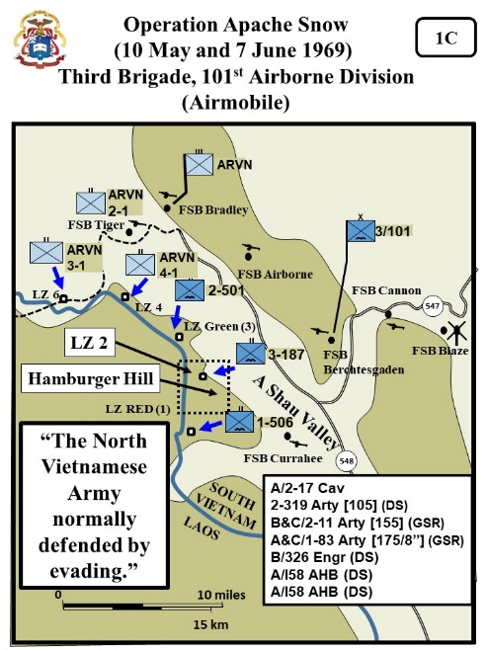
- The 3d Brigade, commanded by Colonel Joseph Conmy, consisted of three airmobile infantry battalions: 1-506th Infantry, 2-506th Infantry, and 3-187th Infantry, and supporting units.

  - One field artillery battalion, 2-319th Artillery, was in direct support of the brigade, with an additional batteries in general support, reinforcing. (Different sources say 10 artillery batteries. John McGrath in The Brigade names seven batteries).

  - The divisional aerial rocket artillery battalion (Cobra Gunships) was also in direct support of the brigade. In addition, an engineer company and two assault helicopter companies from the division’s 160th Aviation Group were supporting the brigade.

  - Supporting brigade operations to the north was the 1st ARVN Infantry Regiment of the 1st ARVN Infantry Division.

- The objective of Operation APACHE SNOW was a reconnaissance in force (RIF) to locate and destroy any enemy found in each battalion’s assigned sector, destroy any enemy infrastructure, and, if necessary, fix the enemy in place until reinforcements could concentrate against them.

Today’s doctrine refers to the RIF as a Movement to Contact (MTC)

- The operation was called a reconnaissance in force (RIF), as the North Vietnamese locations where unknown and would have to be found as the operation progressed.

- Enemy units in the A Shau normally avoided pitch battles with US units and frequently escaped across the Laotian border. (details below from CMH Pub 90-21-1, 5)

  - The accepted enemy template was, “The North Vietnamese Army normally defended by evading.”
  - Enemy tacticians recognized that the allied forces were superior in firepower and mobility. To overcome this superiority, the enemy attempted to attack from ambush and withdraw before allied forces could react.
  - If an engagement ensued, the typical approach in terms of defense was to delay opposing forces and withdraw as soon as possible, while inflicting maximum casualties before withdrawal.
  - The survival of the enemy forces on the battlefield depended on their ability to disengage from or avoid decisive contact with allied forces

- U.S. Battalions normally separated into company sized elements to conduct RIF operations to locate enemy bases, camps, and defensive positions. (Details below from John Carland, Stemming the Tide, CMH, 2000, 358)

  - The smaller units were able to search more ground.
  - One of the goals of the platoon and company size patrols was to lure the NVA into attacking, commanders believed that the North Vietnamese were more likely to make contact with a small force rather than a large one.
  - The risks were justified if the Communists took the bait, because reinforcing units could then quickly pile on.
  - Additionally, the communist forces rarely operated above company strength against U.S. patrols.

- At the brigade level, airmobile assets would be used to shift battalions to large enemy locations to mass as necessary.

- LZs for the battalions were selected in the hilly area west of the A Shau Valley on the Laotian border, the plan being to get US forces between the Communists and their Laotian sanctuary area.

- All operations were conducted within the range of pre-emplaced field artillery located at Fire Support Bases (FSBs).

- In preparation for the operation, the infantry battalions were shifted from LZs and FSBs near Hue to FSBs Blaze and Cannon.

- FSBs Berchtesgaden and Cannon, plus three new or formerly abandoned FSBs were quickly built to support the operation. All were designed to be mutually supporting and allow the entire area of operations to be within the range of field artillery.

- On 9 May (D-1), Several artillery batteries were shifted to these FSBs to support the initial insertions of the infantry battalions.

- On D-Day, 10 May, 65 UH-1H Huey helicopters airlifted the four battalions in consecutive company-sized lifts from FSBs Blaze and Cannon into new LZs along the Laotian border.

  - The 65 troop carrying helicopters (UH-IH) permitted two battalions to be assaulted simultaneously.

  - Each of the landing zones for the initial assault was selected based on the latest intelligence so as to achieve surprise and to place the assault troops into close proximity to suspected enemy locations.

  - An extensive 70-minute artillery, aerial rocket, and air support preparation preceded the combat assaults.

  - The battalions all landed without contact and immediately commenced company-sized RIF operations to find the enemy installations and forces thought to be in the area.

- The battalions were not oriented on any key terrain or assigned the mission to take any specific terrain objective; rather, they were oriented on the enemy and concerned primarily with locating and destroying his forces, supplies and installations wherever they might be found.

- Col. Joseph Conmy, the 3d brigade, 101st Abn Div commander, assigned the area near Hill 937 to the 3rd Battalion, 187th Infantry Regiment.

ANALYSIS

The Draft ATP 3-90.98 / MCTP 12-10C, Jungle Operations April 2020 in paragraph 4.8 states. “Given the challenges to mobility and the dispersed nature of jungle operations, commanders and staff pay close attention to the ability for units to support each other during offensive jungle operations. When developing the concept of operations and scheme of maneuver, commanders and staff use supporting range and supporting distance to determine a feasible concept for mutual support. Mutual support is that support which units render each other against an enemy because of their assigned tasks, their position relative to each other and to the enemy, and their inherent capabilities (JP 3-31)… Supporting range is the distance one unit may be geographically separated from a second unit yet remain within the maximum range of the second unit’s weapons systems (ADP 3-0)… Supporting distance is the distance between two units that can be traveled in time for one to come to the aid of the other and prevent its defeat by an enemy or ensure it regains control of a civil situation (ADP 3-0).

- Was RIF tactic of using platoon and company size patrols to lure the NVA into attacking IAW the need for mutual support and was it justified risk?

- What are the possible dangers of the accepting the enemy most probably COA is evade contact or withdraw as soon as possible if forced into contact?

Future references for the Draft ATP 3-90.98 / MCTP 12-10C, Jungle Operations April 2020 will be Draft ATP 3-90.98, Jungle Ops (2020).

STAND 2: INITIAL CONTACT - MAY 10
VISUALS

2A: DONG AP BIA
2B: RECONNAISSANCE IN FORCE

ORIENTATION

- Virtual View: Initially no change from Stand 1.

- Orientation: Currently above Hill 859 looking north at Dong Ap Bia.

- The mountain of the Crouching Beast was a solitary mountain that rises from the floor of the western A Shầu Valley..
- In 1969, it was a rugged wilderness blanketed in double- and triple-canopy jungle and dense thickets of bamboo. Military maps showed no established trails or village in the area.

- (Because so visible) The Ironwood Forest shows up well – it is located on ridge NW of the mountain.

- The mountain had several peaks.

  - Just to the right of the Ironwood forest is Hill 937 – it is marked with the large tree.
  - The next large tree to the right is the summit of the mountain – which was Hill 981

- (Scan to the left) A tributary of the Xe Khong (Say Kong) River is about 1.2 miles (1.9 km) west of the mountain and marks the border with Laos.

DESCRIPTION

VISUAL 2A: DONG AP BIA [Unless otherwise stated – XXIV Corps Historical Summary. [The PPT builds on the visuals are noted as C1, C2, or C3 etc.]

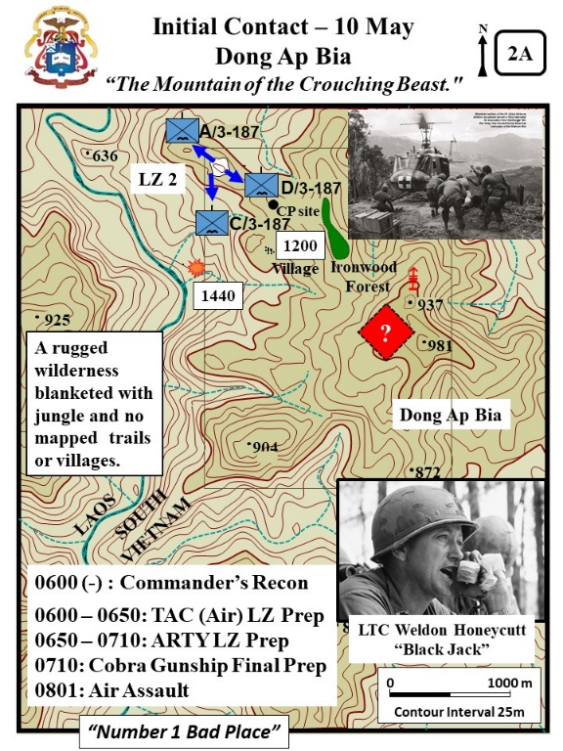
- Col. Joseph Conmy, the 3d brigade, 101st Abn Div commander, assigned the area near Dong Ap Bia to the 3rd Battalion, 187th Infantry Regiment.

- C1: LTC Weldon Honeycutt, known as “Black Jack”, commanded the 3-187th IN. The unit was also known as the “Rakkasans.” The nickname came from their four-year occupation of Japan after World War II.

  - First Lieutenant Frank Boccia, the 1st platoon, Bravo Company of the Rakkasans described Honeycutt as: (Boccia, The Crouching Beast, 4, 433)
    - A “short, wiry, cocky, glacier-eyed and belligerent.” Boccia also stated he was harsh, brutal, egocentric, and demanding.
    - Boccia recalled that he rarely praised and often rebuked in an abusive and scathing way. He was a man that “… was impossible to like.”
    - Despite these harsh words, Boccia also stated “he was the paradigm of a battlefield commander… [and] if you wouldn’t follow him, you wouldn’t follow anybody.”
    - Fifty years after the battle, Honeycutt would refer to Boccia “The finest officer that came down the pike… He was my go to guy.” (WPCFOH, Honeycutt Interview)

  - Captain Robert “Bob” Harkins the Alpha Company commander also remembered Honeycutt as a hard man. (WPCFOH, Harkins Interview)
    - “…he (Honeycutt) chewed my ass every day. I felt most every day that I was going to be fired any minute.”
    - However also remembered him as a great commander and stated, “He gave me a lot of latitude.”

- C2: ? symbol - As part of his overall plan, LTC Weldon Honeycutt selected Hill 937 as one of the areas to be searched following the airmobile assault since intelligence reports gathered in April and May indicated the possible presence of enemy forces in the vicinity of the hill.

VSR: From above Hill 859 circle to the left toward LZ2 while looking at Hill 981. Be careful to keep the view angle slightly down so as not to see the end of the virtual box. Continue to circle around and take up a helicopter view from the NW of LZ2.

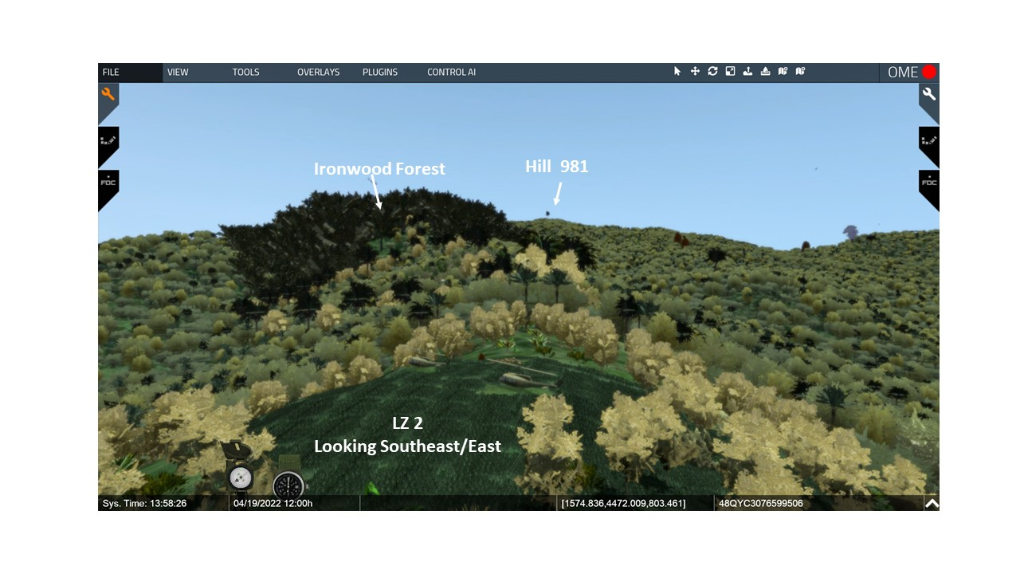

- The battalion commander selected a landing zone approximately 1800 meters northwest of the hill near the Laotian border with the intention of moving southeast toward Hill 937.

- C3: 0600 Commander Recon - At about 0600 -just after first light, LTC Weldon Honeycutt arrived over Hill 937 in a UH-1D Command and Control Helicopter. (From Samuel Zaffiri, Hamburger Hill, 3-5).

  - He was there to direct the prep of the LZ and the landing of his battalion.

  - On one of his passes he received fire from a heavy machinegun on the hill, but could not locate its position.

  - His pilot circled the designated LZ .LZ 2 was nothing more than a small opening in the forest covered with waist-high elephant grass and some brush.

- C4: 0600 – 0650 - TAC LZ Prep
  - An OV-10 FAC aircraft soon arrived and marked the field. Then several Phantom jets arrived and passed over the field dropping ordinance.

  - Bombs and napalm had the desired effect. The elephant grass was burned and flattened and the brush was burning. The airstrikes lasted about 50 minutes.

  - During the airstrikes, Honeycutt departed the area and linked-up with his BN at Firebase Blaze (about 20K to the east).

- At 0620 – 0730, the 3 -187 IN prepared for their air-assault into the A Shau valley (Zaffiri, Hamburger Hill, 5-10).

- The officers and men were nervous and concerned about going to the A Shua Valley.
  - The A Shua was believed to be a “number 1 bad place.”
  - A popular phrase of the day referred to the A Shua Valley, “Yea, though I walk through the valley of the shadow of death I will fear no evil – for I am the meanest son-of-bitch in the valley.”

  - Veterans new the A Shau to be a NVA haven. Just two weeks early the 3-187 had been in a hard fought fight on the eastern side of the valley. The veterans told the newer recruits, “There’s some bad shit out there, real bad.”

- At 0650, the supporting artillery batteries opened up on the Third Brigade’s 5 LZs within the valley. At LZ 2 their fire further flatten the elephant grass and brush.

- About 0700, the first lift departed Firebase Blaze and soon after that the lead companies of the 3-187 IN were in the air and moving toward the A Shau Valley.

- At 0710 the artillery barrage lifted against the LZ and Cobra gunships started the final prep. (Zaffiri, 63- 64).

  - The lead Cobra gunships unleashed the fire onto the ground around the LZs.

  - At this time the LZ prep had been continuous for almost 70 minutes.

VSR: Fly down and land at LZ 2.
- At 0801 hours (10 May), the battalion began its combat assault into the selected landing zone.(Zaffiri, 64)

  - Captain Luther Sanders Delta Company was on the first 16 transports into the LZ.
  - C6 & C7: A & C/3-187- Alpha and Charlie Companies followed in subsequent waves of transports.

  - Bravo was the brigade reserve.
  - The BN HQ commanded the air-assault from the air.

VSR: IAW the discussion point out Dong AP Bia.
- By 0844 the three companies were on the ground and at 0930 the HQ landed.

  - The landing zone was relatively clear and open because of the heavy tactical air and artillery pounding.

  - The surrounding area, including Hill 937 and the ridges leading up to it, was covered with triple-canopy jungle and thick undergrowth which made movement over the steep slopes extremely slow and difficult even under the best of conditions.

  - Visibility was likewise limited in the non-jungle terrain by the heavy bamboo and elephant grass.

VSR: IAW the discussion below show the directions that the companies moved.
- After completion of the combat assault, which was unopposed, LTC Honeycutt, in order to develop the situation -

  - C5: A/3-187 Alpha moved to the northwest had no direct contact with the enemy but did discover evidence that the NVA had been in the area. (Zaffiri, 67)
  - C6: C/3-187 Charlie moved to the south and found an abandon village hidden in the jungle. VSR: Rise up in the air and line up with the smoke on Hill 859. Then fly to the large tree marking the hill top NW of the village. Go to the ground at the large tree and then follow the path into the village. From the center of the village execute a 360 and point out specifics IAW the discussion below.

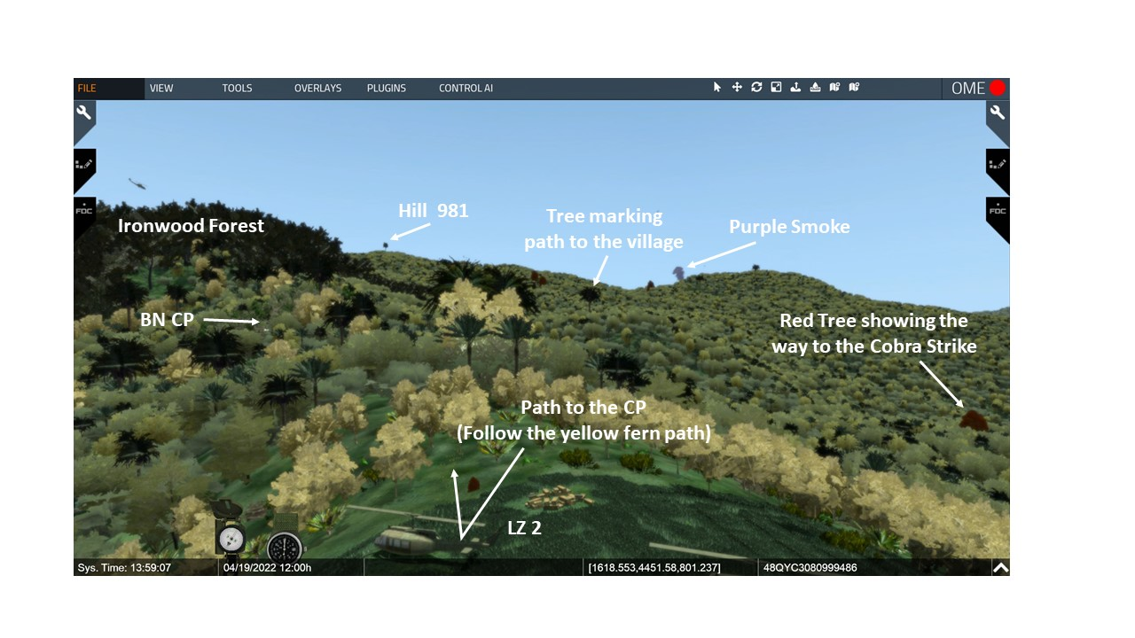

    - The village was not shown on the unit’s maps and some huts had carefully attended gardens and near-by bunkers.
    - A still-smoldering fires and abandoned equipment indicated that the village had been occupied by NVA soldiers very recently.
    - The NVA avoiding contact was their normal procedure. However, the large amounts of abandoned equipment was not typical. Normally the enemy left nothing behind to indicate their presence.

VSR: Fly back to LZ 2 then follow the trail to the BN CP IAW the discussion below..
- C9: CP Site –After landing, Delta move SE up the ridge toward the summit of Hill 981.
  - Soon after landing they passed through a small clearing and then continued to move up the ridge.
  - They had no contact and saw no signs of enemy activity.
  - Elements of the BN TAC moved with Delta.

- By noon, Delta had secured some prominent terrain on the ridgeline leading up to Hill 937. VSR: Pause when first entering the CP area.

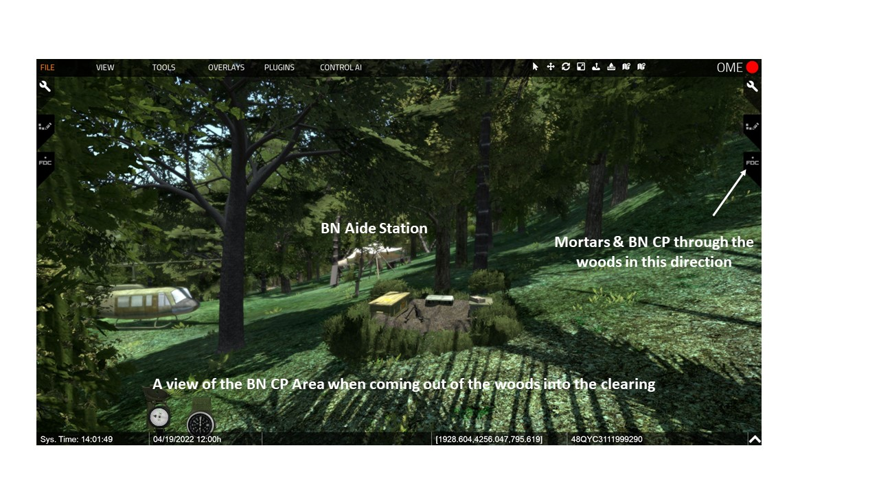

  - Initially only nondescript location on a narrow jungled ridge.

  - It was from this key position, approximately 1200 meters to the northwest of Hill 937 that the battalion established its headquarters.

  - In a short time the area was transformed into a functioning battalion command post. (Zaffiri, 66-67)
    - VSR: Look to the left at the LZ and medical tent. C10: LZ Picture - Honeycutt’s engineers used chain saws to bring down several trees in the NW corner of the position for a one-ship LZ. Near the LZ was a medical tent.
    - VSR: Move into the CP to the mortar area. The engineers also cut several trees in the center of the position so that the company’s 81mm mortars could fire. [actual positions much less deliberate than shown]

    - VSR: Move to the SE corner. The engineers and soldiers cleared away a bamboo thicket for the BN HQ. A lieutenant described the BN CP: “I gave a quick look around. Holes had been dug around the big perimeter… A TOC had been set up, partially dug into the ground, partially built up with sand bags, and so had a couple other structures inside the perimeter…” (Boccia, 429).

    - VSR: Move to the M60 fighting position near the CP tents. The 94 soldiers of Delta then ringed the whole position with fighting positions.

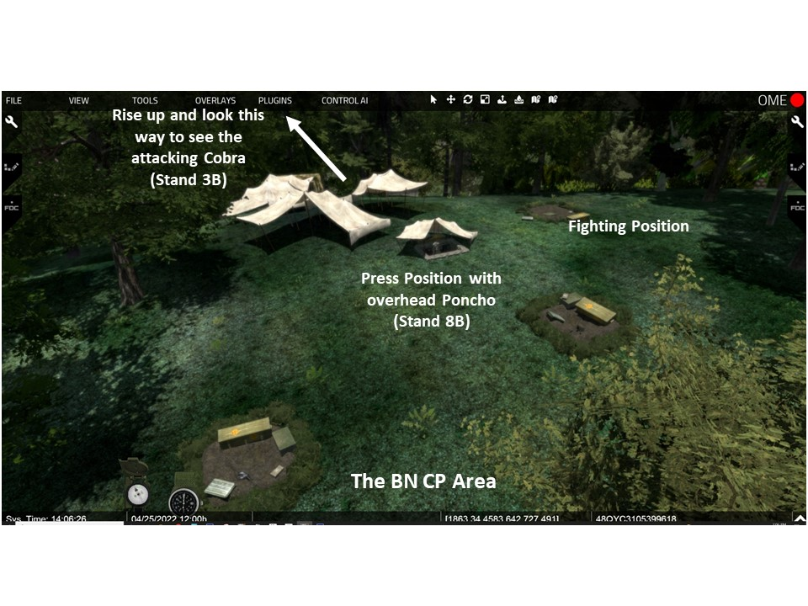

- C11: Contact - Around 1440 was the first significant contact of the day. (Zaffiri, 67).VSR: From the BN CP rise up and look to the southwest for a large red tree. Fly toward that tree and then continue on toward the 2d red tree. In the vicinity of the 2d red tree take a position above and behind the Cobra. IAW the discussion below move down to the trail, hut, and river.
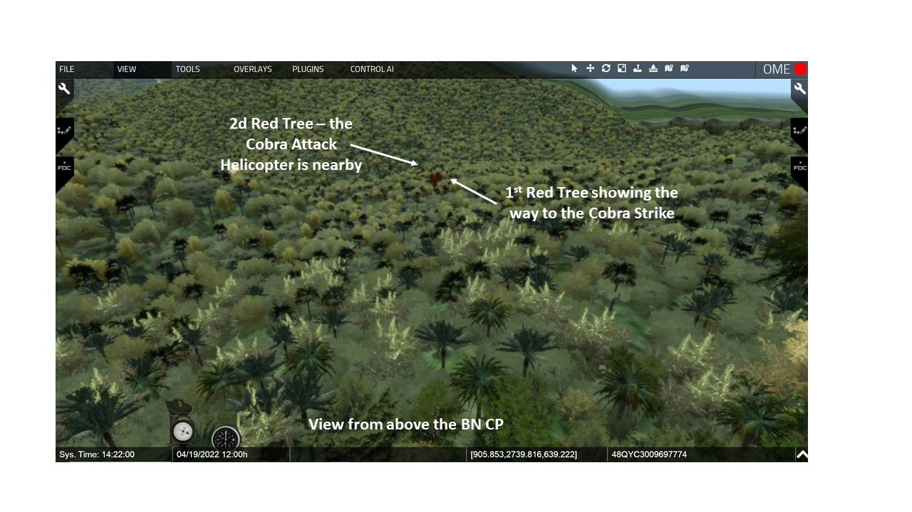
  - A Hunter-Killer Team of Observation LOHs and Cobras spotted 5 or 6 NVA less than 2,000 meters west of Hill 937. The NVA were spotted near a hut and moving down a trail toward Laos.
  - The Cobra gunships engaged the enemy and possibly killed 2 of the NVA.
VSR: Look toward the Hamburger Hill.
- C12: HMG Symbol- Soon after this, an enemy 12.7mm HMG engaged a FAC from f Hill 937. The FAC marked the location of the HMG and Fighter-bombers dropped four 500 pound bombs on the position.

- LTC Honeycutt updated his estimate based upon the discovery of the numerous huts and the aerial contacts. (Zaffiri, 67).

  - He believed that the ground was and enemy base area.

  - Although the area was currently relatively passive and the LZ was not under-fire, he was concerned that the situation could rapidly become very hot.

  - He asked the Col. Joseph Conmy, the 3d brigade commander, to release Bravo Company from the reserve and bring them into the LZ while it was still cold – Col Conmy agreed.

- C13: Terrain Box for the Next Slide.

VSR: Return to LZ2. Also point out the visual as zoomed in to provide more detail in the area from the BN LZ to the mountain summit and point out Dong Ap Bia.

VISUAL 2B: RECONNAISSANCE IN FORCE. [Unless otherwise stated – XXIV Corps Historical Summary. [The PPT builds on the visuals are noted as C1, C2, or C3 etc.]

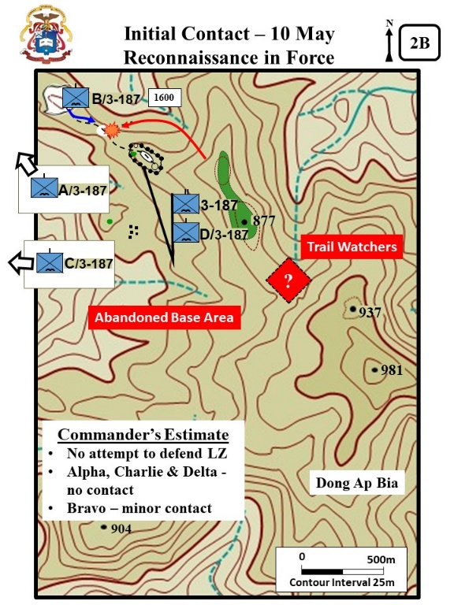
- C1: B/3-187 - About 1600, Bravo (107 men) arrived at LZ 2.

- The platoon leader for 1st platoon, Bravo Company was First Lieutenant Frank Boccia. (Boccia, The Crouching Beast, 3)

  - Frank was an Italian citizen:
    - His father was a diplomate and he was going to college in the US studying English.
    - He joined the Army and went to officer candidate school as a path to U.S. citizenship because he did not want to go home to Italy.

  - He was married and when he departed for Vietnam his wife was pregnant with their first child (John Diconsiglio, Vietnam – The Blood Bath at Hamburger Hill,16)

  - He stated that the Boccia rhymed with Gotcha. But then went on to say that after the first 6 months in the army he gave up on anyone saying his name correctly.

    - His peers referred to as Frank, Bo, or Botch.
    - His men referred to him as L T, Lieutenant, or Lieutenant Botch.

  - He was a prolific reader and writer, and much of the published history on the Battle of Hamburger Hill is based on his book, The Crouching Beast – A United States Army Lieutenant’s account of the Battle for Hamburger Hill.

- Lieutenant Frank Boccia recalled that the Hamburger Hill saga started with a simple mission to recon the top of hill to find a good location to establish the BN CP.

  - “[The] Brigade S2 called Black Jack (LTC Honeycutt) and informed him of the existence of Area 82, a suspected NVA logistics center, thought to be located on a mountain…called Dong Ap Bia, and the base was thought to be centered on or near one of its peaks, Hill 937. Looking at his map, Black Jack decided that, if nothing else, the peak would make a good battalion CP site. Accordingly, he ordered Captain Lee Sanders to take Delta Company and probe the area, and then establish a perimeter for the battalion CP.”

  - The mission was given transferred to Bravo when they landed. (Boccia, The Crouching Beast, 279-280).
VSR: IAW the visual and narrative move down the trail to the clearing SE of the LZ.
- C2: Bravo movement & contact - The company had moved only a very short distance from the LZ (at the saddle) when they began to receive fire from small arms fire, mg’s and rocket propelled grenades (RPG).

  - The company suffered three wounded

  - LT Boccia recalled: “Blam!, Blam! I dove for the ground, one hand holding my rifle, the other pressing my helmet down on my head. RPGs, I thought. F --- RPGs. The initial explosions were followed by the light spatter of AK-47 fire and then, after a second or two, the steady thumping of DP machine gun.” (Boccia, 281)
  - Bravo responded with their organic weapons and were supported by mortars which killed four of the enemy.

  - The Bravo fight. (Zaffiri, 72-73)

    - Soon after engaging the first enemy position, another NVA position opened fire with automatic weapons and RPGs. Cpt. Littnan made the decision to pull back to the vicinity of LZ2 and engage with air-support.

    - Two Skyraiders pummeled the clearing area for about 15 minutes. (Zaffiri, 72).

    - This contact was a surprise because the enemy was between the LZ and the BN CP area which was only about 500 meters to the SE.

    - Notice also that the artillery and TAC (Air) are between two friendly forces. What does this demonstrate about the unit’s willingness to call for “Danger Close?”

- It was now 1900 and dark. BN directed Bravo to dig-in along the north side of the clearing and then continue the advance at day light.

VSR: Rise up in the air and look toward Alpha and Charlie’s movement.
- C3: A & C/3-187 - Alpha and Charlie moving generally to the west toward the Laotian border, made no contact with the enemy during the day.

VSR: Rise up in the air and look toward Dong Ap Bia.
- C4: Commander’s Estimate – LTC Honeycutt’s appraisal of the day (Zaffiri, 75)
  - Enemy made no effort to defend the LZ.
  - Alpha and Charlie had no contact.
  - Bravo had one brief contact.
  - Other BN’s had similar minor contact.

- C5: Abandoned Base Area -
  - No major NVA force remaining in the area.
  - Estimate made that it was an abandoned communist base area.

- C6: Trail Watcher Theory –His estimate was that encountered enemy were nothing more than trail watchers.
  - The NVA had avoided the BN CP area and moved down the trail to recon the US LZ.
  - But had then bumped into Bravo.

- The 2d Battalion, 501st Infantry assaulted onto a landing zone about 5K to the NW and had no significant contact.

- The 1st Battalion, 506th Infantry assaulted onto a landing zone about 6K to the S and had no significant contact.

- The 4th Battalion, 1st ARVN Regiment assaulted into a landing zone about 11K to the NW and also had no significant contact.

- These battalions did discover numerous small caches containing mixed small arms, mortar rounds and crew-served weapon ammunition.

ANALYSIS
VSR: Rise up in the air and look toward Dong Ap Bia.

The intelligence warfighting function is the related tasks and systems that facilitate understanding the enemy, terrain, weather, civil considerations, and other significant aspects of the operational environment. (APO 3-0, 2019, 5-15). Additionally the Draft ATP 3-90.98, Jungle Ops (2020) states in para 2-40, “Combat in the jungle is characterized by long periods of developing a situation and looking for the enemy” and in para 2-43.To fight and win in the jungle, units must—Fight for intelligence

- How did the Army’s collective experience in the Vietnam War influence the LTC Honeycutt’s understanding of the enemy?
- Evaluate Honenycutt’s Estimate of the Situation.
    - Abandoned Base Area
    - NVA element was a trail watcher/reconnaissance group.

3. From the Brigade perspective – what is the estimate of the situation? Are things proceeding as expected?

Page not used – formatted for 2-sided printing
STAND 3: 11 MAY– DEVELOPING THE SITUATION

VISUALS

3A: DISCONCERTING DISCOVERIES
3B: FIRST ASSAULT UP HILL 397
3C: PLAN FOR 12 MAY

ORIENTATION

Virtual View: From the vicinity of the clearing near the LZ.

Orientation: Currently located at the clearing SE of LZ2. The BN CP area is about 300m. The summit of Dong Ap Bia is about 1500 meters to the SE. The river and Laos border is about 1200 meters to the west.
DESCRIPTION

VISUAL 3A: DISCONCERTING DISCOVERIES [Unless otherwise stated – XXIV Corps Historical Summary. [The PPT builds on the visuals are noted as C1, C2, or C3 etc.]

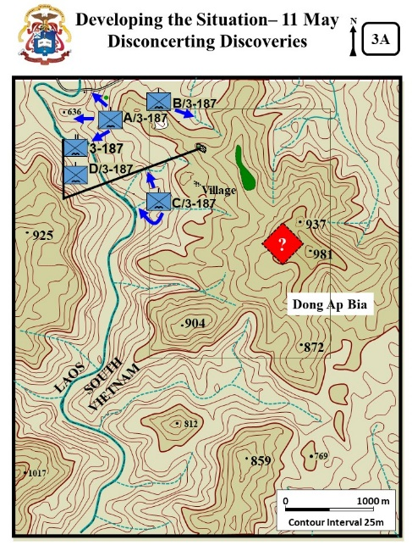
- VSR: Return to LZ 2 and rise up and look to the SW toward Charlie. Charlie continued their reconnaissance in force operations west of Hill 937 along the Laotian border. They made no contact with the enemy but did report finding trails with fresh tracks.

- VSR: Go to the NW end of LZ and follow the path (between two red bushes) to the Super Highway. Note – this is a relatively long trip through the forest. Stop at the “superhighway.” First look to the right up the superhighway, then turn to the left and move down the road to the vicinity of the hut (marked with a red bush) IAW the discussion. Then down to the river. C1: A/3-187 - Alpha also had no contact, but a discovery near the river was said to be “disconcerting.” (Zaffiri, 83-84)

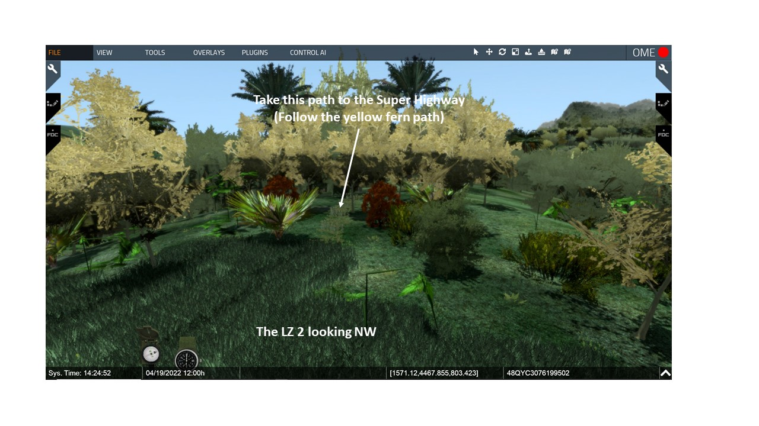

  - Lt. Frank McGreevy’s platoon (1st) had been moving toward the river since about 0800. He had avoided trails because of the danger of ambush. However, his cross-country movement was painfully slow.

  - About 1400, the platoon pushed thru the jungle and discovered an improved road. He referred to it as a “super highway.” The surface was packed and the jungle above was woven together making the road invisible from the air.

  - The road went east around the north side of the mountain and then west toward the river and Laos.

  - Near the river they discovered a hut with bunkers. The way-stationed had an assortment of NVA clothing and equipment, garden, and chickens. There was also a still burning fire which indicated the occupants had only recently departed.

- VSR: Return to the LZ and then to the edge of the clearing SE of the LZ. C2: B/3-187- Bravo resumed its move up the ridge to gain the top of Hill 397.

- C3: Box build for visual 3B.

VISUAL 3B: FIRST ASSAULT UP HILL 397[Unless otherwise stated – XXIV Corps Historical Summary. [The PPT builds on the visuals are noted as C1, C2, or C3 etc.]

- C1: B/3-187 movement - About 1.5 hours after daylight, Bravo resumed its movement up Hill 937.As the company started the move up the hill, Boccia recalled: “Before my platoon moved up the hill, fighter –bombers, and artillery helicopters bombarded its slopes with air strikes and napalm. It didn’t seem like anything could live up there.” (Diconsiglio, Blood Bath, 18-19)

VSR: At the clearing take the trail that angles off to the left (marked with a red bush) Follow the trail up the hill IAW the discussion below.

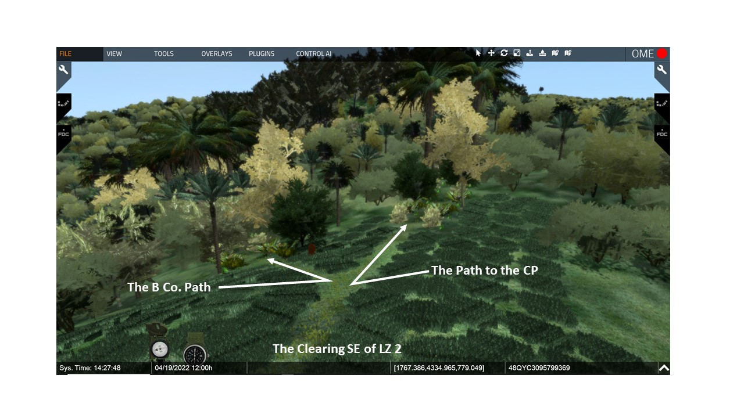
- VSR: Move along the trail to the next red bush. Bravo used a trail as their axis of advance (Zaffiri, 70).
    - The trail wound through the jungle like a tunnel.
    - Overhead the trail was covered with large palm fronds and the sun was blocked out by thick canopy of vine filled trees.
    - Boccia remembered, “Each step was a struggle. Narrow trails snake up the hill into the jungele. The canopy was so dense that we could barely see a few feet ahead of us. The vines kept out the light and the fresh air. The jungle smelled rotten.” (Diconsiglio, Blood Bath, 18-19)
    - The company moved cautiously expecting contact at any minute. (Zaffiri, 75)

- VSR: Move along the trail to the next red bush. Lt. Boccia’s platoon led the way, and he recalled that Cpt Littnan told him, “Frank – take it real easy moving up that hill. Charlie’s had all night to put in a surprise or two for you.” (Boccia, 287)

- C2: Bamboo - VSR: Continue up the trail and pause at the beginning of the bamboo thicket. Then look to the left and right. A short way up the path they ran into a dense bamboo thicket where the only movement possible was along the path.

- IAW the discussion move into the thicket and pause at the area marked with the red bush and NVA equipment. Boccia stated, [about 8 to 10 meters into the thicket] the bamboo lay across the path in swathes, forming a slanting roof about four or five feet high.” It was like a tunnel but there was no way around. At times the tunnel roof was only about 18” (Boccia, 289-290).

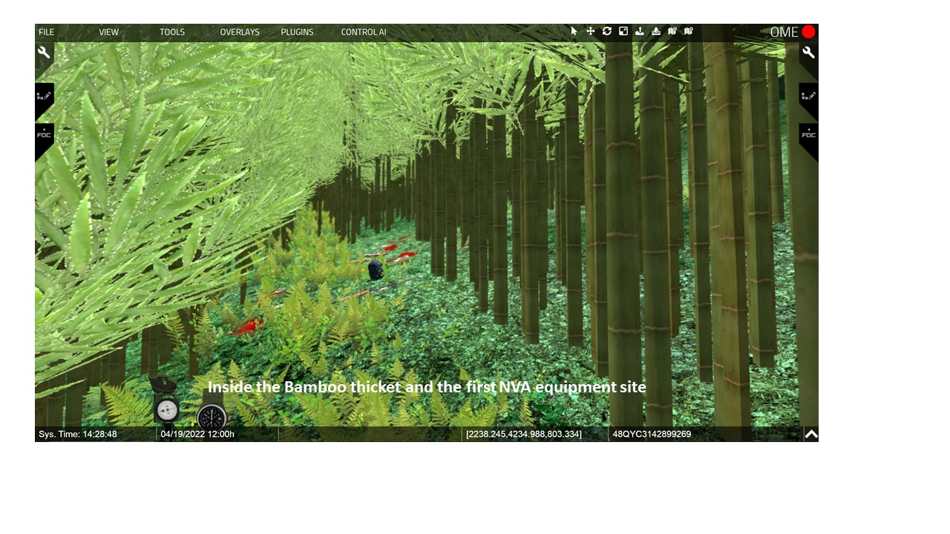

  - C3: 3 Dead NVA - In the movement, the lead platoon discovered three dead NVA. (Zaffiri, 76)

  - The soldiers were young with boot-camp like haircuts. Every indication was that they had not been in the jungle very long.

  - They also discovered two assault rifles, an RPG, and several rocket grenades. One of the dead appeared to be an officer and had a packet of documents and some personal letters.

- VSR: Continue along the path through the bamboo. The platoon struggled through the bamboo. At times they had to crawl. Bulky equipment like radios and M60 mgs had to be dragged behind them.

- C4: Other Indications, VSR: Continue up the hill to the next NVA equipment location just as leaving the bamboo thicket. Near the top of knoll, they discovered blood trails, foot prints, bandages.

- VSR: Continue a short distance to the next equipment location. Then moments later, they discovered a rucksacks filled with rice balls, a brand-new AK 47 in a leather carrying case, and a box of grenades. (Zaffiri, 77)

  - Lt. Frank Boccia, the lead platoon leader, was troubled by the discoveries. They NVA rarely left any hint of their presence.

  - He believed the NVA to his front were not interested in hiding and was well enough equipped that they were not concerned about leaving equipment behind.

  - Boccia recalled that everything was, “Like, this way, dummy!” just keep coming this way we are waiting for you. (Boccia, 293)

  - Rifleman Dennis Helms was Boccia’s radioman. He recalled, “We had to go slow… We knew they were leading us into an ambush… There were blood trails, equipment laying beside the trail.” West Point Center for Oral History [WPCFOH], Helms interview.

  - The end result was the lead platoon moved even slower.

- Nevertheless, LTC Honeycutt pressured Bravo to move faster. (Zaffiri, 77-80)

  - In turn, Cpt. Littan pressured Lt. Boccia to move faster.

  - Lt. Boccia refused to rush his men and at first Cpt Littan reluctantly agreed to the cautious pace.

- VSR: IAW the visual and discussion continue down the trail into the Ironwood forest and pause. The further up the mountain they moved into more open the terrain. Most of the secondary growth and the bamboo thickets thinned out.

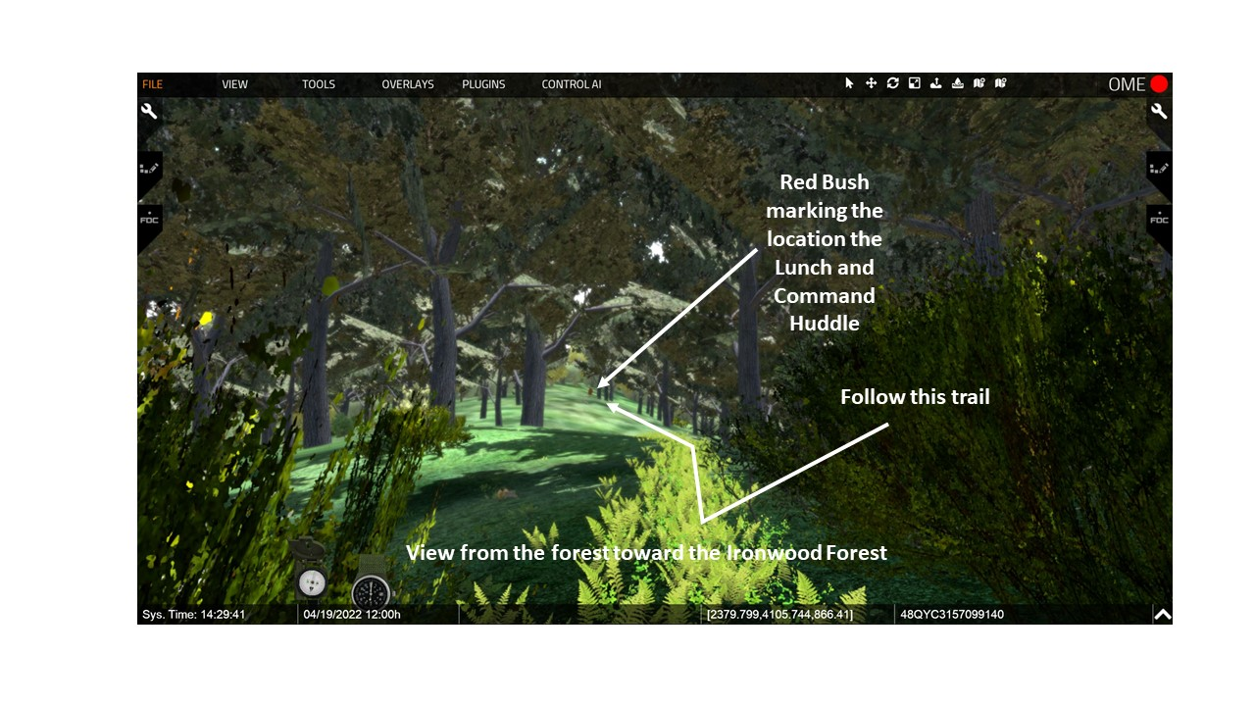
  - There were giant trees and significantly better visibility (Zaffiri, 79).

  - Lt. Boccia recalled, “We were now moving through huge grey trunks, towering over our heads. These were the ironwood and mahogany trees, the largest I’d ever seen. The sun was now overhead, but the forest floor, shaded by the massive crowns, was hushed and gloomy, only here and there could you see a slender shaft of sunlight. I felt uneasy and insecure; this place was too open, too exposed. Visibility to either side and to the front was now as much as 50 or even 100 meters, which in the mountain forests of Viet Nam, is the equivalent of an Illinois prairie. I didn’t like it.” (Boccia, 292)

- VSR: Continue down the trail to the M16 and radio leaning against the tree. Also marked with a red bush and pause. C5: Lunch and Command Huddle - About noon, the company halted for a brief lunch break and a command huddle. (Boccia, 293 and Zaffiri, 79)

  - They planned about a 20 min break.
  - Cpt Littan had Boccia send a squad 500 meters up the trail during the break.
  - The break was extended because of a heavy rain downpour that lasted about 20 minutes.
  - The squad returned and indicated the trail continued toward the top of the mountain. They reported:
    - No contact, but signs of enemy activity.
    - Y junction in trail just short of the next knoll.

- At the end of the break, Littan directed Boccia to move faster. When Boccia started to move out, his radioman had the strap on his radio break. Boccia informed Littman of the need to pause to fix.

- Cpt. Littan frustrated with the slow movement and ongoing pressure from BN decided to move Lt. Charlie (Chuck) Denholm’s 4th platoon to the front. (Zaffiri, 80-82).

- VSR: Continue down the trail to the Y Junction. Marked with a red bush. C6: Move to the Y Junction – While following fresh tracks up the ridge, the company was fired on by a loan sniper that delayed their movement. At the Y junction the unit paused to observe the RPG rocket stuck into the tree and ponder how it got there. It became a reference point for units operating on the ridge.

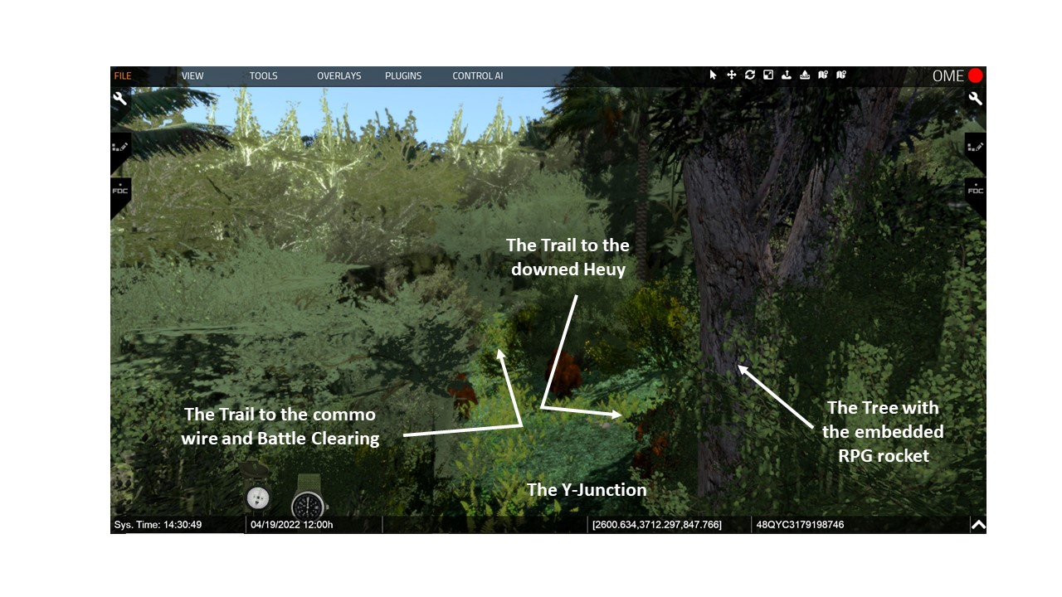

- VSR: Continue down the trail to the Commo wire. Marked with a red bush.C7: Commo Wire – About 1300, Denholm’s lead element discovered communication wire and more tracks leading up the hill.

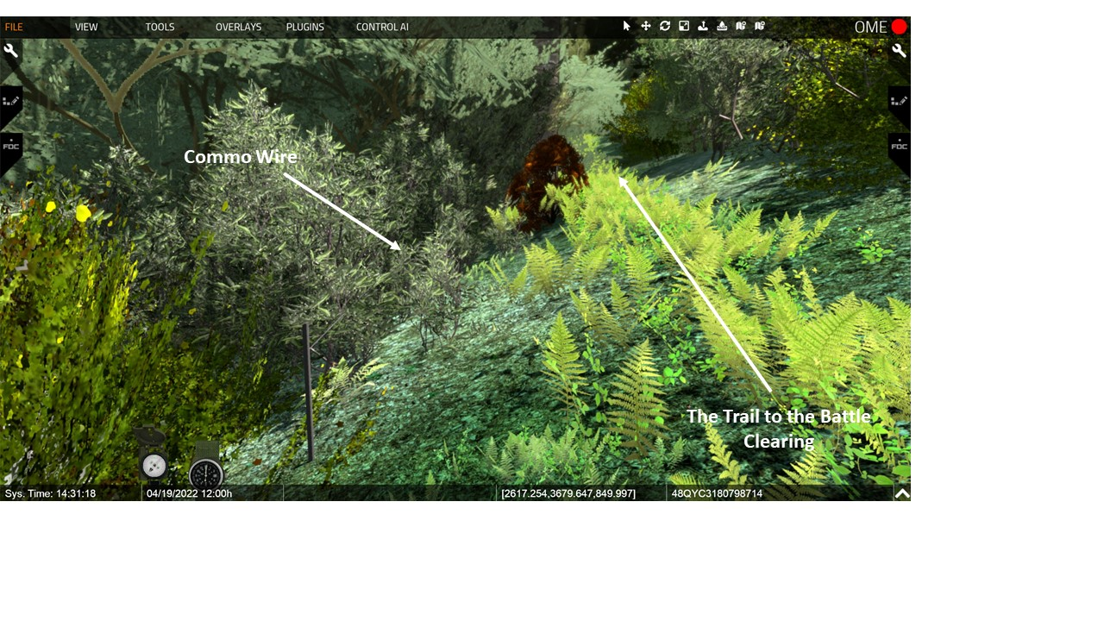
  - The wire was attached to the trees with insulators.

  - Again the discovery troubled the Bravo leaders. The question was, if the NVA had established a communication network then just how many NVA were on the hill?

VSR: Continue down the trail to. Pause at the Razor Back Ridge (the next red bush) for the vignette and then continue to the edge of Battle Clearing.
- C8: The Clearing - Denholm also discovered that the trail moved along a narrow razorback ridge and then through a small clearing (Boccia, 304-305).
  - The steep and narrow ridge increased its incline and the flanks were precipitous.
  - Rifleman Helms vividly remembered the razor back ridge, “…the vegetation was so thick [on both sides] you could not go down on the sides and if you could it was so steep you couldn’t maneuver on it.” (WPCFOH, Helms Interview)
  - The clearing seemed as wide as a football field, but in reality only about 20 meters across and 40 meters deep.
  - It was mostly covered with short scrub brush.
  - There was thick vegetation at the far end.
  - The summit of Hill 397 100+ meters beyond the clearing.

VSR: Move into Battle Clearing and then pause to discuss the ambush.

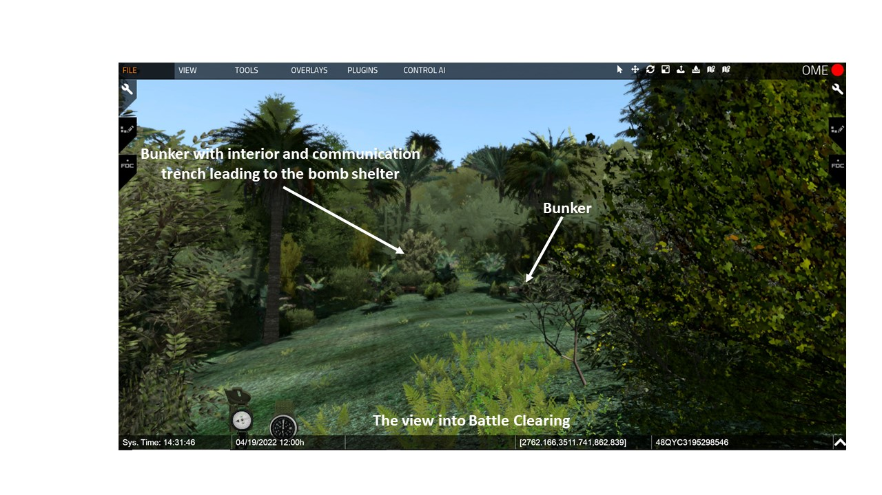

- C9: The Attack Arrow – Shortly after moving into the clearing they were engaged by a well-entrenched enemy force to their front (the clearing). The enemy employed small arms, machineguns, RPGs and mortars.

- The enemy fire seriously wounded Lt. Denholm and killed the lead two men and wounded several others. (Zaffiri, 87-88)

  - Some of the enemy were popping up from spider holes among the US platoon and shooting at point-blank range.

  - Lt. Denholm, despite his wounds, remained in the fight and tried to bring his platoon forward on line. He could not stand or hear due to his wounds – so crawled around to try to pull the wounded back.

  - He brought up two M60 MMG gunners, both were shot down, and overwhelming enemy fire forced the platoon back.

- Bravo was forced to withdraw a short distance to regroup and some of the wounded and equipment were left behind.

  - Platoon Sergeant Louis Garza took charge and maneuvered the two trailing squads forward (Zaffiri, 88)
  - Under a curtain of supporting small-arms fire, the soldiers charged forward and recovered the dead and wounded.

- At this point, pause in the story and show the clearing from the enemy perspective. VSR: Move to the interior of the enemy bunker on the north side of the trail. Also show the trench line back to the bomb shelter.
  - This area gives an example of how extensively the hilltop was fortified.
  - Bunkers all but invisible in the thick terrain.
  - Many of the bunkers connected with communication trenches. Not shown here, but most covered with camouflage or even overhead cover making them more tunnels than trenches.
  - Throughout the area there were A-frame bomb shelters. These would have been underground – we have shown this one above ground for the discussion.

- VSR: Rise up and fly back to the Y Junction. By 1645, Denholm and Garza had pulled the platoon back into the saddle near the Y Junction. (CMH Pub 76-6: Transition Nov 1968-Dec 1969, 30-32). (Details below from Zaffiri, 90)
  - Lt. Boccia was shocked when he saw his fellow platoon leader withdraw back thru his platoon.
  - Lt. Denholm was covered in blood. His legs were wobbly and he walked as if he was drunk. His arms hung limply at his side.
  - Boccia remembered that he kept asking about his men by name.
- In this area (VSR: look up to the NW at the helicopter). Just to the NW of the Y Junction, the company was able to cut down some small trees and brush and make a small forward LZ just big enough for the tiny LOACH helicopter to get into. This would become the B Co. NDP (Night Defensive Position)

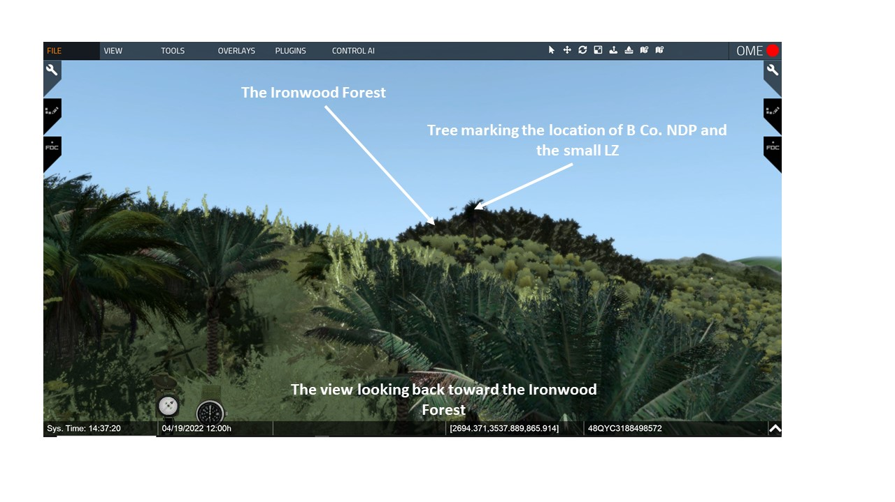

- Denholm’s casualties were shuttle back to the BN CP from the forward LZ in the LOACH Helicopter. (details from Boccia, 303)
  - The Hughes OH-6 Cayuse (nicknamed "Loach", after the requirement acronym LOH—Light Observation Helicopter)
  - It had a landing profile about half the UH-1 Heuy.

- Warrant Officer Eric Rairdon already had already earned the nickname “Crazy” Rairdon.
  - “Crazy” came from his frequent disregard for weather minimums and long hours supporting the battalion.
  - In his association with the Rakkasans he stated “I got to know the people.” and the Rakkasans believed that Rairdon could get to them when no one else could.
  - Lt. Boccia stated, “Pilots are, by my definition, crazy…[Rairdon was] “probably clinically insane.” (Boccia,335and 388)
  - Rairdon in getting the wounded out would overload his tiny helicopter.
    - One ambulatory casualty in the co-pilot seat.
    - One or two stuffed behind the seats.
    - And one each strapped into stretchers on each side.
  - Every time Rairdon came back he brought ammunition, food, and water.

- Cpt. Littnan responded by calling in additional airstrikes and artillery on the suspected enemy bunker locations near the clearing.

VSR: Fly back to the BN CP and then look up and to the north at the incoming Cobra (see the BN CP VSR view with Stand 2A).
- C10: Fratricide at the CP- Friendly Fire Incident: During the evacuation of these casualties, a helicopter gunship accompanying the medical evacuation helicopter inadvertently fired six rockets into the battalion command post position.
  - The fire killed 2 and wounded 35.
  - The wounded included the battalion commander, the artillery liaison officer and the Sergeant Major. (Zaffiri, 91).
  - Over time, 30% of the battalion’s casualties were from fratricide incidents. Most of those be Cobra strikes.

- All of the wounded were subsequently evacuated, except for the battalion commander who elected to remain with his troops.
- Honeycutt had a piece of shrapnel in his back and could barely walk.
- He did fly out briefly that night to have the shrapnel removed and then immediately returned to his battalion. Zaffiri, 99).

- Soon after the friendly-fire incident. A NVA 120mm mortar fired on the BN CP.
- It was firing from Laos and put 5 or 6 rounds into the CP.
- Then five NVA soldiers charged into the CP area from the jungle.
- The BN S-2 section led by Cpt Addison killed three of the enemy soldiers and chased the others back into the jungle. (Zaffiri, 91)

VISUAL 3C: THE PLAN FOR 12 MAY [Unless otherwise stated – XXIV Corps Historical Summary. [The PPT builds on the visuals are noted as C1, C2, or C3 etc.]
VSR: Remain at the BN CP. Rise up at look to Dong Ap Bia IAW the discussion below.
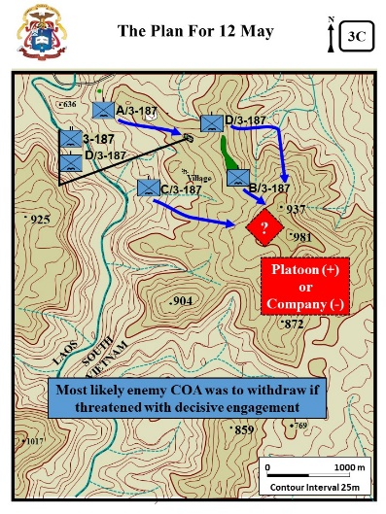
- LTC Honeycutt’s dilemma. (details from Zaffiri, 92-93)

  - He wanted to push Bravo back up the hill immediately.

  - However he realized his CP was not currently capable of coordinating the artillery and air support needed for the attack.

- C1: Estimate - LTC Honeycutt’s estimate of the situation (details from Zaffiri, 93-94)

  - That morning he believed that Hill 937 was occupied by either a NVA recon party or possibly a trail watcher group.

  - Additional intelligence through the day was disturbing.
    - Bravo’s discovery of the communication wire and their subsequent fight at the clearing.
    - Alpha’s discovery of the road and way-station.
    - Documents found by Bravo earlier in the day identified the enemy force as being from the 29th NVA Regiment which, according to the documents, they had only returned from North Vietnam in April.
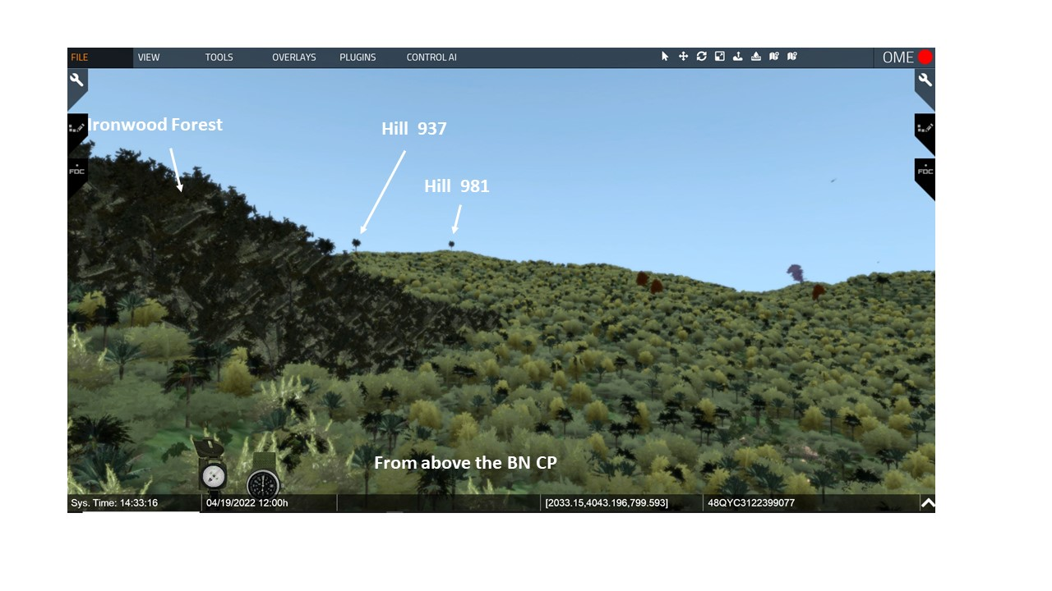
  - This information, supported that a sizable enemy force might be occupying Hill 937. Possibly a reinforced platoon or possibly a company (-) – the largest size force that the NVA normally operated in the field.

- C2: A/3-187 Plan - LTC Honeycutt’s decision. (Zaffiri, 93)

  - Needs to know if more than one platoon on Hill 937. Too much ground and resistance for Bravo.

  - Cancel the Alpha and Charlie RIF in the river valley.

  - Alpha conduct a relief in place with Delta at the BN CP.

  - C3: D/3-187 – VSR: Look to the Delta area. Delta RIF to the NE then due south up the north face of Hill 937.

  - C4: C/3-187 – VSR: Look to the Charlie area. Charlie now to conduct an RIF up Hill 937 to the east. This puts them south and parallel of Bravo

  - C5: B /3-187 – VSR: Look to the Bravo area. On the 12th, Bravo continue to develop the situation toward the top of Hill 937.

  - On the 13th, three companies would move up Hill 937.

  - C6: Enemy COA- LTC Honeycutt based his plan upon his assumption that the enemy would most likely withdraw if threatened with decisive engagement.

- Meanwhile, the 1st Battalion 506th Infantry while maneuvering about 5K south of Dong Ap Bia received mixed 60mm and 82mm mortar rounds resulting in seventeen wounded, all of which were later evacuated.

- About 7K NW of Dong Ap Bia, the 2d Battalion, 501st Infantry encountered minimal contact during the day

ANALYSIS

- The primary purpose of the command and control warfighting function is to assist commanders in integrating the other elements of combat power (leadership, information, movement and maneuver, intelligence, fires, sustainment, and protection) to achieve objectives and accomplish missions (APO 3-0, 2019, 5-11). Additionally Draft ATP 3-90.98, Jungle Ops (2020) para 3-5 (Leadership) states, “Confident, competent, and engaged leaders are critical to successful jungle operations.”
  - Evaluate the BN CP’s ability to provide “confident, competent, and engaged” leadership support after the fratricide incident.

  - Evaluate LTC Honeycutt’s decision not to continue the attack after the BN CP fratricide incident, even though one of four of the Bravo platoons had been in contact with the enemy.

  - Evaluate his estimate of the enemy situation that the enemy would most likely withdraw if threatened with decisive engagement.

- The Draft ATP 3-90.98, Jungle Ops (2020) states:
  - Para 1-23: Jungle terrain can canalize operations due to poor cross-country mobility.
  - Para 1-24: Observation and fields of fire are generally restricted in jungles.
  - Para 2-2: Operations in jungles tend to be isolated actions by small forces because of the difficulties associated with moving and maintaining contact between units.

  - Evaluate the NVA positioning of the first bunker line near the razor back ridge and clearing.

- The Draft ATP 3-90.98, Jungle Ops (2020) states:
  - Para 2.6: Because jungle operations focus on the enemy and are less concerned with terrain, they are often nonlinear in nature. Characterized by a combination of dispersion and concentration, jungle operations often consist of small units conducting reconnaissance operations and movements to contact to locate and fix the enemy.
  - Para 2-1: Leaders conducting jungle operations must retain the ability to converge combat power at decisive points, despite the dispersed nature of jungle operations.
  - IAW this “draft” doctrinal guidance evaluate the 3-187 plan of attack for the next day.

- Evaluate LTC Honeycutt’s emphasis on the need for Bravo to move faster. Why the hurry?

Page Not Used

STAND 4: 12 MAY - FRUSTRATION

VISUALS

Visual
4A: SECOND ASSAULT UP HILL 397
4B: FIREBASE AIRBORNE – NIGHT OF 12 MAY

ORIENTATION

Virtual View: From the BN CP look to the SE toward Dong Ap Bia.

Orientation: Currently located at the BN CP. The summit of Dong Ap Bia is about 1500 meters to the SE.
DESCRIPTION

VISUAL 4A: SECOND ASSAULT UP HILL 397 [Unless otherwise stated – XXIV Corps Historical Summary. [The PPT builds on the visuals are noted as C1, C2, or C3 etc.]
VSR: From the CP look toward area discussed for Delta, Charlie, and the bombardment.

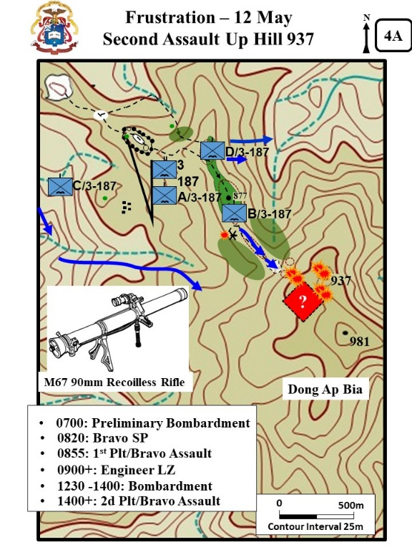
- (12 May) Realizing that he had found the enemy on Hill 937, although he was still unable to determine the size of the force, LTC Honeycutt decided to employ all of his companies to further develop the situation.

- Alpha assumed the mission as battalion reserve and Delta moved out to the east and was to turn toward Hill 937 later in the day.

- Charlie turned around and began moving to southeast to join Bravo.

- Bravo prepared to continue the maneuver against the well-disciplined enemy force which was dug in about 200 meters to their front.

- C1: 0700 Preliminary Bombardment - As on previous days, the hill was continually bombarded with airstrikes and artillery, including 500 and 1000 pound delayed fuse bombs and napalm, in an effort to dislodge the enemy from his fortified positions. (additional details below for Zaffiri, 99- 106)

  - At 0700, the first airstrike hit the hill. Cpt. Littnan wanted Lt. Boccia’s 1st platoon to move up the hill soon after the strikes.

VSR: Fly back to the edge of the Hamburger Hill clearing.
  - C2: Bravo SP - At 0820, 1st platoon moved out with 2 squads up and one trailing.

  - C3: 0855 1st Plt Assault - It took the platoon 35 minutes (0855) to move two hundred meters back to the clearing.
- VSR: Move slightly into the clearing to discuss the fight. Soon after moving into the clearing they were engaged, A HMG also engaged the plt. Boccia remembered,
“Two, perhaps, three claymore mines were blown immediately ahead of us; the fragments whined overhead, into the trees behind us. Then the familiar crackle of of Ak 47s spat out of the woods, and , with paralyzing intensity, the solid bass hammering of the .51 caliber.” (Boccia, 317-318)

VSR: Move to the 90mm position (south side of trail at the edge of the clearing marked with a fallen branch).
- C5: M67 RR. The platoon soon spotted a bunker and brought forward a RR to engage.

  - The RR engaged and destroyed the bunker, but then from another nearby bunker the NVA engaged and destroyed the RR and wounded the two crewmen.

  - Boccia remembered, “I was looking directly at the 90mm team when, to my horror, an RPG hit directly in front of them. The black barrel of the gun went high in the air, emerging out of a cloud of dirt, leaves, and explosives. I saw a helmet go flying; then Clifton and Nelson appeared, their bodies rolling down the slope.” (Boccia, 318-319) Fortunately both men survived with only scratches and bruises.

- The initial RPG served as a signal and then a volley of RPGs hit the lead to squads wounding six men.

  - The platoon medic rushed forward, but was also wounded.
  - Boccia remembered, “The first RPG was a signal. Suddenly, countless NVA soldiers appeared from spider holes, firing volleys of RPGs. We hugged the ground, but grenade rockets kept coming. About 30 NVA soldiers laid down a blanket of machine-gun fire. Tree limbs and branches fell around us. We tried to shoot back, but the assault was too intense. I couldn’t even lift my head.” (Diconsiglio, Blood Bath, 24)

- Lt Boccia estimated his two squads were in contact with at least 20-30 NVA and he received permission to pull back.
  - The platoon returned to its start point dragging its wounded.
  - Cpt. Littnan then called in airstrikes and artillery onto the hill and the company evacuated its wounded to the BN CP.

VSR: Rise up and look back to the NW toward the Engineer/Bravo NDP LZ location marked with a large tree.
- C5: Engineer LZ - To aid in evacuating casualties and in resupply, LTC Honeycutt directed Bravo to prepare a helicopter landing zone near their night defensive position (NPA).

  - A helicopter inserting an engineer squad to assist in constructing the landing zone was hit by enemy fire.
  - The helicopter crashed and added seven more casualties to the list.

VSR: Look toward Hill 397.
- C6: 1230 Bombardment - At this point, Honeycutt coordinated a massive strike against Hill 937 to support another move by Bravo to get up the hill. (Zaffiri, 105)

  - About 1230, fighter bombers hit the hill with 1,000 pound bombs with delayed fuses.

  - Then six supporting artillery batteries pounded the hill for 30 minutes.

  - Then two pairs of Cobra gunships hit the hill with rockets and strafing.

  - At 1400, the fighter-bombers returned with more 1,000 pound bombs.

- C7 – 1400 (+) 2d Plt Assault - Soon after 1400, Honeycutt ordered Bravo to push another platoon through the clearing and up the hill. (details below from Zaffiri, 106)

  - Lt. Eward briefed his 2d platoon and then finished the briefing with an attempt to lighten the moment. “You know those assholes from One Six? They was already up there once today, and you know how they are: They left their Ninety behind. Last night it was Four Six couldn’t keep up with their stuff. Seems like all we’re doing up here is cleaning up after the other platoons. Well, can’t be helped. So if you guys are finished lunch, and are in the mood for a little police call…” (Boccia, 325)

VSR: Move into the clearing to discuss the fight.
  - Lt. Eward’s 2d platoon took the lead. Initially they were confident that the heavy fires brought against the hill had cleared the way.

  - The platoon advanced cautiously, but soon after they moved into the clearing a storm of fire forced them back.

  - Lt. Edward did pick up the 90mm RR left behind by Boccia’s men. He later personally handed it back to Lt. Boccia and remarked, “Excuse me, ma’am, did you drop this.” (Boccia, 327)

- LTC Honeycutt decided to forgo any more attacks until the 13th when Charlies and Delta would be position for the BN to execute a 3 company attack.

VSR: Rise up and look toward Charlie’s movement.
- Unfortunately, Charlie and Delta were having difficulties getting into their attack positions.

- C8- C/3-187 Movement - By late afternoon, Charlie had moved to a position south of Bravo and then dug in for the night. (additional details below from Zaffiri, 104 and 106)

  - At first the company movement was delayed by sniper fire from both the front and flanks.

  - Then about 1820, the NVA ambushed the company from the high ground above the trail.

  - They fired about six RPG’s which all exploded in the trees and rained shrapnel down on the company. The fire wounded eight men.

  - The company responded with mortars, artillery fire, and air support. The company resumed its movement but was again hit with volleys of RPG fire.

  - The second ambush caused no casualties, but convinced the company commander to halt movement for the day about 200 meters south of Bravo.

VSR: Fly back to the Junction and then move NW along the trail into the Ironwood forest. IAW the visual you will see some large rocks off to the right then follow the rocks until you are on the rocky slope going to the east. Then move down the slope stopping about ½ way to the bottom.
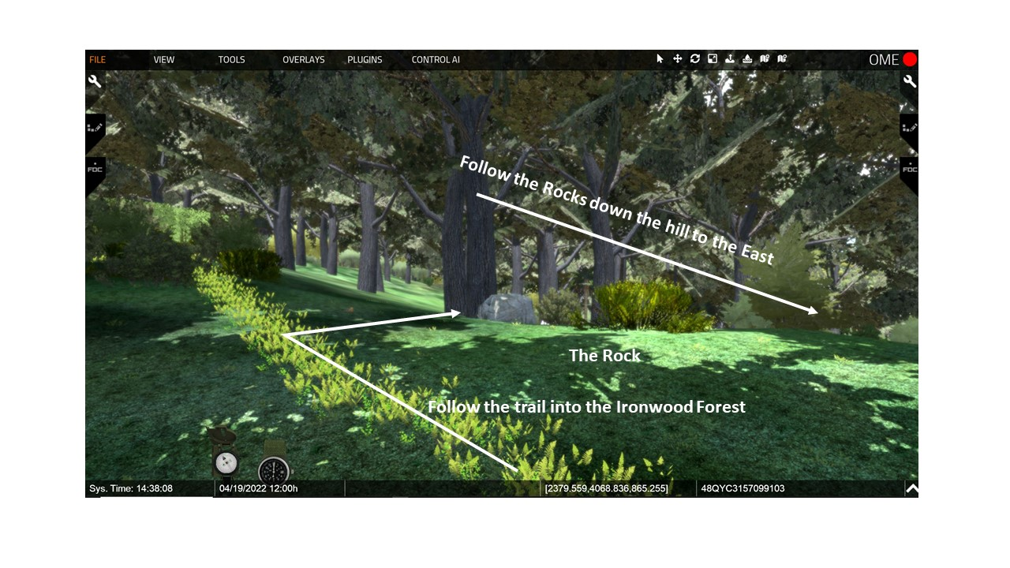

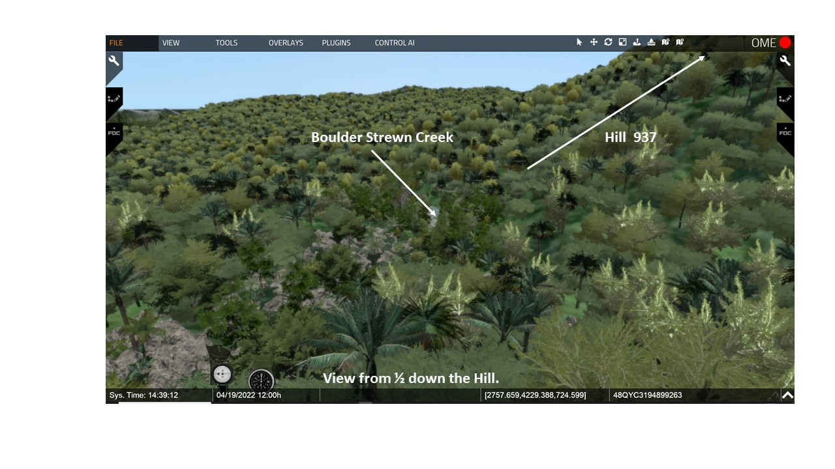
- C9- D/3-187 Movement - Delta was also unable to get into position to support an attack. (Zaffiri, 105 -106)

  - Although sniper fire harassed them periodically, it was the terrain that proved to be a major problem.

  - Moving down the ravine they found the rocky slopes to be 25 to 30 degrees. At times they had lower men down using rifle slings. Some areas were vertical and they had to find a way around.

  - In time the sniper fire increased and the company used flechette rounds from their recoilless rifles in effort to recon the way ahead with fire.

  - All told the company managed to move only 500 meters and was still well short of the bottom of the hill where they needed to be to turn south up the north face of Hill 937.

- The BN engaged Hill 937 and its ridges throughout the night with mortar and artillery fire.

VISUAL 4B: FIREBASE AIRBORNE – NIGHT OF 12 MAY [CMH Pub 76-6, 32-33] [The PPT builds on the visuals are noted as C1, C2, or C3 etc.]
VSR: IAW the discussion look in the indicated direction.

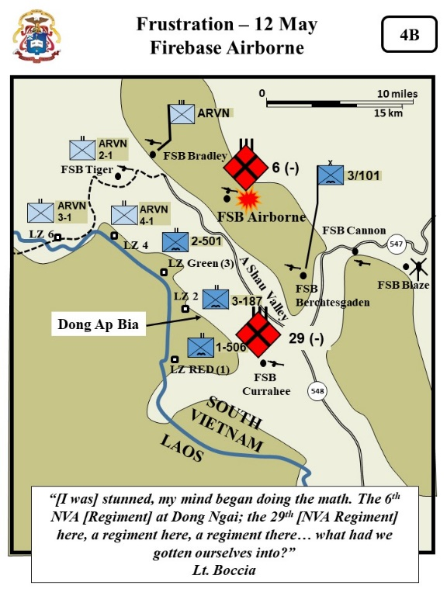
- The other 3d Brigade Battalions had little to no contact that day.

  - VSR: Rise up and look over the ridge to south toward the smoke on Hill 859. About 6K to the south the 1-506th south continued to conduct reconnaissance in force operations throughout their areas of operation encountering limited contact. 1-506th while maneuvering in the vicinity of coordinates YC 309941, encountered three NVA, killing one and capturing his AK-47.

  - The 2-501st (VSR: Return to the ground and look north – rise up not possible because you will see the end of the virtual box. About 7Ks north), the 3/1 ARVN Battalion (VSR: Then look NW) About 15Ks NW, the 3/1 ARVN continued with on reconnaissance in force operations in the immediate area of the Laotian border and discovered a small cache of miscellaneous equipment and weapons (eight individual and twelve crew-served).

- VSR: Look to the NE. However, that night the NVA sent a message to the 101st Division that they intended to fight for the A Shau Valley.

- C1: 6th NVA Regiment – Just before dawn, perhaps to lessen pressure here at Dong Ap Bia two North Vietnamese battalions of the 6th NVA Regiment stormed Firebase Airborne, on the north side of the A Shau Valley. (about 13K’s NE)

  - Sappers penetrated the perimeter and ran through the compound, tossing explosives into bunkers.

  - They destroyed one 105-mm. howitzer and badly damaged a 155-mm. piece, then moved toward an ammunition storage bunker. Grenades flew, and the bunker went up in a flash of fire.

- Ultimately, the defenders drove the North Vietnamese from the base, killing forty. But U.S. losses were also heavy—twenty-one dead and fifty-two wounded.

- C2: 29th NVA Regt & Boccia Quote - Lt. Boccia remembered his thoughts the next morning when he heard about Firebase Airborne, “[I was] stunned, my mind began doing the math. The 6th NVA [Regiment] at Dong Ngai; the 29th [NVA Regiment] here, a regiment here, a regiment there… what had we gotten ourselves into?” (Boccia, 341)

ANALYSIS

- As part of the fires warfighting function, commanders execute and integrate fires, in combination with the other elements of combat power, to create and converge effects and achieve the desired end state. (APO 3-0, 2019, 5-18).

- Evaluate how the LTC Honeycutt’s use of fires may have influenced his decision to attack with Bravo before Charlie and Delta could get into position.

- The other battalions in the brigade are experiencing the basic assumption that -“The North Vietnamese Army normally defended by evading.” Evaluate how this could have possibly influenced LTC Honeycutt’s decision making.

- How does the attack onto Firebase Airborne influence the situation?

- Draft ATP 3-90.98, JUNGLE OPS (2020) Para 1-64 (Environmental Effects on Personnel) states, “The jungle is fatiguing, both physically and mentally.” Para 1-79, states that units can perform for about 4 hours if they maintain about a 50/50 work/rest and consume 1 quart of water per hour. (High Humidity and average temps of about 84 degrees). From the Environmental Effects on Personnel perspective, evaluate LTC Honeycutt’s afternoon decision to forgo any more attacks until the 13th when Charlies and Delta would be position for the BN to execute a 3 company attack.

Page not used – formatted for double sided printing

STAND 5: THIRD ASSAULT UP HILL 397 - 13- MAY

VISUALS

5: THIRD ASSAULT UP HILL 397- 13- MAY

ORIENTATION

Virtual View: Return to the vicinity of the Bravo NDP look to N to Delta and then SW toward Charlie.

Orientation: Currently in the vicinity of the Bravo NDP. Hill 937 is about 750 meters to the SE. Delta is about 750 meters to the North and Charlie about 500 meters to the SW.
DESCRIPTION

VISUAL 5: THIRD ASSAULT UP HILL 397- 13- MAY [Unless otherwise stated – XXIV Corps Historical Summary. [The PPT builds on the visuals are noted as C1, C2, or C3 etc.]

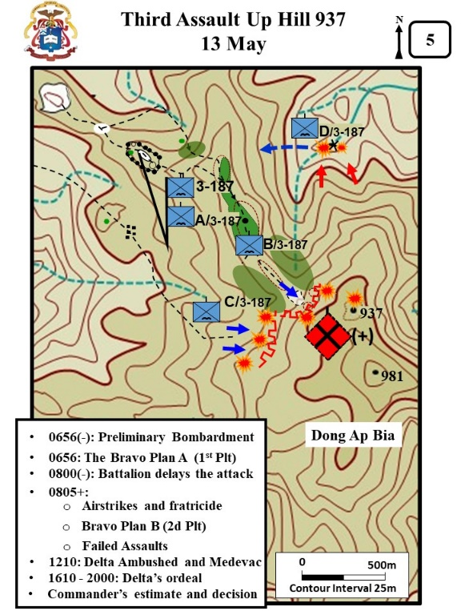
- The situation remained relatively unchanged on 13 May. Charlie, Bravo and Delta, now generally abreast but separated by several hundred meters, resumed their movement up Dong Ap Bia.

- The heavy bombardment of the hill resumed in the early morning hours.

VSR: Move forward to the edge of the clearing.
- C1: 0656 Bravo Plan A - Captain Littnan planned to try to trick the enemy with a fake bomb run. (Details below from Zaffiri, 125-126)

  - At 0656, Cpt. Littnan and Lt. Eward (2d Plt) crawled forward and marked the enemy bunker line with smoke.

  - Fighter-bombers then hit the target with 1,000 pound bombs with delayed action fuses.

  - The Bravo 1st platoon (LT Boccia) was then told to go forward but stop 75 meters short of the bunker line.

  - Cpt Littnan planned to hit the bunker line with another wave of fighter aircraft with 1,000 pound bombs.

  - A third wave would then come in to force the NVA into cover, but not drop bombs. Boccia was then to rush forward into the bunker line.
VSR: Rise up in the air and look to the S toward suspected enemy positions in front of Charlie.
- C2: BN delays the attack. Sometime before 0800, Battalion delayed the assault onto mountain because of problems with Charlie getting into position. (Details below from Zaffiri, 126-128)

  - Charlie moved up a draw and received heavy fire from two sides.
  - BN diverted the fighter-bombers planned for Brave to support Charlie. The airstrikes would come in between Bravo and Charlie.

- C3: 0805 Airstrikes and Fratricide - At 0805, the first strike went in and Boccia reported that the strike was dangerously close to his platoon.

  - Cpt Littnan confirmed with the FAC that the bomb was on target.
  - After the second attack run – Boccia again reported the bomb was to close. Boccia reported, “That shit is landing too close… I know it is… We’ve got shrapnel falling all around us.”

  - Again, Cpt Littnan confirmed with the FAC that the bomb was on target and for Boccia to keep his head down.
  - The next bomb blew down trees in Boccia’s area.

  - Sp. 4 Nelson was hit in the side with shrapnel. Boccia tried to stop the next plane from coming in but was unsuccessful.
  - The bomb again blew trees down in the plt area. Again Littnan and Boccia argued whether or not the bombs were too close to the plt. Cpt Littnan insisted that they were not to close.

  - Moments later Boccia angrily reported:
    - Lt. Boccia recalled reporting, “I just took a KIA from that bomb that landed nowhere near us.” (Boccia, 358)

    - Samuel Zaffiri in his interviews of the battle stated that others remembered Boccia screaming into the radio, “You’re killing my F- people! You’re killing them! Those F- bombs that aren’t supposed to be landing too close just killed one of my men! Do you hear me?”

- Cpt Littnan ordered Boccia off the net. He wanted to better understand the incident and did not want the FAC and fighter-bomber pilots to become overly cautious.

  - Cpt Littman sent the 1st Sgt forward to investigate.
  - The First Sergeant confirmed that a soldier (PFC Myles Westman) had been killed, but that the soldier had moved to the top of the ridge between the two companies to watch the show and was not wearing his helmet.
  - Nonetheless, Boccia’s platoon morale was shattered.
  - Rifleman Helms recalled, “It affected everyone in our platoon…he [Westman] was such a good guy.” (WPCFOH, Helms Interview)

- C4: Bravo Plan B - Cpt Littnan moved Lt Eward’s 2d plt to the front to take the lead and advance resumed.
  - Zaffiri states that Littnan considered relieving Boccia from his plt command, but took no action.
  - Boccia makes no mention of the possible relief in his book, but says Littnan recognized he needed time to collect himself and told him, “Frank, you have to get over this, I need you” (Boccia, 359).

VSR: Return to ground level at the edge of the clearing and then move into the clearing.
- C5: Failed Assaults - Again, Bravo could not push past the clearing that was blocking their advance. (Details from Zaffiri, 130)

  - Eward put two squads forward. However, the enemy came out of their holes and trenches, and counterattacked with 20 to 30 men.

  - Eward’s plt lost three wounded and retreated.

  - Cpt Littnan was at a loss of what to do next.

  - The enemy had been bombed, napalmed, and heavily bombarded with artillery for 3-days and showed no sign of giving up the fight.

VSR: Rise up in the air and look toward Charlie.
- Charlie also continued to push slowly forward in the face of heavy resistance and like Bravo could not make any progress up the hill.
- Charlie also had a plt(-) [2 squads] guarding a PZ for evacuating wounded at the base of the ridge. That PZ was attacked and lost 2 men KIA and one WIA. (Boccia, 363)

- Artillery support was continuous.

  - The forward air controllers were always overhead and did a magnificent job of placing airstrikes on enemy positions.

  - Many of the targets were pointed out by the battalion commander who was flying at low level overhead so as to get a better view of the situation.

VSR: Return to the rocky slope on the east side of the Ironwood forest ridge and then move down the ridge to the stream.

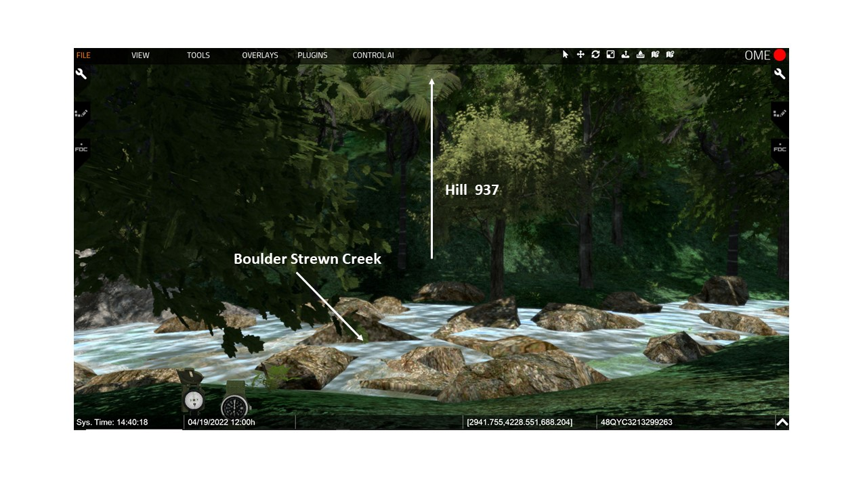

- C6: 1210 Delta Ambushed - Delta’s Ordeal - Delta maneuvering north of Bravo received mortar and RPG fire wounding seven members of the 1st Platoon. (Details below from Zaffiri, 132-143)

  - PFC Mike Smith remembered that the terrain was “very steep, very difficult.”(WPCFOH, Smith interview)

  - The company had finally reached the bottom of the ravine but now had to cross of boulder strewn creek.

  - VSR: Cross over the stream and then rise up to show Hill 397 At 1210, the lead plt crossed over the creek and started up the north face of Hill 937.

  - Soon after the crossing the company was hit by several RPGs that wounded at least five men.

VSR: Look back to the stream to discuss the Medevac incident.
  - C7: Medevac -A medevac helicopter arrived but was shot down by an RPG. The helicopter fell on the medavac site and killed several more. The final total was 7 dead and 7 wounded.

  - C8: NVA Attack - An NVA element came off the hill an attacked Delta.

  - Close air shooting into the jungle helped keep the enemy back.

VSR: Rise up and look toward the BN CP.
  - C9: Delta Ordeal - By 1610, the company had re-crossed the creek and was heading back up toward the BN CP.
    - They carried out their wounded but had to leave the dead.
    - Captain Sander’s remembered, “It was the most exhausting, physical day…we had to get these [wounded] guys up the hill.” (WPCFOH, Sander’s Interview)

  - By 2000, they were 600 meters short of the BN CP. But it started to rain and they could no longer move up the 45 degree slope.

  - The company formed a night defensive position (NDP). Throughout the night the company was spooked by sounds and believed the enemy was closing in on their position and fired out in all directions.

  - Many of the officers and NCO’s believed there was nothing out there, but were challenged throughout the night to hold the unit together and prevent a panic.

  - They had to wait till the next day to complete the move to the BN CP and evacuate the wounded by air.
VSR: Fly back to the vicinity of the Bravo NDP and then look toward Charlie’s area.
- Charlie also had a rough night in their NDP located only 150 meters below the summit.

  - The soldiers were “nervous and skittish” after dealing with sniper fire all day.

  - At 1940 they were hit with heavy mortar fire wounding five men.

  - After the mortar fire a nervous soldier thought he heard movement and fired. The fire resulted in the entire perimeter opening fire.

  - The listening posts (LPs) were still to the front and had difficulty getting the shooting to stop.

  - Even a AC-47 Spooky gunship (equipped with miniguns) was brought on station to engage the perceived enemy sightings. Fortunately none to the LPs were hit.

VSR: Look toward Dong Ap Bia IAW the discussion below.
- C10: Commander’s estimate and decision.

  - After the day's action, the battalion commander was convinced that the NVA was occupying Hill 937 at least company (+) strength.
    - The mostly likely course of action for significant force of NVA was to avoid decisive contact.
    - NVA units rarely operated in a maneuver environment above company strengths.
    - Believed to be a company size force conducting a delay to allow the enemy to break contact.

  - He acknowledged that Charlie and Bravo’s attacks had not brought simultaneous pressure against the enemy and Delta had been stopped well short of the hill top.

  - Bravo’s axis of advance limited because of the terrain.

  - Directed Charlie to maneuver further to the south against the enemy’s flanked.

- He believed that a coordinated attack by his three companies would be successful in pushing the enemy off the hill.

- Meanwhile, the 1-506th (about 6Ks to the south)continued search and destroy missions in its assigned area of operations moving northwest along high ground checking extensively along the slopes of the A Shau Valley. During the day, A Company found eight huts, which were considered to be part of a possible staging area, and small amounts of ammunition.
- About 15K to the NW, 3/1 ARVN Battalion found a large cache consisting of eight vehicles, seventy-eight individual, and twenty-five crew-served weapons.

ANALYSIS
- The intelligence warfighting function includes the task to “Conduct information collection.” The process is driven by commanders and includes conducting operations to develop the situation (APO 3-0, 2019, 5-15).

DEVELOP THE SITUATION THROUGH ACTION
3-46: During operations, commanders develop the situation through action. Developing the situation requires information. Commanders fight for information while in contact with enemy forces… Developing the situation through action to collect information is inherently part of displaying disciplined initiative… Commanders enhance situational awareness and understanding by assigning information collection tasks (reconnaissance, surveillance, security operations, and intelligence operations) to collect information requirements…
3-37: Often information can only be provided by close combat that forces enemy forces to reveal their capabilities, locations, and intent.

- Evaluate LTC Honeycutt’s decision to attack the hill with two companies.
- After the attack, LTC Honeycutt reassessed the size of the enemy force. Evaluate his estimate that the NVA was occupying Hill 937 at least company (+) strength.

- The accidentally airstrike against Bravo is the unit’s second fratricide incident. Draft ATP 3-90.98, JUNGLE OPS (2020) Para 3-30 states, “The restrictive terrain and limited number of LOCs tend to compartmentalize forces and increase the risk of fratricide.” Within the 210 pages of the draft ATP, fratricide is mentioned 75 times. How did the terrain possibly contribute to the fratricide incident? Evaluate Captain Littnan’s and Lieutenant’s Boccia’s actions during the fratricide incident. Consider the following:
  - Captain Littnan’s location
  - Why was it important to Captain Littnan that the FAC not become overly cautious in the bomb runs?
  - Evaluate Captain Littnan’s decision to move 2d platoon to the front.
- Draft ATP 3-90.98, JUNGLE OPS (2020) Para 5-13 (Jungle Defensive Operations) states, “Maneuver allows a defender to achieve and exploit a position of advantage over an enemy. Defending forces are not static and, instead, seek opportunities to maneuver against the attacking force.” What is the significance of the NVA attacks against Charlie’s rear area and Delta at the crashed MEDEVAC site? Possibly the NVA strong enough and confident enough to attack and not just wait in defensive positions.

- Charlie and Bravo’s attacks had not brought simultaneous pressure against the enemy and Delta had been stopped well short of the hill top. At this point the battalion’s attack onto the hill was only executed by one platoon at a time. Is Honeycutt’s assumption that the enemy would most likely withdraw if threatened with decisive engagement still valid?
STAND 6: COORDINATED ATTACK - 14 MAY

VISUALS

6A: FOURTH ASSAULT UP HILL 397
6B: LIEUTENANT BOCCIA’S MISSION
6C: THE THIRD BRIGADE, 101ST AIRBORNE DIVISION PLAN

ORIENTATION

Virtual View: Remain at the Bravo NDP and rise up in the air and look toward the key locations noted in the orientation.

Orientation: Currently in the vicinity of the Bravo NDP. Hill 937 is about 750 meters to the SE. Delta is about 700 meters to the North and Charlie is maneuvering toward Hill 904 which is about 850 meters to the South
DESCRIPTION

VISUAL 6A: FOUR ASSAULT UP HILL 397 [Unless otherwise stated – XXIV Corps Historical Summary. [The PPT builds on the visuals are noted as C1, C2, or C3 etc.]

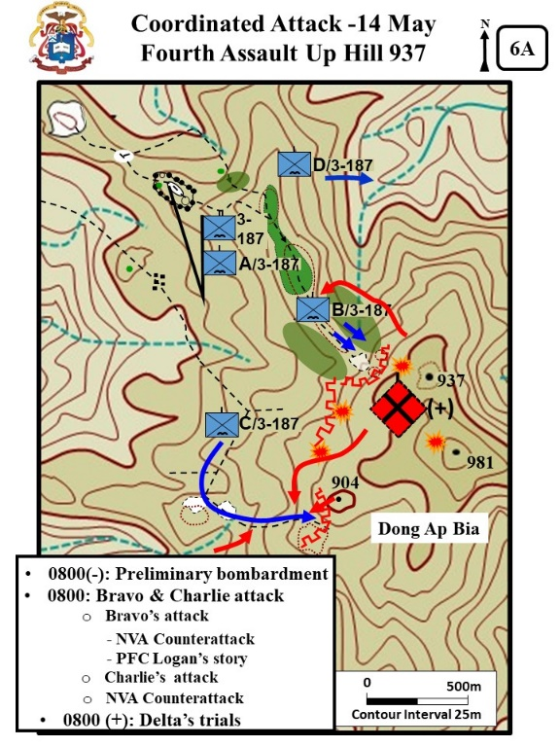
PART 1: BATTALION

- LTC Honeycutt wanted to execute a concentrated attack to push the enemy off Hill 937. (Details below from Zaffiri, 145)

  - Honeycutt believed the three company advance would disperses the NVA defensive effort.
  - The plan was for the companies to approach the hill from three different directions:
    - Bravo from the west
    - Charlie also from the west but up a small ridge 150 meters south of Bravo Company
    - Delta from the north.

- As usual, the forward air controller arrived early and began to bomb the enemy locations.

- Each of the companies was supported by a separate artillery preparation on their planned route of advance.

PART 2: Bravo and Charlie Attack

- C1: 0800 Bravo and Charlie Attack - At 0800, the Bravo and Charlie attack kicked off as planned, and in spite of the heavy artillery and air preparation, the companies immediately began to receive enemy fire.

VSR: Fly to a position just short to the Battle Clearing and then into the clearing.
- C2: The Bravo attack - Bravo attacked with two platoons on line. Again the attack bogged down when they tried to push through the clearing. (Zaffiri, 146-148)

  - Lt Eward’s plt had three squads on line and when about 10 meters into the clearing the NVA detonated mines in the trees that wounded 4 men.

  - Eward’s men regrouped and moved forward again. Again the NVA detonated mines and wounded three more men.

  - Eward reported that he could not advance.

  - At the same time SFC Garza’s plt was advancing parallel to Edward, but also could not make much headway.

VSR: Rise up in the air and look back toward the Bravo NDP LZ.
- C3: NVA Counterattack & PFC Logan story - While two of Bravo’s plts advanced up the hill, the NVA attack Lt. Boccia’s plt that was guarding the LZ and bring ammo forward.

- Eventually both of the lead platoons (2d and 3d) had to pull back.

- Again “Crazy” Eric Rairdon came into the tiny forward LZ to shuttle the wounded back to the BN LZ at the CP. (Boccia 376)
  - Rairdon made three trips and evacuated 10 men.
  - Rairdon remember taking fire, “They were shooting at me, but I was extremely lucky that they were missing consistently.” (WPCFOH, Rairdon Interview)

VSR: Return to the edge of the Battle Clearing.
- Unfortunately when the lead platoons pulled back. Sgt. John Eden (1st plt, Boccia) , who had been carrying ammo forward, was wounded and left behind. (Details here and below from Boccia, 372-375).

  - When Pfc Tim Logan heard his good friend Eden was left behind he left his M60 MG and ran forward to get his buddy.

  - He found Logan, then bandaged and splinted his leg. The ankle had almost been severed by MG fire.
  - Logan carried Eden to the 1st plt position and the medic immediately went to work.
  - Boccia chastised Logan for running forward and then thanked him for his heroics. Logan brushed off the heroics claiming, “Eden owed me 50 bucks, Lieutenant. A man’s got to look out for his investments.”
    - Logan then began to harass the medic for taking so long and stated, “tell me something. Ain’t that the best splint you ever seen? I mean, field expedient n’ all. Whaddaya say Doc?”

  - Lt Boccia was amazed and remember, “Logan –the F—idiot – was obviously far prouder of the splint than he was of having run into a killing zone, alone and without weapon, to rescue a comrade.”
  - As they started to stretcher Eden away, Logan tried again to get the “Doc” to compliment the splint. The “Doc” replied:

    - “A fine splint. Congratulations. I’m glad you paid attention in first aid class. But there’s one thing.”
    - Logan had bandage the mangled right leg, but then in the excitement of the moment splinted the unwounded left leg stating, “Remember to splint the broken leg, not the good one. It’s better for the patient.”

VSR: Fly south to toward the three Red Trees. The Right Red Tree marks the Charlie Clearing. Then move to the east and go down to the trail on the east side of the clearing. Then up the trail.

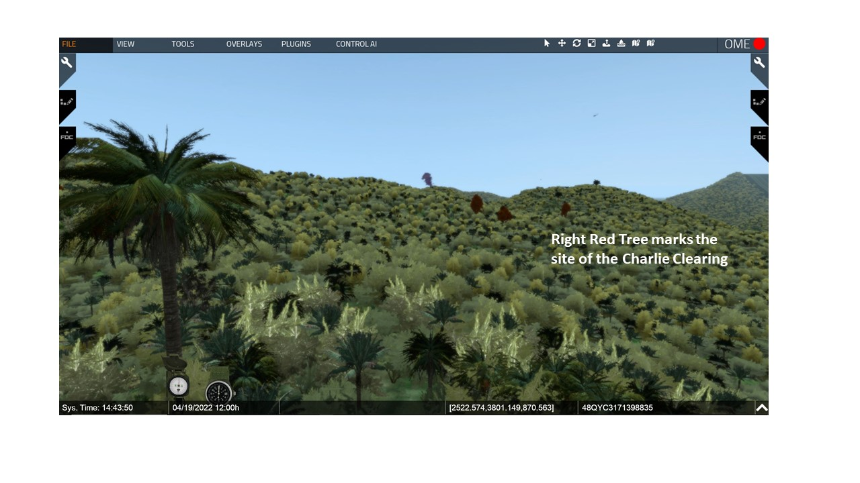

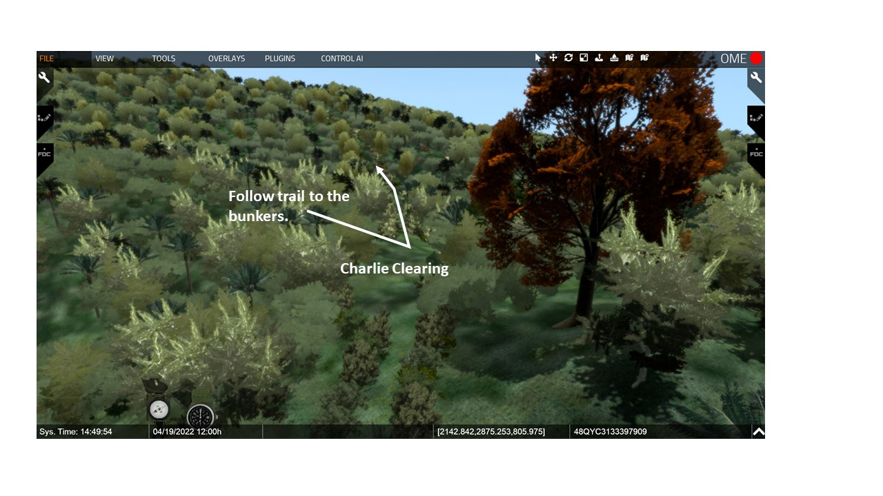

- C4: The Charlie Attack - Charlie maneuvered further to the south to avoid the bunker line that had stopped them on the previous day.

- Lt Goff’s 3d Platoon moved up the hill with 2 squads online.

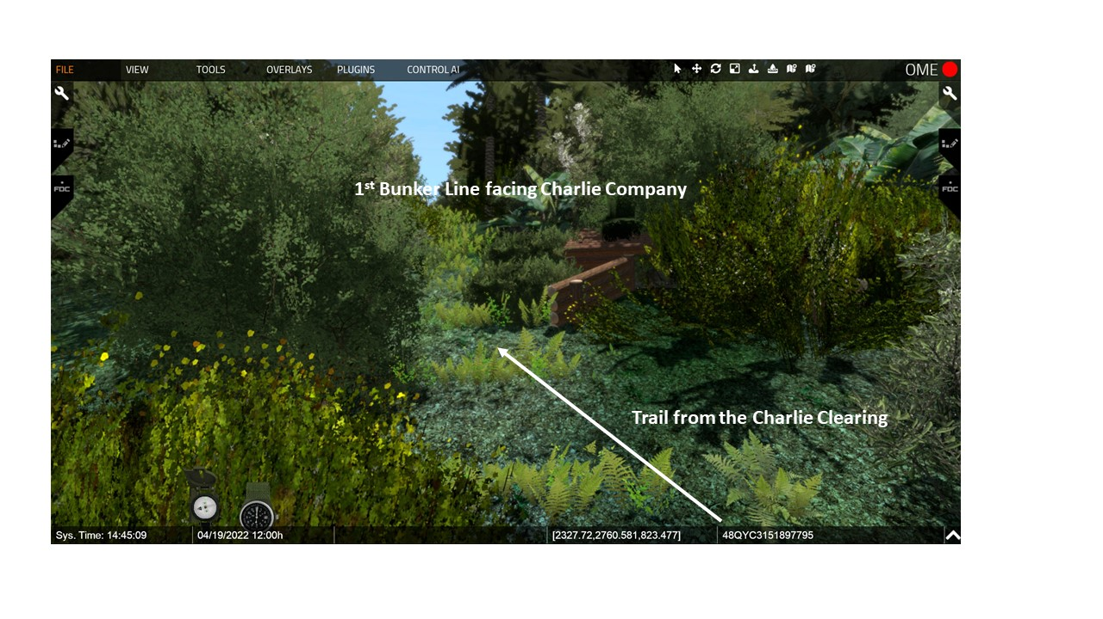
VSR: Move up to the 1st bunker line.

- At the edge of the mountain, they engaged bunkers with RR fire and destroyed three bunkers. ( details below from Zaffiri, 148-151)

  - The plt moved through the bunker line into a saddle – through the saddle was a narrow trail. Sixty to 70 meters above the trail was the western edge of Hill 900.

  - Goff moved his men into the saddle and up the western face of Hill 900. The platoon had six wounded as they fought their way through the bunker line.

  - At 0903, Cpt Johnson reported he was 40 meters from the top of Hill 900.

VSR: Rise up slightly into the air and look to the NVA counterattacks.
- Soon after that the enemy counter-attacked.

  - C5: NVA Counterattacks- One group swarmed down the Hill straight into 3d Platoon.
  - Another group slipped down Hill 937 and poured fire into the platoon’s flank.
  - Another group that had hidden in a large draw maneuvered against the platoon’s rear.

- At 0931, Cpt Johnson reported that 3d platoon had 2 dead and 15 wounded, and that he was withdrawing.

  - LTC Honeycutt denied the permission to withdraw and order Johnson to get his other two platoons into the fight. He emphasized that any withdrawal would expose Bravo’s flank.

  - LT Sullivan’s platoon then moved up on Goff’s left.

VSR: Look to Delta.
- C6: Delta’s Trials - Delta was having difficulty getting into position to attack up the north face of Hill 973. (Zaffiri, 162)

  - The company moved back down the draw fighting against small ambushes and sniper fire all morning.

  - At late morning, the company was still well short of the creek at the bottom of the draw.

VISUAL 6B: BOCCIA’S MISSION [Unless otherwise stated – XXIV Corps Historical Summary. [The PPT builds on the visuals are noted as C1, C2, or C3 etc.]
VSR: From above the Bravo NDP look toward Hill 937.
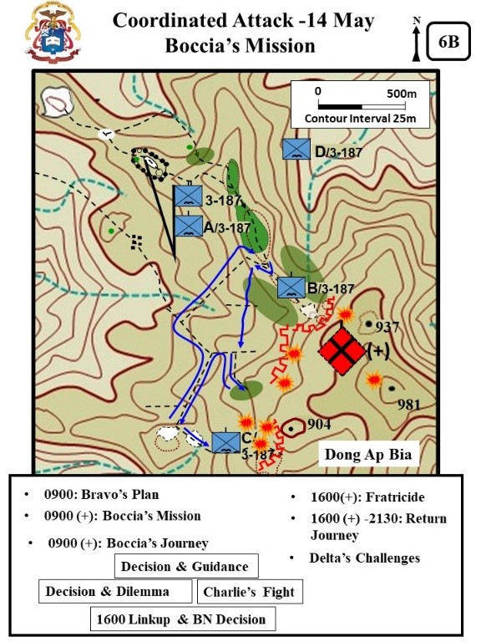
- Bravo’s Plan - Cpt Littnan and LT Boccia planned to execute a fake airstrike and then rush in. [Boccia, in his book places this plan earlier in the day. (Zaffari, 151-153)

- Boccia was worried about the morale of his men. He remembered, “I wondered – for the first time – how they would respond. They were tired and afraid, never a good combination.” (Boccia, 378-380)

  - When Boccia briefed his platoon they were incredulous that they were being asked to attack the Hill again.

  - One man stated, “That f--- Honeycut wants to get us all killed”.

  - Another stated, “If that sonofabitch want to take this f--- mountain so bad, why don’t he do it himself.”

- Boccia ignored the complaints and continued to brief the plan. (Boccia, 378-380)

  - When it was time to move out there was hesitation. However, the squad leaders took over and all basically said, “Okay, get your shit. Let’s go. Lieutenant said move, so move.” (Boccia, 379).
  - As they moved out, the lead squad leader walked beside the Lt and asked “Whatta we do when we get up there.”

  - Lt Boccia responded back with, “We kick the fuckers off the hill.”

    - The squad leader laughed back. “Oh. Okay. It’s good to have a plan, ya know.”
    - All the men around then laughed and passed the work back that the Lt said were are going to “kick the fuckers off the hill.”

  - Lt. Boccia thought to himself “God bless NCOs”

- C1: Boccia’s Mission - Boccia moved the platoon into an attack position, but was then told by Littnan to cancel the attack, and instead move to help Charlie. (Boccia, 380-381)

  - Boccia was grateful the attack was postponed, but also worried.

    - Troubling to know that he had to move his decimated platoon – down to 30 men – to help a company that no longer had enough men to carry its own equipment and wounded.
    - Worried about moving cross-country in enemy invested terrain.
    - He inadvertently asked out loud – why me. Cpt Littan responded. “Because, Black Jack requested it. His exact words were: send that big-headed wop over there.”

- C2: Boccia’s Journey - Meanwhile, Boccia (Bravo) moved out to try to support Charlie. The information below will overview a series of decisions that Lt. Boccia makes along the route to Charlie. (Zaffiri, 154-155 and from Boccia, 381-382)

VSR: Move to the Y Junction take the western fork.
  - Boccia recognized that time was critical so he had the men drop packs at the NDP – they brought water, extra ammo, and medical supplies.
    - They moved down through the LZ to the trail junction. Boccia remembered, “The RPG, I noted, still was stuck in the tree. The trail leading back to the battalion CP led off to the right, north. The arm instead followed a path to the southwest…”
VSR: At the Y-junction take the west/south fork and follow the trail then pause at the down Huey. At the crashed UH-1 the trail veers to the left. Continue down the trail to the large rock.

  - He continued the story, “Charlie’s ridge was due south, so the trail … would take us too far out of the way. Besides, following enemy trails while the area was crawling with enemy just wasn’t very bright. Just to remind us… the burned-out Heuy…lay like a huge dead bug on the slope...”

VSR: at the large rock turn left into the jungle. Follow the small rock markers a short distance into the jungle and pause.

  - He decided to leave the trail and descended the hill to move due south.

- About 0930, Boccia could hear that Bravo had resumed the attack. (Zaffiri, 155-156)

  - SFC Garza had taken charge of 3d Plt.

  - 3d platoon (Bravo) fought its way into the second bunker line, 30 meters further up the hill, where it came under intensive enemy fire and could go no further.

VSR: Rise up in the air and look to the south for two side-by-side red trees. Then fly across the jungle a go to the ground. Between the two trees follow the path south.
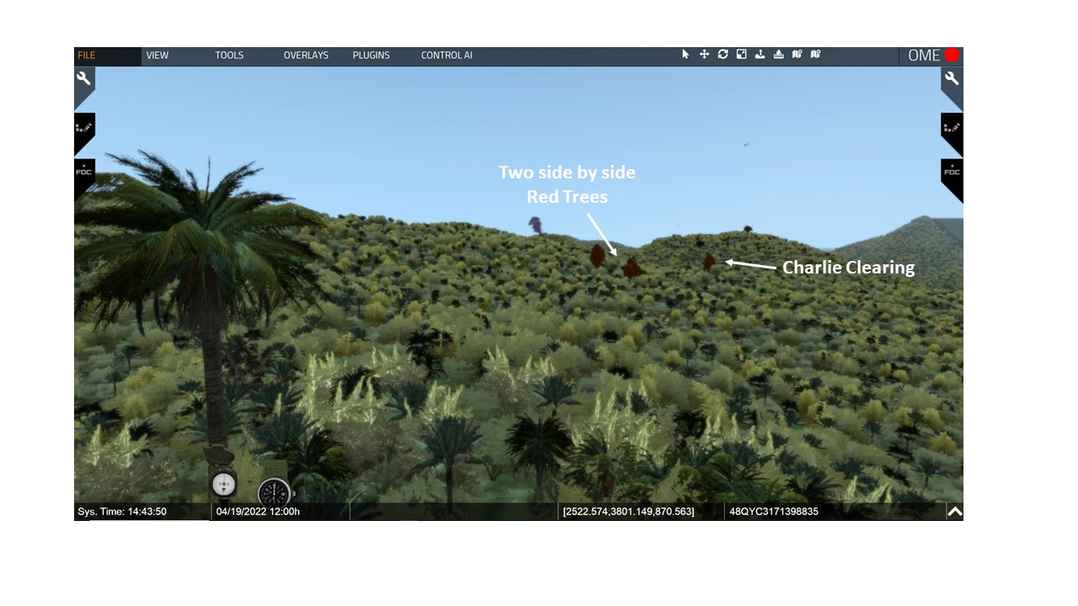

- Movement through the jungle was slow and cautious to avoid ambush. “Despite the pressure of time, however, we moved slowly. I can ignore orders, tactics and common sense, but I could not ignore the memory of what happened to Chuck’s platoon. We took our time.”

  - C3: Decision & Guidance - During the movement, LTC Honeycutt called Boccia directly to check on his progress. (Boccia, 382)

  - Lt. Boccia recalled that most of his past conversations with the BN Cdr usually consisted of heated counseling on some failure on his part to meet the commander’s standards.

  - Boccia thought of LTC Honeycutt of somewhat of a hard-ass. This time when he called to check on progress. In the radio call Honeycutt directed, “I want you there ASAP. And BO – you do what you have to, to take care of things. Understand?

  - Lt. Boccia was concerned about the guidance “do what you have to do” and also somewhat confused because the BN Cdr and never called him BO.

VSR: Move up to the bamboo thicket, pause at this location after looking left and right IAW the discussion.
- C4: Decision and Dilemma – About 500 meters to the south, Boccia found an east to west cross trail. There was also a small trail that led south up the hill. (Boccia, 382-384)

  - To save time, Boccia decide to follow the trail up the hill.

  - The trail moved through the typical heavy growth but then moved up to a bamboo thicket that appeared to be impenetrable other than along the trail. He remembered, “The bamboo was over ten feet high, so the trail led like a tunnel through it.”

  - Boccia’s point man then halted the movement when the heard enemy voices. Boccia had to make a decision on what to do. He remembered, “The voices were so low I couldn’t recognize them, as either English or Vietnamese… But suddenly, several voices broke out, loud and shrill, followed immediately by the chatter of small arms fire and the gassy snap of an RPG being fired.”

  - The RPG confirmed it was an enemy unit and Boccia recognized he was within 25 meters of an NVA unit firing at Charlie on the ridge just above them.

VSR: Rise up to show how close the Charlie area is to the current location.
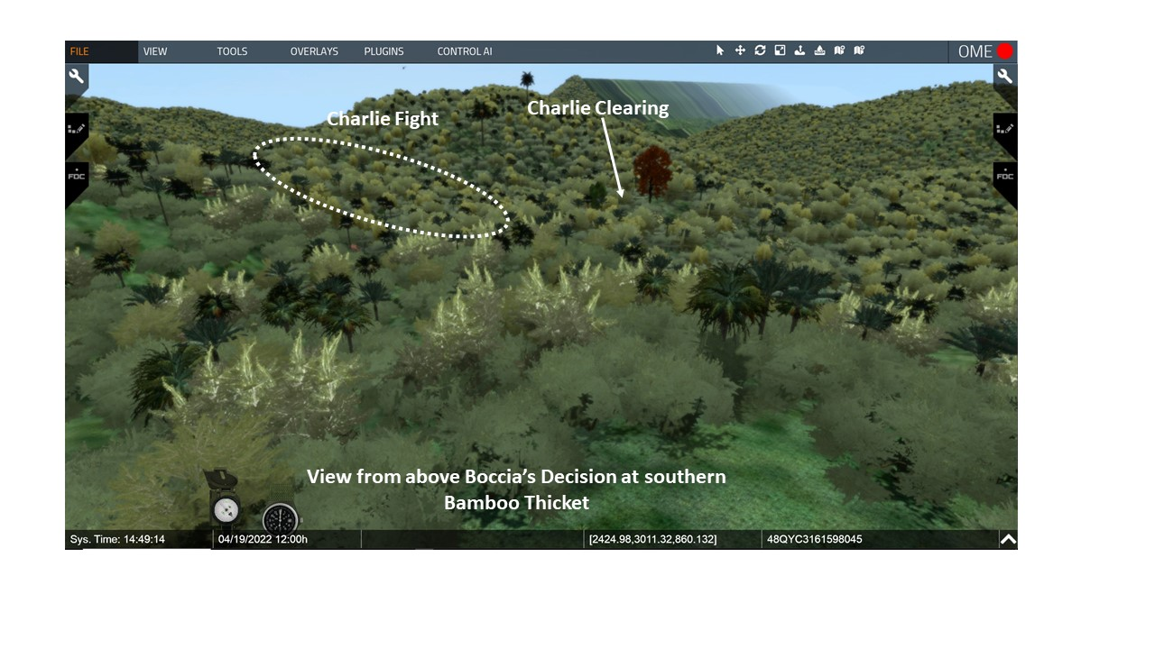

  - Boccia faced a dilemma. He wanted to attack the enemy to his front. He remembered– “I wanted to really kill somebody, and not in a clinical, detached manner by robotically calling in some far-away artillery shells, but to lead a screaming, cursing, bloody-minded assault on these miserable peckerheads who’d been making life difficult for men and my men.”

VSR: Continue to look toward the area of Charlie’s fight – IAW the discussion below.

- C5: Charlie’s Fight - While Boccia made his decision the situation at Charlie company things had gone from bad to worse. (Zaffari, 152–153)

  - Lt Sullivan’s 2d Platoon, Charlie had only moved a short distance when it received heavy enemy fire.

  - Within about 30 minutes the platoon had several killed and wounded.

- Participants remember that Lt. Goff fought like a mad man. (Zaffari, 151–156)

  - He continually engaged enemy bunkers with a M79.
  - His personnel example kept the platoon in the fight and not running to the rear.

  - The two platoons had 30 wounded and two killed. Cpt Johnson again asked permission to withdraw.

  - During the withdrawal, the two platoons took more casualties with attacks against their stretcher parties.

- Cpt Johnson brought forward his 1st platoon (Lt. Joel Trautman) to help with the withdrawal. Trautman came forward and found the company leadership traumatized and took over the command of the withdrawal. (Zaffiri, 156-161) – Details below from West Point Center for Oral History [WPCFOH], Trautman interview.

  - Trautman remembered, “I crawled up to him (the company commander). I asked him what he wanted me to do, and he was non-communicative. He was not talking to me.”

  - Trautman then moved forward to organize the company. He recalled, “[The 18th] was the worst day of my life. The weight of the world was on my shoulders.”

  - About 1400, Trautman started the withdrawal.

- Meanwhile, Boccia backtracked to find another way to get to Charlie. VSR: Look to the north, then west, then southwest. Then fly to the vicinity of the Charlie LZ (marked with LOACH). Then IAW with the discussion move east down the trail to the SE clearing.

- C6: 1600 Linkup and BN Decision –VSR: Move up to the edge of the SE clearing and look slightly left and right. At 1600, Boccia (Bravo) linked up with Charlie at their company CP area.

  - He found at the LZ 20 to 30 dead and wounded and minimal security. He put two squads around the clearing for security and then sent one squad forward to find out what was going on.

  - Boccia remembered that, “I felt my stomach flip. Jesus. Charlie Company had disintegrated. . Now I understood Black Jack’s words… You do what you have to, understand?” (Boccia, 390)

  - In time, Boccia discovered that the company was preparing to evacuate its First Sergeant, two platoon leaders, the company XO, two platoon sergeants, six squad leaders and forty enlisted men.

- One of those that was evacuated was SFC Sammy Hoskins who had been blinded by a RPG blast while dragging back the wounded Lt. Goff. (WPCFOH, Hoskins interview)
  - He remembered just how small the Charlie LZ was, “The Loach (Helicopter) could come in there (the Charlie LZ). He would put one skid on the side of the hill and sit there and hoover.”

  - He also remembered his evacuation. They put me in the back of that thing. I had my head sticking out one side and my feet out the other side in the backend of the Loach.

- Boccia was concerned that Charlie Six, Cpt. Johnson (Cpt Jessup) was in shock and no longer effectively commanding the company. (Boccia used a fictitious actious name Jessup when refereeing to Cpt Johnson – from Trautman interview)

  - Boccia’s radioman recalled, “they [Cpt Johnson and his radioman] both had black stares on their faces… it was like a nightmare… nobody was in charge…the captain was out of it.” (WPCFOH, Helms interview)

  - Lt. Trautman was commanding the 41 men remaining in the company.
  - Honeycutt spoke by radio with Lt. Boccia, “Soon as you get all the wounded out, I want you to load up as much gear as you can, and then burn the rest. Then move back to Bravo’s NDP area. You tell Charlie Six I want him and the rest of Charlie with Bravo tonight.”
  - Boccia helped with the evacuation and then went back partially along the retreat trail to recover abandoned equipment.

  - Most of the recovered equipment had to be burned. Lt. Trautman remembered, “…we just made a big bonfire and burned all the food, equipment, ruck sacks, everything that had been left.” (WPCFOH, Trautman interview)
- In order not to expose Bravo unnecessarily by the withdrawal of Charlie, the battalion commander directed both companies to pull back to a defensible position. Bravo gave up the ground that SFC Garza had taken and moved back to there NDP.

- C7: Fratricide -During the Bravo withdrawal there was another fratricide incident. (Zaffiri, 164)

  - A platoon from Alpha was sent forward to help Bravo carry the wounded and it was hit by Cobra gunships that wounded 4 men – one fatally.

  - Again, Honeycutt was furious. BN had not called for the gunships and brigade did not know where they came from.

  - Latter discovered that the gunships were flying in support of 1-506th but had got their coordinates for the strike very muddled.

VSR: Rise up in the air and refer to the visual for the return Journey.
- C8: Return Journey - LTC Honeycutt directed that Charlie pull back and jointly occupy the Bravo NDP. (Boccia, 397-400)

  - It was a difficult night march. Boccia had a hard time keeping Charlie moving. At one point, Cpt Jessup (Johnson) tried to reassert his command and ordered Boccia to stop and set up a NDP.
  - Lt. Trautman remembered that Cpt Johnson kept, “obstructing Boccia efforts to get us back to Bravo that night… It was not a fun night” (WPCFOH, Trautman interview)

  - Boccia continued to tell Cpt Jessup (Johnson) they were almost there and ignored the ordered. Lt. Trautman followed along as the rearguard with the remainder of Charlie.

VSR: Fly back to the Bravo NDP.
- At 2130, they arrived back at the Bravo NDP. Boccia’s radioman recalled, “that was really a bad day” (WPCFOH, Helms interview)
- Cpt Littnan counseled Boccia, “Before you think too badly of them, remember what they went through… You never know. Everyone breaks, sooner or later. Everyone. Most of us are just lucky enough not to be in Jessup’s (Johnson) position… Don’t judge Jessup (Johnson) until you’ve been there.”

VSR: Rise up in the air and look to Delta.
- C9: Delta’s Challenge - Delta’s attack up the north face of Hill 973 never came about. (Zaffiri, 162)

- They did not arrive back at the creek at the base until 1354. While recovering the dead from the previous day they were hit MG fire and RPGs.
- The company now had an additional 10 wounded. Five of which were litter cases.
- Cpt Sanders called for artillery, airstrikes, mortars and gunships, and after 20 minutes the enemy backed away.
  - About 1430, Cpt Sanders requested and received permission to cancel his portion of the attack and bring his wounded back. (The Charlie and Bravo withdrawal was in full motion by 1430.

VISUAL 6C: THE THIRD BRIGADE, 101ST AIRBORNE DIVISION PLAN [XXIV Corps Historical Summary. [The PPT builds on the visuals are noted as C1, C2, or C3 etc.]

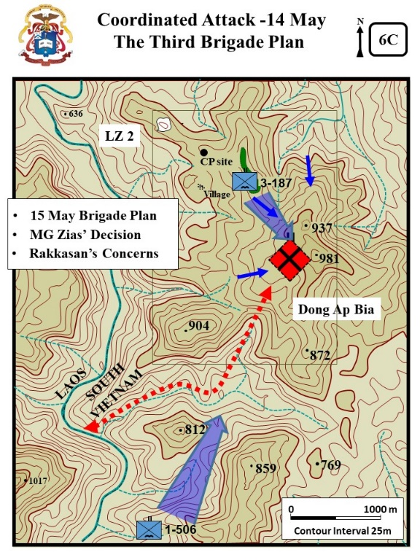
- The brigade commander (Col. Joe Conmy), who had been following developments closely, to include visiting the 3-187th on the ground, determined that additional forces would be required in order to take the hill. (details below from Zaffiri, 167)

- Based on the day's contact, LTC Honeycutt and Col. Conmy assessed the enemy strength on the hill as being from two companies to a battalion.

VSR: From the Bravo NDP rise up in the air look to south toward the purple smoke on Hill 859.

- C1: Brigade Plan - Accordingly, he ordered, the l-506th, which had been operating to the southwest of Hill 937, to begin moving the 4,800 meters to assist the 3-187th.
  - C2: The Draw –VSR look toward Hill 859 and Hill 904. Both leaders concerned that the enemy was reinforcing the hill through the draw SW of Hill 981 that led down to the river and Laos.

  - Col Conmy wanted 1-506th to move in and control that draw by the morning of 15 May. Most of a day and night to move 4,800 meters and get into position (about 3 miles).

- C3: MG Zais’ Decision - MG Melvin Zais (Commander 101st ABN DIV) also concerned about the stalemate at Dong Ap Bia (Zaffiri, 167-168)

  - NVA actions at Dong Ap Bia were contradictory to their previous actions. Normally they fought hard but then withdrew before massive U.S. firepower could be brought upon them.

  - Zais questioned why the NVA now fighting to retain an insignificant mountain.

  - Zais was being pressured to give up the fight. However BG Jim Smith (asst div commander) recommended they continue fight and the decision made to continue the fight “to a successful conclusion.”

VSR: From the Bravo NDP look to Dong Ap Bia.
- C4: Rakkasan’s Concerns - LTC Honeycutt determined at the end of the day that his companies had 12 killed and over eighty wounded. (Zaffiri, 167 -170)

  - LTC Honeycutt recognized it would take time for brigade to move in another battalion and he planned to continue the attack. He was concerned that if he did not attack then the enemy would attack him.

  - At the BRAVO NDP, Lt Boccia (Bravo) was worried that his men would not follow him up the hill again. (Zaffiri, 169-170).

    - His men were very focal in their usual “bitching and complaining.”
    - But then one of his men jumped up and ran to the edge of the NDP and yelled out, “Hey, Ho Chi Minh, we’re gonna kick your ass off that mountain tomorrow. Do you hear me, Ho? Tomorrow we’re comin up there, and we’re gonna kick your f--- ass.”

    - A few men laughed, but soon most of the platoon was laughing.

    - Lt. Boccia was stilled worried about going back up the mountain, but now felt some relief in the understanding that he was sure his men would follow him.

  - Cpt Sander’s (Delta) was also concerned about continuing the attack that worried him. (Zaffiri, 170-171)

    - From his NDP he could look through a gap in the jungle and see Dong Ap Bia. He could see at least a hundred of small fires burning on the mountain. They burned in three irregular rows around the mountain.
    - He believed them to be cooking fires – the NVA were cooking a three or four day supply of rice.

    - He was concerned – they are up there and “They are up there… and they don’t give a damn if we know it.”

- BN could also see the fires and there was no letup in the artillery and air bombardment throughout the night.

- The other maneuver battalions involved in Apache Snow continued to accomplish their search and destroy missions in the area of operations encountering light enemy resistance and many contacts with enemy trail watchers.

ANALYSIS

- APO 3-0, 2019, 3-39: Mission command is the Army's approach to command and control that empowers subordinate decision making and decentralized execution appropriate to the situation, and the ATP 3-90.98, JUNGLE OPS (2020) in para 1-64 states that commanders must “train their subordinates to assume greater responsibilities” because of the non-linear nature of jungle operations. . How is LTC Honeycutt’s direction to LT Boccia “do what you have to do” both a good and bad example of Mission command?

Fundamental principles of Mission command:
  - Competence.
  - Trust.
  - Shared understanding.
  - Commander’s intent.
  - Mission orders.
  - Disciplined initiative.
  - Risk acceptance.

- Troop leading procedures is a dynamic process used by small-unit leaders to analyze a mission, develop a plan, and prepare for an operation. (APO 3-0, 2019, 4-11).

  - Evaluate LT Boccia’s COA analysis when he discovered the NVA at the bamboo thicket.

  - Evaluate LT Boccia’s overall execution of the mission to help Charlie company.

- The protection warfighting function is the related tasks and systems that preserve the force so the commander can apply maximum combat power to accomplish the mission. APO 3-0, 2019, 5-25. In regards to protecting and preserving the force evaluate LTC Honeycutt’s decision to move the remnants of Charlie to the Bravo NDP.

- The Draft ATP 3-90.98, JUNGLE OPS (2020) in para 4-8 states, “Offensive operations in the jungle orient on the enemy, not the terrain. Wherever units find the enemy, they destroy or defeat it in that location. If units allow the enemy to escape, they will have to find the enemy again.” IAW the “draft” doctrinal guidance evaluate MG Zais decision to continue the fight.

- The Draft ATP 3-90.98, JUNGLE OPS (2020) in chapter 3 (Combat Power in Jungle Regions) and APO 3-0 (2019) 5-30 states, Commanders consider mutual support when task-organizing forces, assigning areas of operations, and positioning units. It further defines Supporting distance (5-23) as the distance between two units that can be traveled in time for one to come to the aid of the other and prevent its defeat by an enemy…

  - Evaluate LTC Honeycutt’s plan for Delta Company to attack the north face of Hill 937 as part of a 3-company coordinated attack.

  - Consider the following factors affect supporting distance:

    - Terrain and mobility.
    - Distance.
    - Enemy capabilities.
    - Friendly capabilities.
    - Reaction time.

  - Summary of events.
    - He gave the company the mission on 12 May to move the approximately 1,000 meters. Delta moved 500 meters. No participation in the BN attack.

    - At 1210, 13 May, Delta arrived at the bottom of the ravine after a movement of approximately 250 meters. They are still 500 meters from the summit of Hill 397. Both Charlie’s and Bravo’s attacks had culminated by this time. NVA ambush inflicts numerous casualties and Delta withdraws.

    - At 1354, 14 May, Delta arrived at the bottom of the ravine – movement of approximately 700 meters. By this time the Charlie and Bravo morning attacks had again culminated. Delta again forced to withdraw after a punishing NVA ambush.

Additional Thoughts
LTC Scalard in his 1996 essay, “The Battle of Hamburger Hill: Battle Command in Difficult Terrain Against a Determined Enemy” stated “These three days were a period of intensely unpleasant “discovery learning” for Honeycutt and his men. Map reconnaissance and helicopter overflights did not indicate that his initial scheme of maneuver was impractical. It took Delta Company’s three-day ordeal to do so. Though Honeycutt had a long and distinguished record as a combat commander in both Vietnam and Korea, be underestimated Ap Bia Mountain and the NVA facing him.” (Scalard, 168)

STAND 7: THE SECOND COORDINATED ATTACK - 15 May
VISUALS

7A:Delimma and Decision
7B:Fifth Assault Up Hill 397

ORIENTATION

Virtual View: Switch the Data Base to the “Bald Hill.”
- From the BN CP look to the SE toward Dong Ap Bia
- Then fly up and circle the mountain –always looking toward the bald area.
- Then return to the CP and take up a view with Hill 937 on the left, Hill 981 center, and smoke on Hill 859 on the left.

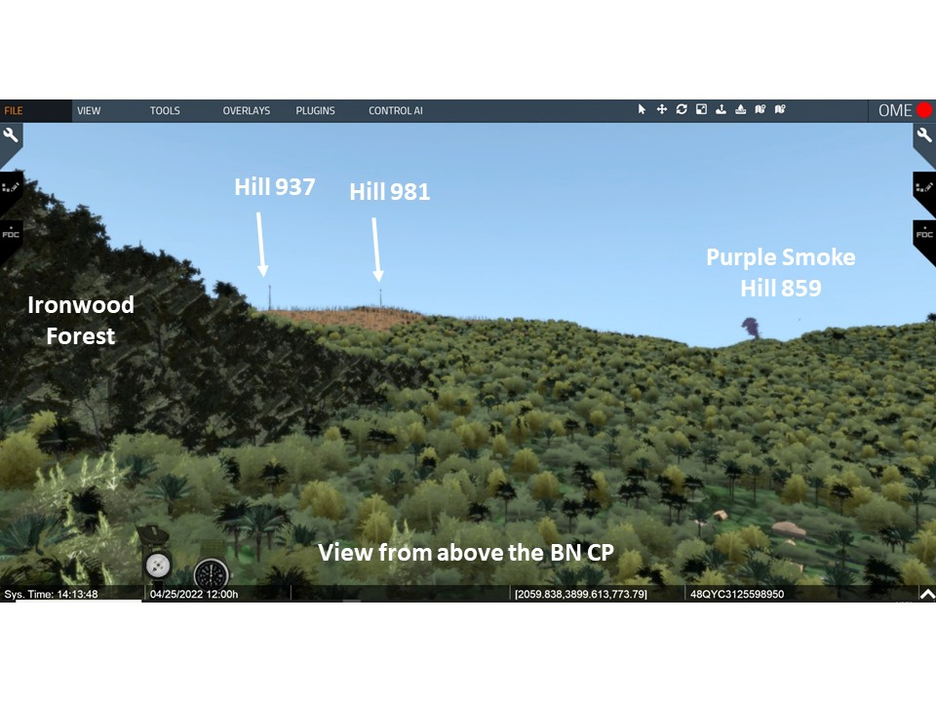
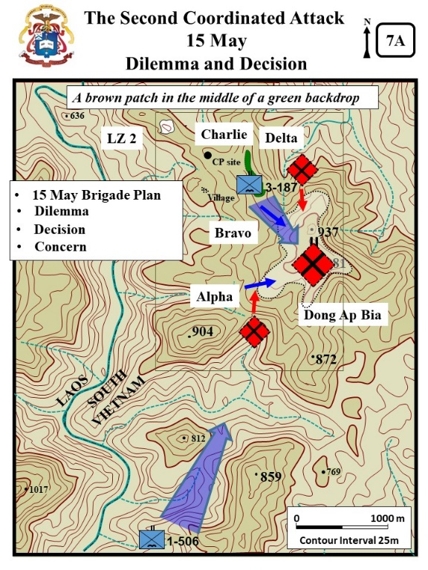
Orientation: Currently located at the Rakkasans’ BN CP. The summit of Dong Ap Bia is about 1500 meters to the SE. The 1-506th is operating near Hills 812 and 859 about 3200 meters to the south.
- By now, the once thickly covered hill was completely bald and just a brown patch in the middle of a green backdrop. What was once a triple-canopy covered hill was now barren and chewed-up by several days of artillery and air strikes.

- A sergeant recalled: “The hills were pockmarked from bombs. I could make out Hill 937… It was a brown patch in the middle of a green backdrop… There was nothing left but mud and slop and trees that looked like twisted telephone poles.” (Diconsiglio, Blood Bath, 30, 44- 46)
- Cpt. Harkins remembered, “By this time we had put so much ordinance onto that hill that it began to look like a football field with a bunch of blown up trees all over the place.” (WPCFOH, Harkins interview)

DESCRIPTION

VISUAL 7A: Dilemma and Decision [XXIV Corps Historical Summary. [The PPT builds on the visuals are noted as C1, C2, or C3 etc.]

- VSR: Look toward the 1-506th (The Purple Smoke):The Brigade plan called for a two battalion assault onto Dong Ap Bia with the 1-506th attacking the south slope of Dong Ap Bia.

- The 1-506th continued its movement toward Hill 937 encountering sniper fire.
  - However, the biggest challenge was the terrain. Movement was extremely slow due to the exceptionally rugged terrain, and heavy vegetation.
  - So far, the battalion was able to cover only 1,500 of the 4,800 meters to the Mountain.
  - The end result was the battalion was not in position to support the brigade attack.

VSR: Look back toward Dong Ap Bia and to the flanks IAW the discussion below.
- C1: Dilemma – When Honeycutt received word that 1-506th was not in position to attack the south slope of Dong Ap Bia or to interdict the large ravine leading to Laos, he faced a dilemma (Zaffiri, 175).

  - He could attack on his own again. (could ask as a question)
    - Plus – maintains the initiative.
    - Minus - His lone battalion was attacking what he believed to be a battalion defending the hill.

  - He could hold his position. (could ask as a question)
    - Plus – allows time to reorganize the battalion.
    - Plus – time to further punish the enemy with artillery and airstrikes.
    - Minus – relinquishes the initiative to the enemy.
    - Minus – faces the prospect of an enemy attack upon his companies at the time and location of their choosing.

- C2: Decision - LTC Honeycutt believed he needed to keep the pressure on the enemy while brigade moved the 1-506th into the fight, he therefore rearranged his companies to continue the assault. (Zaffiri, 175).

  - Honeycutt still believed they might possibly withdraw to avoid US artillery and airpower if he could execute a BN level attack from multiple directions.

  - Charlie took responsible for the security of the BN CP and Alpha moved forward to attack along with Bravo.

  - Delta reported that they were still struggling to evacuate their dead and wounded and would not be able to participate in a morning attack against Hill 937.

- C3: Concern - He was concerned that the NVA had moved forces into the draws on his flanks to attack the companies from the rear when they moved up the hill.

VISUAL 7B: FIFTH ASSAULT UP HILL 397 [XXIV Corps Historical Summary of the Battle of AT Dong Ap Bia (Hamburger Hill) 10 – 20 May 1969, Tab B:15-17) [The PPT builds on the visuals are noted as C1, C2, or C3 etc.]
VSR: From the BN CP continue to look at Dong Ap Bia.

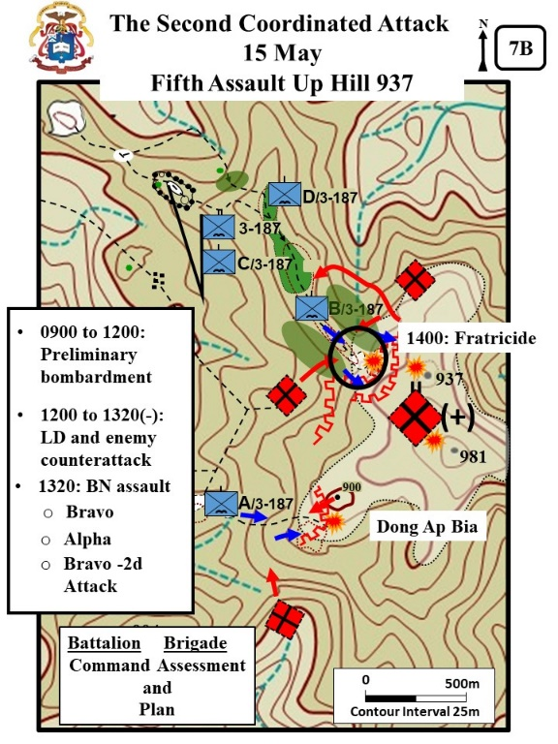
- After completion of the exchange between A and C Companies. There were airstrikes and artillery bombardment against the hill for 4-hours.

- C1: 1200 to 1320(-) LD and enemy counterattack - Around noon, the Alpha and Bravo started their move up the hill. (Zaffiri, 175)

  - He directed the companies to be slow and deliberate.

  - Soon after starting their assault, Honecutt directed the two companies to stop and take up positions on the ridge facing the draws on their flanks.

  - The NVA came out of the south draw expecting to hit Alpha in the rear, but instead went up the ridge into their defensive positions and then retreated back into the draw.

  - BN then directed air-support and artillery into the draw. It was later determined that most of a NVA company was destroyed in the draw.

- C2: 1320 – BN Assault - Alpha and Bravo resumed their assault about 1320.

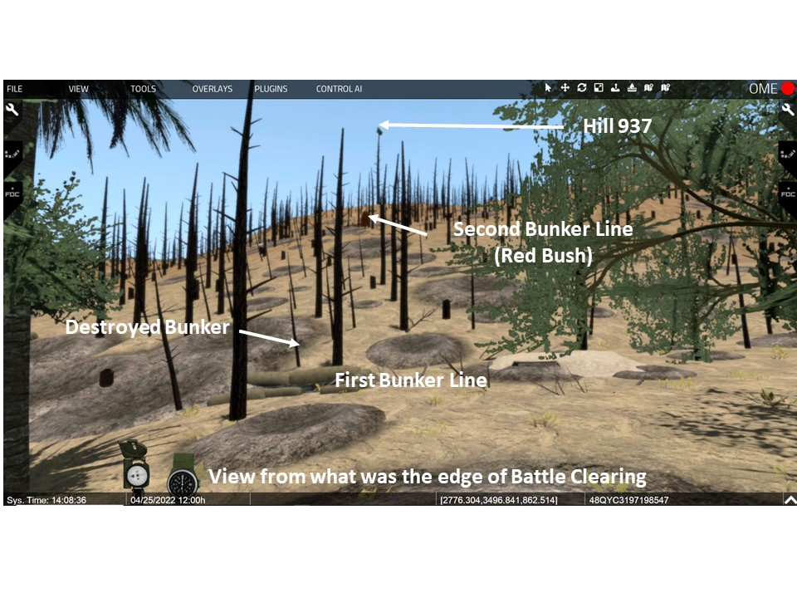

- The enemy resistance was extremely determined and by early afternoon both companies were in heavy contact.
  - The enemy troops skillfully employed command detonated claymore mines which had been emplaced during the night resulting in several US casualties.

  - Particularly true in B Company as they again tried to move through the clearing.
VSR: Fly up to the trail SE of the Y Junction and then move up to the edge of the clearing.
- C3: Bravo - In the assault Cpt Littnan received a grazing wound from one of his soldiers that accidental fired his rifle. All were surprised at his mild counseling of the guilty soldier. (Zaffiri, 176-177).

VSR: Move up to the destroyed bunker on the left of the trail then move toward the second bunker line (marked with a red bush).
- Bravo pushed through a line of bunkers but the NVA second line of Bunkers stopped the advance. SFC Garza called for air-support against the second line of bunkers. (Zaffiri, 180-181)

VSR: Look to the rear to discuss the fratricide.
- C4: 1400 Fratricide - At1400 hours, Bravo was approaching the top of the hill when a supporting aerial rocket artillery gunship inadvertently fired on B Company knocking out the company's command group; two members of the company were killed and 14 wounded, including the company commander. (Zaffiri, 181-182)
  - Cpt. Littnan had called for the gunship strike and had SFC Garza mark the target with green smoke.
  - Littnan had instructed the LOH on the azimuth of attack for the gunship and requested one rocket to adjust fire from.
  - The gunship came in opposite from the azimuth requested and fired a full volley of rockets.
- LTC Honeycutt directed Lt. Boccia to take command of the company and continue the assault. VSR: Rise up and look to the area of the counterattacks.
  - C5: NVA Counterattacks - The NVA then counter-attacked with enemy forces hitting the flanks and also working around to the rear to hit the LZ. Lt. Boccia decided he could not continue the attack and instead organized a defense against the enemy counter-attack.

  - When asked for his situation, Lt Boccia – now the acting company commander – reported, “We’re in trouble. Two Six (2d Platoon) is reporting very heavy fire from his east, north, and south, and my One Five (1st Plt Sgt) down at the LZ says he’s got enemy units to his south and west.” (Boccia, 409)

VSR: Return to the friendly edge of the clearing.
  - Boccia withdrew his lead platoons and concentrated at the NDP and LZ. They gave up all the ground that had been taken.

VSR: Rise up in the air to discuss and look toward Alpha.
- C6: Alpha – At the same time as the Bravo fight, Alpha continued slugging it out with the entrenched enemy and progressed an additional 75 meters up the hill. (details below from Zaffiri, 185-186).
  - Alpha Co. was attacking from a little more southerly route than Charlie had done.
  - Despite heavy casualties the lead platoon pushed up the hill. Then Lt. McGreevy saw his plt sgt take a direct hit from a RPG.
  - The death of the beloved plt sgt caused the platoon to lose momentum.
  - McGreevy decided that with 50% of his platoon wounded and a few dead that he had to pull back.
  - C7: NVA attack from Hill 900 - As they pulled back the NVA counter-attacked and Lt McGreevy had to organize a rearguard to allow the other men to drag the wounded back.
VSR: IAW the discussion look back toward Hill 937.
- C8: Bravo 2d Attack - At 1520, Captain Butch Chappel arrived at the BN LZ. Honecutt briefed him to go forward, take command of Bravo, and continue the attack (Zaffiri, 186-187) (Boccia, 413- 421).

  - Along with Chappel was Lt Lou Charles. He took over 3d Platoon and SFC Garza became the acting 1st Sgt again. (the 1st Sgt was wounded in the helicopter attack).
  - LT Boccia told Cpt. Chappel that Bravo was at 50% strength and could not attack. Nevertheless, the company had orders to attack.
  - At 1600, the Bravo attack started. The NVA had reoccupied the 1st bunker line and put out more claymores.

  - Boccia and Eward’s platoons were partially demoralized from the morning incidents and drastically understrength. Boccia had entered the fight with 34 men and now had 17. Eward was about the same. (Boccia, x)

  - Their attack quickly lost momentum and bogged down. They then had to fall back.

VSR: Fly to BN CP and take up a view of 937, 981, and 859. IAW the discussion look toward the areas being discussed. (Same as initial orientation Stand 7)

- C9: Assessment and Plan - The battalion commander assessed the situation.
  - It was doubtful that Alpha and Bravo could continue to advance.
  - LTC Honeycutt directed the companies to pull back and establish a two company night defensive positions.

- The companies had so many wounded to carry that much of their equipment and ammunition had to be piled up and burned. (Zaffiri, 187).

- That day Alpha lost 17 men and Bravo lost 19.
  - Both companies received replacements that night - cooks and clerks from the rear.
  - Both companies now reported a strength of 67 men – less than half of their authorized strength. (Zaffiri, 188)

- C10: Brigade Assessment and Plan - The Brigade S-3 came to the BN that night to brief the brigade plan. (Zaffiri, 189).
  - Two-battalion assault onto Dong Ap Bia.
  - 3-187 was to be the supporting effort. Move forward until contact and continue to exert pressure, but no assault up the hill.
  - 1-506th would make the main attack from the south and sweep up and over the hill.
  - Honeycutt did not believe 1-506th could get into position and asked what was he to do if that happen.
  - Honeycutt also believed the enemy would have another night to use the large draw leading down to the river and Laos.

- He was told not to attempt another ground attack up the hill until the 1-506th was in position to support the 3-187th from the south.
- While the companies returned to their NDPs the Air Force and artillery continued to pound the hill.
  - Sporadic contact continued throughout the night including several enemy probes on the battalion's night defensive positions.
  - Enemy movement was detected in several areas.
  - The battalion requested and received continuous support from AC-47 gunships in addition to the always available artillery support.
VSR: Look toward Hill 981.
- It became apparent, based on the day's contact, that the enemy force was more than just a battalion-size element.
  - Some of the NVA troops killed during the day had fresh haircuts, clean uniforms and new weapons confirming that reinforcements were being slipped into the area, undoubtedly from across the Laotian border.
  - The enemy force appeared to be well trained and disciplined, adept at camouflage and concealment, and capable of delivering a high volume of accurate fire against the US forces.

- Based on a reevaluation of the situation, the brigade commander decided not to attempt another ground attack up the hill until the 1-506th was in position to support the 3 -187th.

  - The 1-506th continued its movement toward Hill 937 encountering only periodic small arms fire as they moved.

  - 2-501st, still on reconnaissance in force operations in the area surrounding FB Airborne, encountered light enemy resistance. The enemy also harassed FB Airborne with mortar fire. There was little damage, but a clear indication that the NVA were still very much interested in this area.

  - On 15 and 16 May, 3/1 ARVN Battalion continued to exploit the cache area discovered on the 12th west of La Dut. They found individual weapons, one 82mm mortar tube, and large quantities of ammunition. Also discover the graves of forty NVA soldiers recently killed in air strikes.

ANALYSIS

- As part of the fires warfighting function, commanders execute and integrate fires, in combination with the other elements of combat power, to create and converge effects and achieve the desired end state. (APO 3-0, 2019, 5-18).
  - The 15th May attack included a 4 hour preliminary bombardment of the hill.
  - Evaluate how the use of “fires” may have influenced LTC Honeycutt’s decision to continue the attack even though 1-506th Infantry was not in position to support the attack.

- Evaluate the significance of the numerous enemy attacks into the company rear areas and against the flanks of the battalion flank.

The NVA continuously slipped behind the American lines, hitting logistical support landing zones (LZs) and command posts (CPs). This problem caused each company and battalion commander to leave a substantial portion of his force in the rear to cover his LZ and CP and ensure the flow of supplies, the evacuation of casualties, and uninterrupted command and control. In addition to securing their LZs, attacking companies had to provide for 360-degree security as they maneuvered, since the terrain prevented them from mutually supporting each other. (Scalard, 169)

Page not used – formatted for double sided printing

STAND 8: WAITING FOR THE CURRAHEES - 16 AND 17 MAY

VISUALS

8A: Waiting for the Currahees – 16 May
8B: Setting The Conditions – 17 May
8C: Estimate of the Enemy Situation

ORIENTATION

Virtual View: From the BN CP take up a view of 937, 981, and 859. IAW the discussion focus on the areas being discussed. (Same as initial orientation Stand 7)

Orientation: Currently located at the Rakkasans’ BN CP. The summit of Dong Ap Bia is about 1500 meters to the SE. The 1-506th is operating near Hills 812 and 859 about 3200 meters to the south.

DESCRIPTION (16 May)

VISUAL 8A: Waiting for the Currahees – 16 MAY [XXIV Corps Historical Summary. [The PPT builds on the visuals are noted as C1, C2, or C3 etc.]

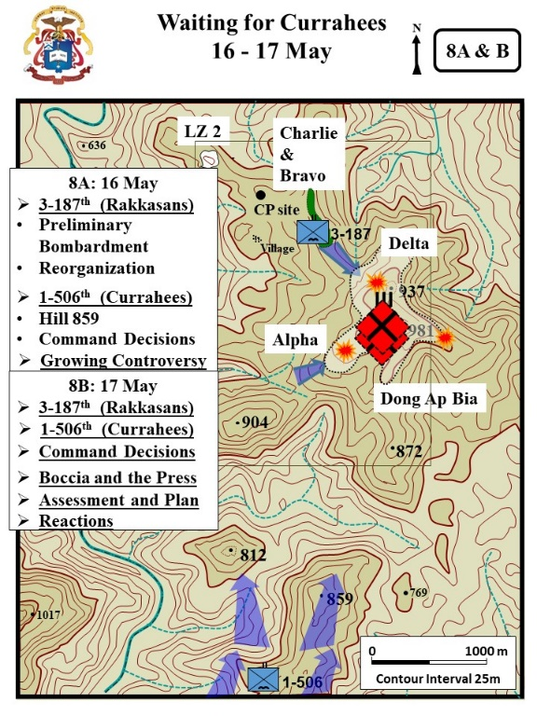
- LTC Honeycutt wanted to be prepared if told to continue the attack. (Zaffiri, 193)
  - At 0734, airstrikes hit the hill with 1,000-pound bombs and continued for about one hour.
  - After the air strikes, the artillery pounded the hill.

VSR: IAW the visual point out the company locations.
- Honeycutt shifted his companies in preparation to continue the attack.
  - Delta’s experience on the north-slope convinced him that no attack was possible there.
  - Delta was shifted to take over Bravo’s sector.
  - Alpha was to continue their attack.
  - Bravo assumed joint security of the BN CP with Charlie.

- At O830, Alpha and Delta started moving into their attack positions but were careful not to move far enough forward to get in contact with the enemy.

- 3-187th also received replacements that day- about 15 for each company.
  - These were primarily rear-area personnel from brigade and division.
  - Lt. Boccia platoon received 5 men, bringing the platoon up to 21 men – about 50% strength. (Boccia, 430)

VSR: Look to south to the area where 1-506 is maneuvering. (Vicinity the Purple Smoke)
- C1: 1-506 and Hill 859 - The 1-506th (Currahees) continued its movement to the north. However, the already slow movement was slowed even further by increasing enemy resistance.

  - The battalion fought against heavily fortified bunkers in the vicinity of Hill 859.

  - Artillery, gunships and airstrikes were employed to suppress the enemy's fire; however, the enemy persisted. The battalion continued to slug it out up the ridge suffering several casualties during the day.

  - Optional - Private Mike Serrano, a draftee private from California remembered, “We weren’t a quarter of the way to the summit (Hill 859) before we were attacked. I didn’t even see the enemy. They jumped out of these deeply dug bunkers and fired at us from every angle. The noise was deafening. The fighting was so bad that helicopters couldn’t land to resupply our ammo… We go a little higher up the hill – maybe a third of the way up… But we took heavy casualties from NVA ambushes. They weren’t going to let us up that hill – no ifs, ands, or buts. We clawed for every inch of ground.” (Diconsiglio, Blood Bath, 30, 34-35)

VSR: Shift the view back toward Dong Ap Bia.
- C2: Command Decisions - It became obvious to Col Conmy (3d Brigade) and LTC Honeycutt that the 1-506th would not be in position for the coordinated attack on Dong Ap Bia that day and the time for the two battalion coordinated attack was shifted to the morning of the 17th.

- C3: Growing Controversy - The 16th was also the beginning of the Hamburger Hill controversy. (Zaffiri, 197-1980
  - Jay Sharbutt, a young associated press journalist asked General Zais – “Why are you attacking this mountain with troops? Why don’t you just pull back and hit it with B52 strikes?”
  - Zais explained that to hit the mountain with B52 strikes he would first have to pull his troops back 2 miles.
  - He also explained that the close air-support and artillery on hand exceeded what the B52s could do and they were not needed.
  - Zais also stated, “Besides, you hate to give up ground you’ve gained… You have to fight as hard to retake it. Backing off is just not something commanders like to do.”

- In time, Jay Sharbutt’s reporting would call into question US Army leadership, policy and tactics.

ANALYSIS (16 May)

Now discussing 16 May, at mid-day on 13 May, the 3d brigade commander ordered 1-506th Infantry to move 4,000 meters north to support the 3-187th.
  - Col. Conmy expected the Currahees to be ready to provide support to 3-187th by the morning of 15 May (1 ½ days movement).
  - After 3 ½ days of movement the Currahees were still not in position to support a 2 battalion attack onto Dong Ap Bia. (All above from Scalard, 168)
  - Col. Comny was an experienced combat commander with significant experience with both the terrain and enemy in Vietnam.

How did his previous experience with how the enemy fought and what other factors may have influenced his underestimation of both the terrain and enemy that Ap Bia Mountain?

DESCRIPTION (17 May)

VISUAL 8B: Waiting for the Currahees – 17 MAY [XXIV Corps Historical Summary of the Battle of AT Dong Ap Bia (Hamburger Hill) 10 – 20 May 1969, Tab B:15-17) [The PPT builds on the visuals are noted as C1, C2, or C3 etc.]
VSR: From the BN CP continue with the view of 937, 981, and 859. IAW the discussion focus on the areas being discussed. (Same as initial orientation Stand 7)

- C4: 3-187 Infantry- Honeycutt kept his companies in their NDPs.(Zaffiri, 198)

  - The battalion made preparation for the attack on the following day.

  - It was decided that the best way to support the attack by the l-506th was to simply move up the hill exerting maximum pressure on the enemy's defenses from the northwest.

  - There was no enemy contact during the day. LTC Honeycutt very concerned that if his battalion continued to remain in it NDPs that the enemy would come off the hill and attack him.

VSR: Look to south to the area where 1-506 is maneuvering. (Vicinity the Purple Smoke)
- C5: 1-506 – The l-506th continued its movement toward Hill 981 against increasing resistance.

  - The enemy on Hill 859 was well dug-in and occupied concentric rows of mutually supporting bunkers which he defended with determination.

  - The l-506th continued their advance, however, fighting from bunker to bunker in order to progress. To assist them, artillery, gunships and tactical air provided continuous support. CS gas (tear gas) was also used to dislodge the NVA from their bunkers.

  - By nightfall the battalion was still not in position to launch the attack the next morning.

VSR: Shift the view back to Dong Ap Bia
- C6: Command Decisions - Brigade was determined that the two battalion coordinated attack on Hill 937 was not going to be possible and rescheduled the attack for 18 May.

  - Plans were finalized during the day. Elements of the 3-187th were to move to the best position possible from which to support by fire the main attack by the 1-506th coming from the southwest.

  - The attack was to be supported by a CS gas (tear gas) preparation in addition to a heavy tactical air and artillery preparation.

  - Flak jackets were issued to the attacking companies in an effort to reduce casualties even though the extreme summer temperature made wearing them almost unbearable. Extra ammunition and other supplies were also issued during the day.

  - The pounding of the enemy positions by artillery and air continued throughout the day and night.

VSR: At the BN CP take up a view of a fighting position with an overhead poncho (See the BN CP VSR view with stand 2A).

- C7- Boccia’s and the press. (Zaffiri, 204-205) (Boccia, 431)
  - Lt. Boccia was not happy that many reporters had that day arrived in the BN area, and he decided to play a joke on them.

  - The reporters were preparing their night time sleep areas with overhead ponchos, and Boccia offered a suggestion in that they should notice that the combat troops did not have ponchos over their positions. He explained that at night the moonlight reflects off the poncho and attracts RPG fire. The reporters immediately took down their ponchos.

  - Boccia returned to his plt area and put up his poncho for the night and prayed for an especially heavy rain that night.

VSR: From the BN CP shift the view back toward Dong Ap Bia
- C8- The Brigade Assessment and Plan (Zaffiri, 205-206)

  - Brigade informed LTC Honeycutt that the enemy of the hill was the 29th NVA Regiment. They believed the regiment had two battalions in the area and each was at least 600 strong.

  - The 29th considered a very good unit. That it was fully equipped with heavy weapons and well supported by logistical units.

  - Brigade confirmed that 1-506th still fighting for Hill 859 and not yet in position to attack Hill 937.

  - Honeycutt told to attack in the morning to exert pressure, but not to become decisively engaged. Brigade did not want the enemy to have the opportunity to shift forces against 1-506.

  - Brigade plan called for a “deluge of high-drag bombs and napalm from 0800 to 0830.

  - The sixty minutes of artillery prep.

  - Brigade believed that with the heavy prep, the 1-506th could push over Hill 859 and then start up the south slope of Dong Ap Bia.

  - LTC Honeycutt was not confident that the 1-506th could get to the south face of the Crouching Beast.

  - Nevertheless he prepared his BN to make a 2 company assault up the mountain against an enemy regiment.

- C8- The reaction of the 3-187 Companies. (Zaffiri, 206-207).
  - Cpt Sander’s (Delta) admitted later admitted he was overcome with a feeling of “total hopelessness.” During that hopelessness he told Lt. Lipscomb “We ain’t got a chance in hell.”

  - He then regained his composure and briefed his platoon leaders. The plan was simple.
    - Two platoons on line and then “balls to the wall.”
    - Do not stop for anything. Do not stop for the wounded. Let them crawl down the mountain on their own.

  - After the briefing, his men told him that a new name was going around for the hill. It was “Hamburger Hill” because grinds men up and turns them into hamburger.

- Meanwhile the other units of the brigade continued to maneuver in their assigned sectors.
  - 2-501st continued their search and destroy missions to the north, and west of FB Airborne encountering bunkers and equipment caches. Little contact was experienced during the 17th.
  - The 2/1 ARVN Battalion searching an area southwest of FB Bradley discovered four Russian trucks, five bulldozers, and 3,000 pounds of TNT, all which were destroyed.

ANALYSIS (17 May)

VISUAL 8C: Estimate of the Enemy Situation [The PPT builds on the visuals are noted as C1, C2, or C3 etc.]
VSR: Continue with view from the BN CP at Dong Ap Bia
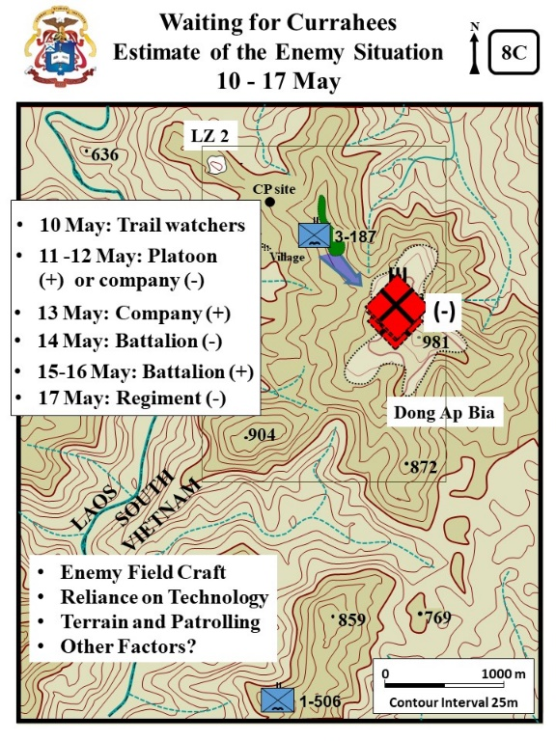
- A review of the daily estimates of the enemy situation shows that the U.S. commanders had consistently underestimated the strength of the enemy on the hill.
  - 10 May: Trail watchers or recon platoon
  - C1: 11 -12 May: Reinforced platoon or company (-)
  - C2: 13 May: Reinforced company
  - C3: 14 May: Battalion (-) 1-506th ordered to join attack on Dong Apr Bia
  - C4: 15-16 May: Reinforced battalion.
  - C5: 17 May: Regiment (-) with two light infantry battalions. Each battalion was believed to be at least 600 men. The 29th considered a very good unit. That it was fully equipped with heavy weapons and well supported by logistical units.

- C6: The intelligence warfighting function and its related tasks are driven by commanders, and it involves analyzing information from all sources and conducting operations to develop the situation. (APO 3-0, 2019, 5-15). Evaluate the U.S. commander’s (LTC Honeycutt and COL Conmy) underestimation of the enemy strength. Consider the following factors:
  - Enemy: The U.S. commanders recognized that they were in for a tough fight. However, they had little evidence as to the enemy's actual strength and dispositions. The NVA, masters of camouflage, completely concealed their bases from aerial surveillance.

  - Reliance on Technology: The NVA effected their command and control mainly by runner and wire, leaving no electronic signature. The NVA moved at night along trails covered by triple-canopy jungle, confounding observation from above.

  - Terrain and Patrolling: U.S. commanders had to generate their own tactical intelligence. Patrols, captured equipment, installations, documents, and occasionally prisoners provided combat commanders with the raw data from which to draw their assessment of the enemy order of battle and dispositions. However, gathering this information took time and the treacherous terrain at Dong Ap Bia slowed movement and limited observation. The end result was that it took days to ascertain to enemy strength. LTC Scalard in essay about Battle Command at Hamburger Hill referred to the process as “intensely unpleasant discovery learning" (168)

  - Other Factors?
Page not used – formatted for double sided printing

STAND 9: BRIGADE ATTACK - 18 MAY

VISUALS

9A: The Brigade Plan
9B: Sixth Assault Up Hill 397 – Morning
9C: Sixth Assault Up Hill 397 – Afternoon

ORIENTATION

Virtual View: From the BN CP take up the view of 937, 981, and 859. IAW the discussion focus on the areas being discussed. (Same as initial orientation Stand 7)

Orientation: Currently located at the Rakkasans’ BN CP. The summit of Dong Ap Bia is about 1500 meters to the SE. The 1-506th is operating near Hills 812 and 859 about 3200 meters to the south.

DESCRIPTION

VISUAL 9A: The Brigade Plan [Unless otherwise stated – XXIV Corps Historical Summary. [The PPT builds on the visuals are noted as C1, C2, or C3 etc.]

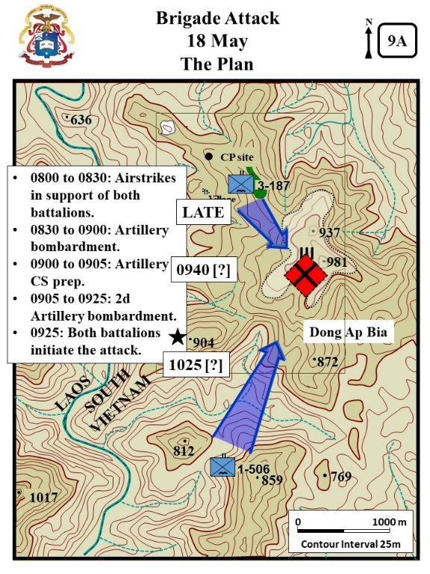
- Brigade provided a timeline for the attack soon after daylight: (Zaffiri, 209)
  - 0800 to 0830: Airstrikes in support of both battalions.
  - 0830 to 0900: Artillery registration.
  - 0900 to 0905: Artillery CS prep.
  - 0905 to 0925: Artillery prep.
  - 0925: Both battalions initiate the attack.

- Initial execution and problems with the CS. LTC Honeycutt tried to get the CS canceled, but found out that Division had inserted the CS into the Brigade plan and that it was non-negotiable. Zaffiri, 209-210).

- C1: Late - Airstrikes arrived 30 mins late and pushed back to time line.

- C2: Star - The regular artillery prep was on target.

- C3: 0940 [?] - The CS prep did not go in till 0940.

  - The first volley missed the top of the hill and landed near Alpha 3-187. Most of Alpha’s gas mask had wet filters and they failed to work. Several men were caught in the gas and were momentarily incapacitated.

  - The second CS volley landed on target. High winds quickly dispersed the gas.

  - Specialist Philip Perron, a 20 year old riflemen in Charlie, remember, “They figured the NVA would all crawl out of their holes coughing and gagging… Anyway the wind shifted and the whole CS Gas theory didn’t work.” (WPCFOR, Perron Interview)

- C4: Star - The artillery continued to pound the hill as the two battalions moved out in the attack, the 3-187th with two companies from the northwest and the l-506th with three companies from the south.

VISUAL 9B: Sixth Assault Up Hill 397 – Morning [XXIV Corps Historical, Tab B:15-17) [The PPT builds on the visuals are noted as C1, C2, or C3 etc.]
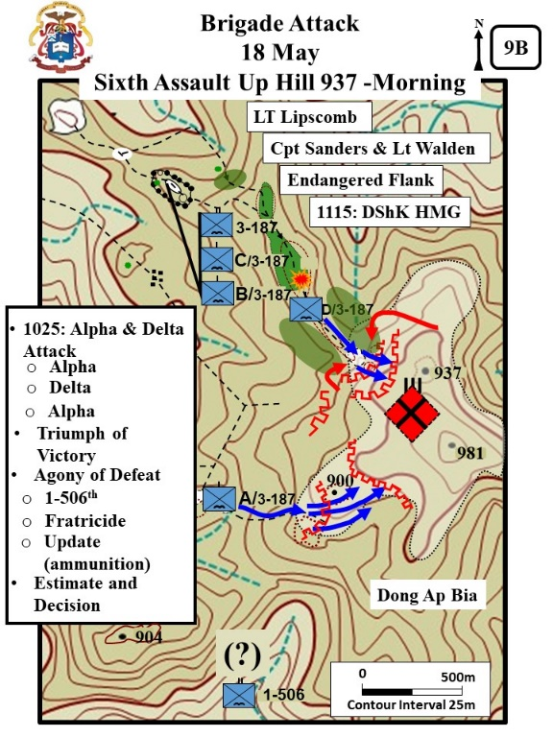
Virtual View: Continue with view from the BN CP of 937, 981, and 859.
- At 1025, the 3-187th attack started. The soldiers were heavily loaded with flak vest, 40 magazines and sometimes as many as ten grenades per man.

- The 3-187th was immediately engaged by a determined enemy force. (additional details from Zaffiri, 210-211 below)
  - The fire was intensive and withering but the two companies were able to push on.
  - The battalion commander was immediately overhead calling for artillery and mortar fire on the enemy positions and guiding his companies in the direction which appeared to have the best chance of success.

VSR: From the BN CP focus on the area of Alpha’s attack.
- C1 Alpha - Alpha pushed through the first line of bunkers without much resistance. (Zaffiri, 211)
  - They were either partially abandoned or the air and artillery strikes had neutralized them.
  - As the companies inched up the hill, the enemy fire grew in intensity.
  - LT McGreevy, the lead plt in Alpha, was wounded by an RPG blast.
  - At that point the Alpha attack stalled against a 2d line of bunkers.

VSR: Focus on the Delta sector, then fly up to the edge of the woods and move up to the 2d bunker line IAW the discussion below (See the view from the edge of Battle clearing with Stand 7B).

- C2: Delta – Delta was particularly hard hit by automatic weapons fire, RPGs and claymore mines; casualties were heavy. Cpt Sanders remembered, “We burst out of the wood line and it is the most instance fire I have ever seen…incredible, it was very intense.” (WPCFOH, Sanders Interview)
- C3 Lipscomb - LT Lipscomb with the lead plt (2d Plt) of Delta was able to push through the first bunker line. (Zaffiri, 210- 212).
  - About 30 meters from the first bunker line, Lipscomb’s platoon went prone into the skirmish line but continued to advance by crawling forward.

  - Enemy fire wounded 3 soldiers, but the plt continued to advance. Plt members remembered the Lt yelling: “Let’s go!” – “Move up!” – and “Let’s get these bastards”

  - Lipscomb moved the plt forward using fire and maneuver. Men would rise up and dash forward a few meters and then go back to the prone position.

  - In time, three more men were wounded. But the plt moved into the enemy bunker line.

- For the first time the men of Delta observed enemy soldiers abandoning the forward positions and trying to retreat up the hill. Five in one group and seven or eight in another group. Most were shot down.

  - Nevertheless, claymore mines slowed his attack. Capt Sanders was close behind the Libscomb plt with Lt. Walden’s plt in tow.

  - After the first bunker line, Lipscomb’s plt was stalled by enemy claymore type mines that wounded three more men. Cpt Sanders right behind the plt yelled for Lt Lipscomb to continue forward.

  - Lipscomb’s plt charged forward against the second trench line. An enemy grenade killed Lipsomp and heavy fire killed and wounded several other soldiers.

- C4: Sanders & Walden - LT Walden’s 1st Plt (Delta) attack (Zaffiri, 212-215)

  - Cpt Sanders directed Lt Walden to pass through the lead plt and continue the attack. Moments later, Cpt. Sanders was seriously wounded (1200H) and directed LT Walden (who was wounded) to take command of the company.

  - Walden notified BN, requested ammunition resupply, and continued the attack. But NVA in the draw to the left slowed their advance.

- The NVA also maneuvered into the draw on the right.VSR: Move SSW to the M60 position on Delta’s right flank - Marked with a Red Bush.

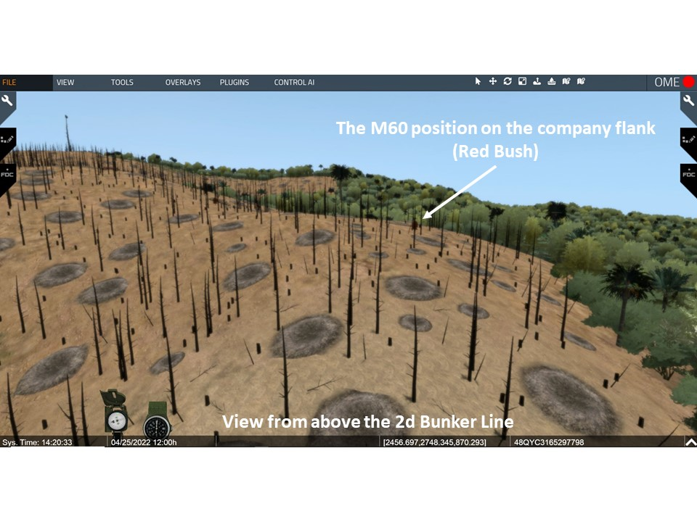
  - Walden maneuvered MG teams to his flanks because the NVA were trying to hit the two platoons in the flank and trying to work around to their rear.

  - C5: Endangered Flank - On the right flank – Sp. 4 Harris and Little covered the flank with their M60 MG. Their fight demonstrates the intensity of the fight.

    - Harris and Little fire several belts of ammo at the NVA manueuring to the rear of the company.
.
    - Specialist Little remembered thinking, “What is going on? Is this really happening to me?

    - A moment later, Harris was seriously wounded and Little took over the gun. PFC Roy Mathew crawled over and assumed the assistant gunner position.

    - Sgt. Joe Bell directed Little to maneuver to the right. Little remembered how difficult it was to get over the fallen tree trunks. An enemy grenade stunned him and he lost hearing in the right ear.

    - In the new position he fired steadily for about five minutes and defeated the NVA attack.

    - The M60 MG over-heated and jammed, Little and Mathew abandoned the gun a followed the plt up the hill. Little had only his 45 pistol. Mathew was shot and killed.

    - Little passed by a dead rifleman and took his rifle, ammunition, and bag of grenades. He then joined the firing line.

VSR: Shift back to the position just short of the 2d bunker line.

- C6: DShK HMG – In the fight against the 2d bunker line, Lt. Walden moved up and down the line of 1st and 2d platoons urging the men forward.

  - Then about 1115, the line starting taking fire from a heavy MG position below the military crest and in between two ridges. Optional - VSR: Shift to the HMG position looking back toward the U.S. Advance (located in the saddle between 937 and 981- marked with a red bush.

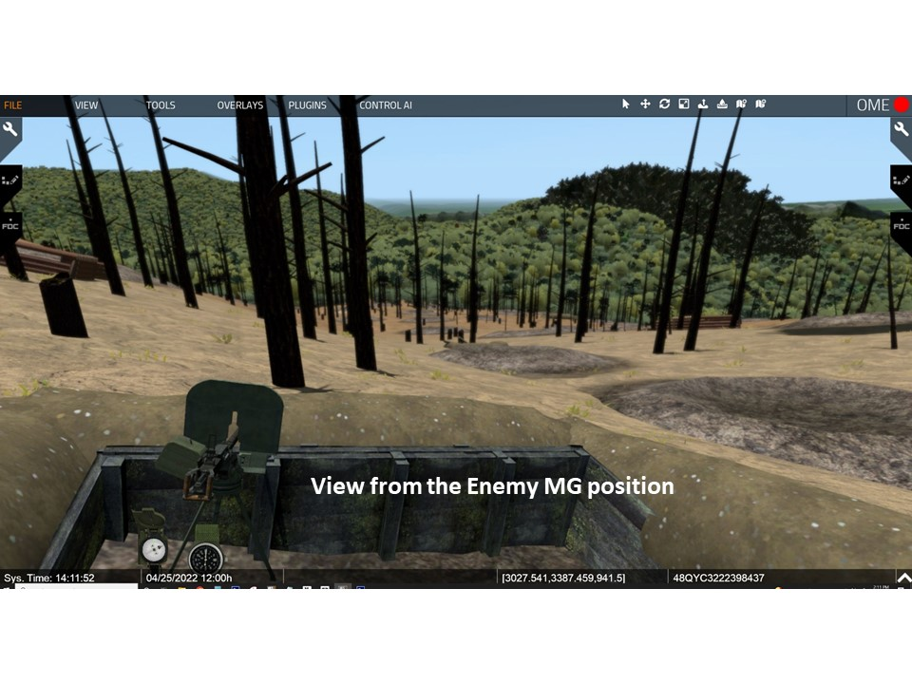

  - Lt. Walden tried to maneuver a squad against the MG, but several men were killed and wounded.

  - Pfc Rocklen, a radioman, crawled forward, marked his own position with smoked and then guided a Skyraider Fighter-bomber onto the target – which silenced the HMG..

VSR: Shift to the Alpha’s area. Need to rise up and look SW for the red tree. Move to the tree to pick up the trail to the first bunker line.

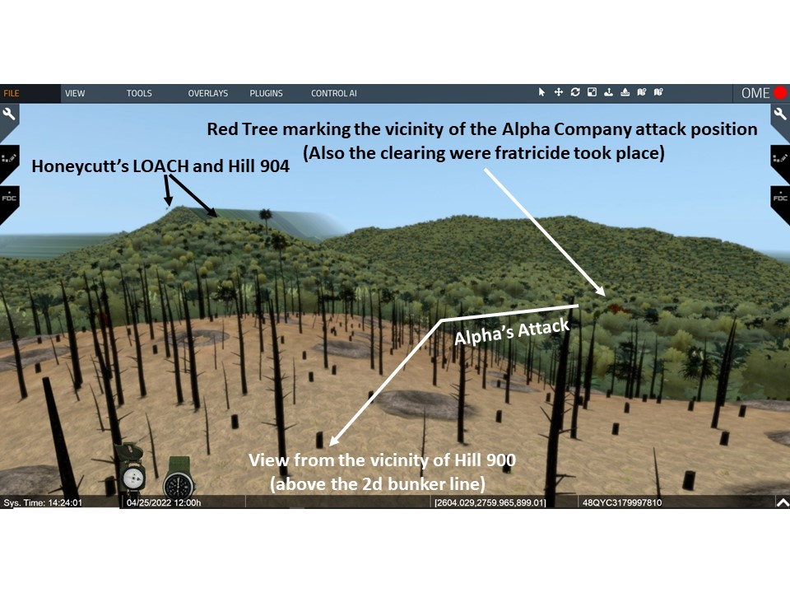
- C7: Alpha - On the BN right, Captain Harkins’ reenergized the Alpha advance after Lt. McGreevy was wounded. (Zaffiri, 215 – 216)

  - He pushed Lt Bresnahan’s 3d Plt forward through the stalled 1st Plt.
  - The 3d Plt pushed through the 1st bunker line and started fighting the second bunker line.
VSR: IAW the discussion move into the 2d bunker line- marked with red bush.
- C8: Triumph of victory - LTC Honeycutt believed he was finally on the verge of capturing the hill (Zaffiri, 215 - 216)

  - Cpt Harkins’ reported that Alpha was close to the top of the hill and into the second line of bunkers.

  - LT Walden (Delta) reported: “We’re pushing hard. We’ve got the bastards on the run.”

VSR: Rise up in the air and look toward the 1-506 area IAW discussion.
- C9: Agony of Defeat - The anticipated triumph of victory was quickly tempered by bad news.

  - Alpha was watching out for the 506th on their right flank. However, there was no contact with them.

  - The 1-506th attack:

    - The l-506th had initiated their attack immediately following the artillery and air preparation.
    - Intensive fire slowed their move up Hill 859 as they fought from bunker to bunker.

    - Brigade reported that 1-506th was still not in position and was making slow progress in their attack against Dong Ap Bia.

VSR: Rise up in the air and look back to the area of the fratricide – red tree in Alpha’s rear.
  - C10: Fratricide- Bravo reported that one on their platoons bringing forward ammunition was hit by Cobra gunships – 1 KIA and 4 WIA.

  - C11: Alpha and Delta update - Enemy resistance slowed the momentum of the attack and both companies were short of ammunition. Both companies reported that they were stalled along the 2d bunker line.
VSR: Look north toward the area where Delta is fighting.
  - Delta reported that Lt Walden and 1st Sergeant Thomas Sterns had been wounded. The company had no remaining officers and was at less than 50% strength and almost out of ammunition

- C12: Estimate & Decision- LTC Honeycutt’s estimate and decision. (Zaffiri, 216-217)

  - Delta and Alpha stalled just short of and within the second bunker line.

  - Both companies fighting it out with the enemy only 20 meters away.

  - Delta was combat ineffective. Directed them to suspend the attack and hold in place.

  - Directed Cpt Johnson (Charlie) to move up the ridge and pass through the remnants of Delta to continue the attack. He was also to amalgamate the remnants of Delta into Charlie.

VISUAL 9C: Sixth Assault Up Hill 397 – Afternoon [XXIV Corps Historical Summary. [The PPT builds on the visuals are noted as C1, C2, or C3 etc.].

VSR: Continue to look toward the area where Charlie and Delta are fighting (Hill 937).
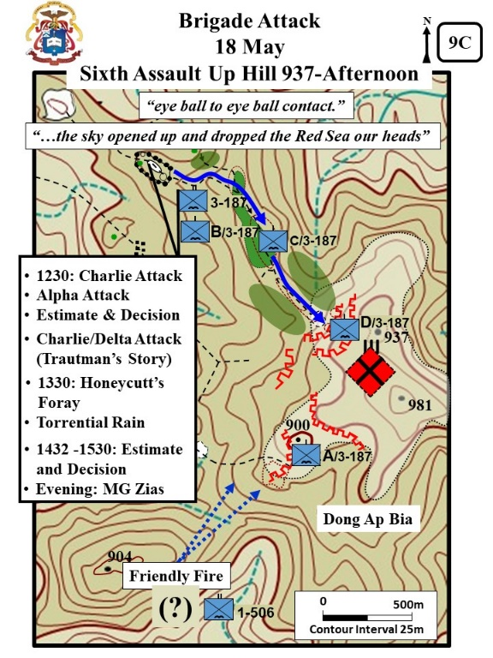
- The Charlie Attack (Zaffiri, 217- )

  - At 1230, Charlie moved out toward the hilltop. With them was a platoon from Bravo loaded down with ammo for Charlie and Delta.

  - Charlie moved up fast. However, when still 60 meters behind Delta they found that the enemy had re-occupied the first bunker line and temporarily halted the Charlie advance.

  - LTC Honeycutt from a LOH personally directed mortar and directed the movement of Charlie to get them on the move again.

VSR: Look toward Hill 904 (marked with Red Tree and LOACH above the Hill). IAW with the discussion move to the LOACH on Hill 904. Point out Alpha’s position and the smoking marking 1-506 on Hill 859. [see the previous VSR view]
- C1: Alpha Attack - Then Cpt Harkins (Alpha) reported they were receiving heavy fire from the ridge on his flank and rear. (Zaffiri, 217-219)

  - Honeycutt questioned the report, because that was the reported location of 1-506th.

  - Brigade confirmed that 1-506th was just northeast of Hill 904 and Harkins confirmed he was taking fire from that location.

  - Honeycutt flying with “Crazy Rairdon” took the LOH to Hill 904 and requested that 1-506th mark their lead element with smoke.

  - 1-506th marked with smoke and Honeycutt determined they were well to the south.

VSR: From Hill 904 look back toward the Alpha and Charlie fight.
- C2: Estimate and Decision - Honeycutt updated his estimate of the situation (Z, 219-220)

  - 1-506th not in position to support the attack on Hill 937.

  - Two companies (Alpha and Delta) in were in what he called “eye ball to eye ball contact.”

  - Third company (Charlie) moving up to support.

  - Reasoned that if he tried to pullback the enemy would counterattack.

  - Decision was to continue the attack. Told Cpt Harkins and Johnson. “We’re not gonna hold anymore. We’re gonna continue the attack. I’m not gonna turn tail and have you all shot in the back. We’re gonna push those bastards off that hill.”

  - He requested Brigade reinforce him with units. A company or platoons. Believed his shot up companies no longer had the command structure needed to integrate individual replacements.

  - Brigade stated they would move in company immediately.

VSR: Return to the area of the Charlie fight just short of the second bunker line (Hill 937).
- C3: Charlie/Delta resume the attack. (Zaffiri, 220-221)

  - Captain Johnson moved into the Delta position and consolidated their remnants with Charlie.

  - Honeycutt from the LOH directed Johnson to maneuver an element up a finger on the left.

  - Johnson and Lt. Trautman believed the enemy resistance was to strong and that any attack was suicidal.

  - Honecutt insisted.

VSR: IAW the discussion move into the 2d bunker line.
- Lt. Trautman’s attack. (Zaffiri, 221- )

  - One of Trautman’s squads refused to move forward.
  - Some remembered: (Zaffiri, 221- )
    - Lt Trautman told them, “Look…, if I go with you, will you go?”
    - One of the men stated, “If you’ll lead us, I’ll go.” And all the others agreed.

  - Trautman remembered, “I picked up my weapon and walked though my men and said, ‘come on let’s go.’ I didn’t know if they were going to follow me or not, but they did.” (WPCFOH, Trautman interview)

  - He led the charge up the hill at a run, jumping into to bomb craters, and then running forward again. All five men followed him. Trautman remembered, “We tried scappering up this sheer hill side with no cover.” (WPCFOH, Trautman interview)

  - They made it about 30 meters until they took casualties and the men stopped to care for the wounded man-they then retreated.

  - Trautman was several meters to the front yelling for the men to follow when he was hit in the left leg.

  - Trautman slipping in and out of consciousness was isolated and alone. He remembered, “I was up there [alone]… I thought I was going to die there.” (WPCFOH, Trautman interview)

  - Fortunately, a sergeant led a fire team to rescue the Lt and pulled him back into the friendly lines.

- It became increasingly difficult for the companies to move in face of the withering enemy fire so the attack ground to a halt.

Optional VSR: Move to the vicinity of the Y Junction and then IAW the discussion below move forward onto the razor back ridge.
- C4: Honeycutt’s Foray - LTC Honeycutt’s was still overhead in his LOH calling in airstrikes and adjusting artillery and mortar fire. But decided to personally intervene to get the attack moving again. (Zaffiri, 223-225)

  - At about 1330, he spoke by radio with both Harkins (Alpha) and Johnson (Charlie). Both Captains stated they could get the men moving again and take the Hill.

  - Honeycutt, with the BN S3, Major Collier, and his three RTO’s moved forward to join the ground attack.

  - From the old Bravo LZ they moved forward and soon after leaving the LZ they were ambushed along the razor back ridge.

  - Grenades knocked Maj Collier down and stunned him. Honeycutt and the 3 RTOs engaged and killed six to seven NVA coming up out of the draw.

  - Honeycutt then moved forward and joined up with Charlie.

VSR: Rise up in the air and look toward Dong Ap Bia.
- C5: Torrential Rain - At about the same time a torrential rain fell turning the slopes of the bald hill into a virtual mud slide.

  - It was impossible for the soldiers to keep their footing and they kept sliding back down the hill.
  - Lt Boccia remembered, “This wasn’t rain: It was as if the sky opened up and dropped the Red Seas our heads… The water, tons of it, penetrated the loosened soil, turning it quickly into a liquid, slurry-like wave. Gravity took care of the rest. Men were literally washed down the slopes, absolutely powerless to stop their descent.”

- C6: Estimate and Decision - Honeycutt again updated his estimate of the situation. (additional details from Zaffiri, 225-229)

  - Charlie, Alpha, and Delta lacked the combat power and the ammunition to hold their position against a determined counter-attack.

  - The rain and mud prevented the promised reinforcements and ammo from getting forward.

- At 1432, Honeycutt recommended and received permission from Col. Conmy to withdraw. Unfortunately the companies left behind many of their dead. A furious Honeycutt order both Captains to lead teams back up the hill to collect the fallen. (additional details from Zaffiri, 225-229)

- During the day the battalion had 14 men killed in action and 64 wounded.

VSR: Look back toward the old Bravo fwd LZ.
- “Crazy Rairdon recalled that 18 May, “was my last work day on Hamburger Hill.” (WPCFOH, Rairdon interview)
  - He already had 13 hours flying time that day when he went in to pick up some more wounded.
  - He was at a company forward LZ and recalled, “it was toward the end of the day, it was getting dark. I got shot through both legs.”
  - The next day another Loach brought in a pilot. Rairdon’s Loach blocked the LZ so the replacement pilot had to jump down. Rairdon was concerned that he would break his legs in the jump. The pilot made it ok and threw Rairdon into the back of the Loach and took him to a medical facility.

VSR: Return to the BN CP and take up the view of 937, 981, and 859. IAW the discussion focus on the areas being discussed

VSR: Remain at BN CP and look toward Dong Ap Bia.
- C7: Evening, MG Zias - By nightfall, the 1-506th had progressed to within approximately 600 meters of the crest of the hill where they established their night defensive position.

- Division and Brigade decision to reinforce

  - The Division Commander, MG Melvin Zais, followed every minute of the action, as he had been doing since 10 May. In order to have a clear and complete picture of what was happening, he spent most of every day either overhead following the action from his helicopter or on the ground talking with the troopers and their leaders.

  - At this point in the battle at Dong Ap Bia, the Division Commander had a choice of either turning his back on the entire operation or pressing on. After carefully reviewing the situation, General Zais decided to reinforce the 3-187th and l-506th with two additional battalions in order to completely surround the hill.

  - General Zais discussed his decision with MG Troung, CG, 1st ARVN Division, who eagerly made available the 2/3 ARVN Battalion for employment as one of the reinforcing battalions. The 2-501st, which had been operating just to the east of the Ashau Valley was designated to be the second reinforcing battalion.

- MG Zais and Col Conmy had also canceled the one company reinforcement for 3-187 IN. (Zaffiri. 230-232 and Boian, MG Zais, 32-33)

  - Zais decided instead to send 2-506th IN to do a relief in place with 3-187th.

  - LTC Honeycutt found out about the decision when LTC Gene Sherron arrived at the 3-187 IN CP to discuss the relief.

  - Soon after that, MG Zais arrived at the 3-187 IN CP.

  - LTC Honeycutt convinced Zais that 3-187 IN deserved the opportunity to remain in the fight. Honeycutt convinced Zais and also negotiated the attachment of Alpha of 2-506th to his depleted BN.

- During the night, plans were developed for a four battalion coordinated attack on the morning of 20 May.

ANALYSIS

- Evaluate LTC Honeycutt’s request for brigade reinforce him with units (a company or platoons). Why did he believe his companies could no longer integrate individual replacements?

- The Draft ATP 3-90.98, Jungle Ops (2020) in para 3-5 (Leadership) states “[in jungle operations leaders] listen to their Soldier’s concerns and keep them informed as the situation changes. They share in the privations of jungle combat and ensure their subordinates adhere to the practices necessary to remain effective in this harsh environment. IAW this doctrinal guidance evaluate Lt. Trautman’s leadership challenge of motivating the soldiers of 3-187th Infantry to continue the attack.

- Evaluate MG Zais decision to allow 3-187 Infantry to continue the fight.

- APO 3-0 (2019) 3-65, states that commanders are responsible for “Employing mutually supporting forces along different axes to strike from unexpected directions to create multiple dilemmas for the enemy.” It further states, Commanders seek every opportunity to make enemy forces operate in different directions against massed capabilities at the time and locations of their choosing. Evaluate the BN, BDE, and DIV level commander’s adherence to this principal.

  - 3-187th attempted its first multiple company attack on day 3 of the battle.

  - 3d Bde ordered 1-506^{t} to join the attack on day 4 of the battle. The unit was not in position to support a two battalion attack until day 8 of the battle.

  - Division directed on day 8 a 4 battalion assault for 20 May (day 10).

- Harkin’s Counsel - The night in the NDPs there was much talk by soldiers that they would not go back up the hill. Captain Harkins (Alpha) remembered talking with three soldiers who told their platoon leader that they would not go up the hill again. The soldiers said they were scared – asked why didn’t they just bring in B-52s, and why was the BN attacking alone – where was the rest of the brigade.

  - Harkins took the time to talk with the soldiers. How could you approach this leadership challenge?

  - What Harkins did: He explained that help was on the way. Tomorrow they would not be alone.

  - Admitted that he was also afraid – “Only a fool wouldn’t be scared of going up that mountain again.”

  - But then told them. “We’re soldiers, and our job is to do what we’re ordered to do. And if we’re ordered to go back up that hill, then that’s what we’re going to do.”

  - The three men agreed to follow their leaders up the hill if ordered to do so.

STAND 10: HAMBURGER HILL - 19 AND 20 MAY

VISUALS

10A: Setting the Conditions for Success – 19 May
10B: The Seventh Assault Up Hill 397 -20 May

ORIENTATION

Virtual View: Continue with the bald hill data base.
- From the BN CP continue with the view of 937, 981, and 859. (Same as initial orientation for Stand 7)
- Additional directions and distances noted in the description narrative.

Orientation: Currently located at the Rakkasans’ BN CP. The summit of Dong Ap Bia is about 1500 meters to the SE.

DESCRIPTION
(Part 1: 19 May)

VISUAL10A: Setting the Conditions for Success [XXIV Corps Historical Summary. [The PPT builds on the visuals are noted as C1, C2, or C3 etc.]

- May 19, the brigade devoted primarily to preparation for the attack on the morning of 20 May.

VSR: Rise up and look over Dong Ap Bia to the east.
- 2-501st and the 2/3 ARVN Battalion.

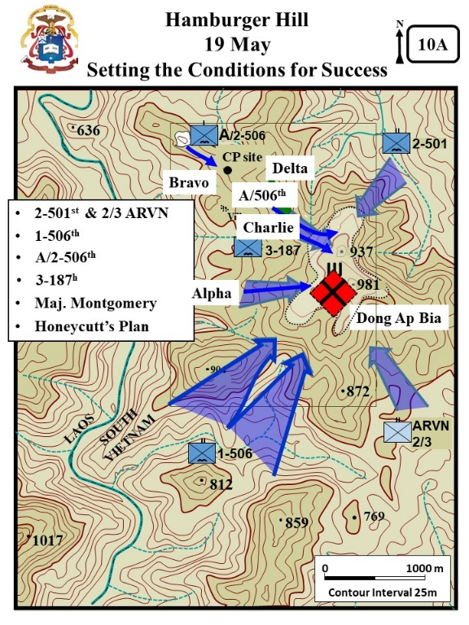
  - The 2-501st was combat assaulted into a position 1200 meters northeast of the summit. (About 1600 meters from our current location)
VSR: Look over Dong p Bia to the SE
  - The 2/3 ARVN Battalion was moved from Hue and combat assaulted into a landing zone approximately 1200 meters east-southeast of the summit. (About 2500 meters from our current location).

  - The landings of both battalions were unopposed and they immediately moved up the hill to establish their attack positions for the following day.

VSR: Look to the south to where the 1-506th is operating. (A little less than 3Ks to the south)
- C1: 1-506 - Meanwhile, the l-506th continued to push up from the south in order to be in a better attack position by nightfall.

  - The enemy resistance, as on previous days, was determined. The bunker to bunker fighting continued.(Details below from Zaffiri, 244-252)
  - At 1030 attack Hill 900. Alpha led with Charlie following.
  - Fought for 3+ hours – lost 19 wounded and found 21 dead NVA within the bunkers.
  - Tried to continue toward Hill 937, but when they again met resistance the battalion was exhausted and could not continue forward.
    - Charlie initially followed Alpha, but then swung to the right and moved up Hill 900 from the southeast.
  - By dark, the BN was within a few hundred meters of the top of the hill.

VSR: Focus of the BN CP IAW the discussion.
- C2: Sgt Wiknik – Here, at the 3-187 CP, A/2-506th arrived to reinforce the 3-187th. Sergeant Arthur Wiknik was with A/2- 506th. (Diconsiglio, Blood Bath, 30, 44- 46)

  - .He was 20 year old “shake and bake” sergeant. Most career noncommissioned officers rise through the ranks in the Army only after years of service. However, the demand for NCO's in Vietnam far exceeded the available supply.

  - The Army decided to select the best and brightest from basic training and send them to the NCO Academy at Fort Benning, Georgia.
    - At graduation they earned the rank of E-5, known to everyone in the military as an instant NCO! An instant Sergeant! A Shake & Bake Sergeant!
    - However, they had no more experience than the soldiers in their squads.

  - His arrival in the 3-187th IN area was a learning experience.
    - The 3-187 IN had been living and fighting from the BN CP location for 9 days.
    - Sergeant Wiknik had never been in the field for an extended time and had never been in combat. He remembered, “I remembered thinking, “What happened here? …There was garbage everywhere. The place smelled like human waste. We walked silently past soldiers who’d been fighting for days. They looked like zombies. They were filthy and unshaven. And they had a glassy look in their eyes. We called it the ‘thousand-mile stare’ – the dead, distant gaze of men who spent too long in combat.”

  - Sgt Wiknik first time under fire will be discussed at a later time in the staff ride.
- VSR: Look toward Dong AP Bia. C3: 3-187 - 3-187th integrated the new company into the battalion and prepared to attack on the 20th.

  - The battalion commander spent a good part of the day over Hill 937 directing air, artillery, and mortars against the enemy positions.

  - A relentless pounding of the hill was continued throughout the day and night.

- By nightfall, all four battalions were in position for the attack.

- C4: Maj Montgomery - That evening the Brigade S-3 (Maj Montgomery) flew into the 3-187 area to brief the plan. (Zaffiri, 242-242).

  - He told LTC Honeycutt that the Rakkasans were to be a fixing force.

  - They were to advance till in contact to hold the enemy in place while the other BN’s took the hill.

  - LTC Honeycutt voiced his disapproval of the plan. “I don’t like it… Because we ain’t goin’ through that fix-the-enemy-place routine again. The next time we get to the top of that mountain, we’re gonna take the sonofabitch. If the 506th gets there, that’s fine. And if the 2/501st gets there, it’ll be great. And if the ARVN get there, I’ll be F—n thrilled. But we ain’t goona sit here like [before] and get our asses shot off waiting for them.”

  - Brigade agreed to let 3-187 push to the top of the hill.

VSR: Take up a position looking over the LOACH at Hill 937/981 and focus on the areas of the companies IAW the discussion.

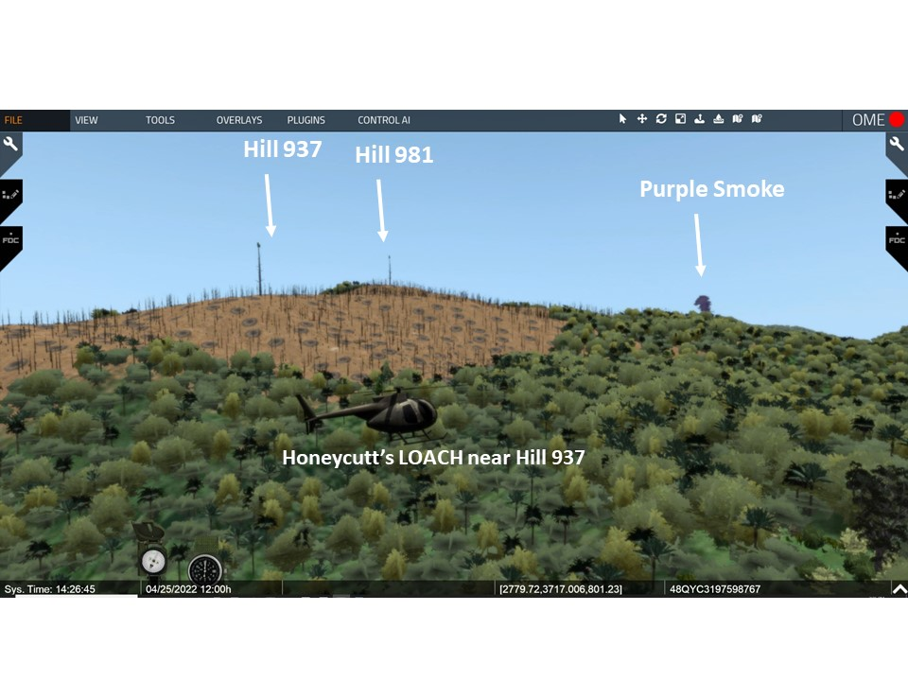

- Honeycutt’s plan (Zaffiri, 243 - 244)

  - He took all the company commanders into the air for a commander’s recon.
  - C5: Honeycutt’s Plan - The briefed the plan.
    - Charlie the main effort along the main ridge- through the clearing at up the ridge.
    - C6: Alpha- Alpha parallel to Charlie up the southern spur again.
    - C7: A/506th – A/2-506 initially following Charlie then at the clearing swinging to the left to protect Charlie’s left flank.
    - C8: Delta - Delta was the reserve.
    - C9: Bravo - Bravo responsible securing the BN CP.

DESCRIPTION
(Part 2: 20 May)

VISUAL 10B: The Seventh Assault Up Hill 397 [Unless otherwise stated – XXIV Corps Historical Summary. [The PPT builds on the visuals are noted as C1, C2, or C3 etc.]
VSR: Remain at the LOACH position and focus on the area IAW the discussion.
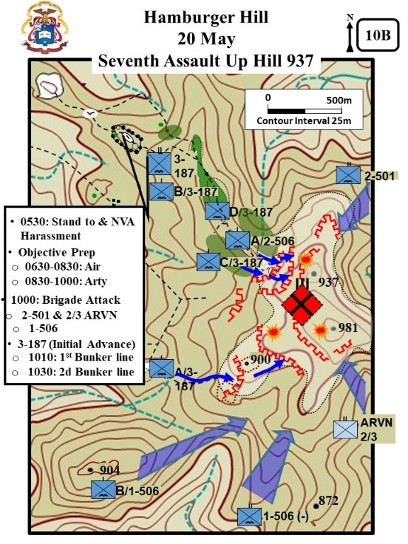
- VSR: Look back at the BN CP. 3-187 IN stand to at 0530. At 0630 a NVA squad attacked the western perimeter of the BN CP with RPGs. About the same time a NVA suicide bomber got into the A/2-506th perimeter and wounded four men. (Zaffiri, 253-254).

- C1: Objective Prep – VSR: Look toward 937 and 981. According to plans, Hill 937 was again bombarded with airstrikes and artillery, which seemed even more intensive than on previous days. (Details below from Zaffiri, 255-256).
  - 0630 -0830: Air bombardment.
  - 0830 – 1000: artillery bombardment.

VSR: Look toward 2-501 and 2/3 ARVN areas of operation.
- C2: Brigade Attack - At 1000: Following the preparation, the four battalions moved out in a coordinated attack.
  - The 2-501st, attacking to the northwest encountered only slight enemy resistance but did discover numerous abandoned huts and bunkers.

  - The 2/3 ARVN, attacking to the southwest, encountered some resistance, but was able to continue the advance up the hill.

VSR: Look toward 1-506th area of operation.
- C3: 1-506 - The l-506th, attacking to the northeast, had to fight their way up the ridge. The attacking companies continued to receive small arms, RPG, and mortar fire as they progressed. (Details from Zaffiri, 255).

VSR: Look toward the companies IAW the discussion below.
- C4: 3-187 (Initial Attack) - The 3-187th attacked to the southeast with three companies abreast. (Details from Zaffiri, 255).
  - Alpha on the right.
  - Charlie in the center
  - A/2-506th on the left.
  - Honeycutt controlled the movement from the air (today flying himself)

- 1010 at the first bunker line – found to be deserted. However, the riflemen destroyed or sealed the bunkers with satchel charges before moving on.

- C5: 2d Bunker Line - At 1030 – Initially in the maneuvering toward the 2d bunker line there was no contact.
VISUAL 10C: Hamburger Hill Taken [Unless otherwise stated – XXIV Corps Historical Summary. [The PPT builds on the visuals are noted as C1, C2, or C3 etc.]
VSR: Remain with the LOACH and look toward 2-501 and 2/3 ARVN areas of operation.
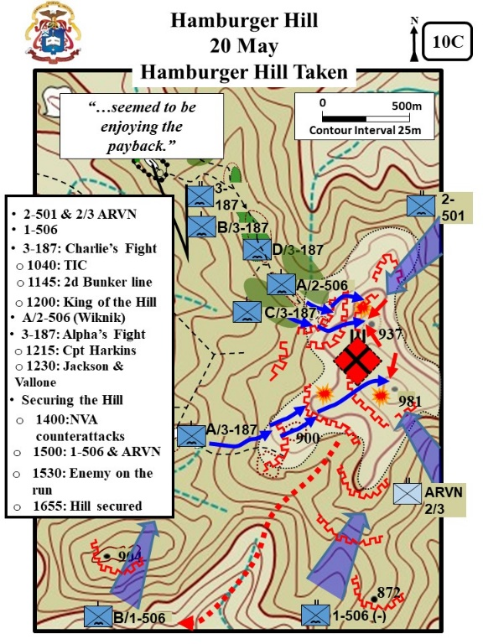
- In the East, 2-501 and 2/3 ARVN
  - The 2-501st cautiously advanced up the hill against only minor resistance.

  - The 2/3 ARVN, encountered stiffening resistance, but was able to continue the advance up the hill.

VSR: Look toward 1-506 area of operation.
- In the south, 1-506th fought up the hill against fanatical resistance, including numerous local counterattacks by the NVA. (details from Zaffiri, 264-265).
  - The battalion sustained numerous casualties with its Bravo Company being especially hard hit.
  - A platoon from its Charlie Company, led by Lt. Ian Shumaker, sent to assist Bravo also sustained numerous casualties.
  - Nevertheless, the Currahees continued to push up the hill.

VSR: Go to the ground at the 2d bunker line (Charlie – Hill 937).
- In the west, the Rakkasans initial maneuvers were unopposed, as the battalion approached the 2d bunker line, the enemy, as if waiting for the opportune minute to opened fire.

VSR: Discuss Charlie’ fight for the 2d bunker line IAW the discussion below.
- C1: Charlie’s Fight - Charlie’s fight (details below from Zaffiri, 257-259)
  - At approximately 1040, 10 to 15 NVA rose up from a trench along the 2d bunker line and opposed Charlie with RPGs – at least 7 in Charlie wounded.
  - Charlie returned fire and the NVA rolled grenades down the hill - at least 4 more in Charlie wounded.
  - At 1145, the fight for 2d bunker line still ongoing, and Charlie brought forward 90mm RR to fight the bunkers.

VSR: Pass through the 2d bunker line a pause at the destroyed bunker near the top of the Hill 937.

- King of the Hill - About 1200, Lt Donald Sullivan’s 2d Plt, Charlie had taken several bunkers and had men on top of the hill. They were soon followed by more of Charlie.

- LTC Honeycutt was immediately above the battle piloting an OH-6 observation helicopter.
  - Charlie had seized a few bunkers on the top of the hill. However they were alone with dug-in enemy to the right and left, and amongst them.
  - Honeycutt was worried that an enemy counter-attack might push Charlie off the hill
  - He therefore ordered both Alpha and A/2-506th to move faster and secure Charlie’s flanks.

- Part of the post battle controversy was Associated Press journalist Jay Sharbutt’s description of LTC Honeycutt always in the air above the battle.

  - One description of Honeycutt was, “…hovering in his LOH, snorting and fuming at his men to keep the attack moving.”

  - However LOACH Pilot “Crazy” Eric Rairdon remembered, “on rare occasions I would take Honeycutt up and we would orbit and he would be directing operations from the air. The way I remember it, he was on the ground a lot more than he was in the air. He was there with his men at the scene of the battle.”(WPCFOH, Rairdon, Interview)

VSR: From current position, look toward the A/2-506 area of operation.
- C3: A/2-506 (Wiknik) – Soon after Alpha surged to the top, A/2-506 also seized the north portion of the hilltop and secured Charlie’s north flank.
  - Arthur Wiknik, the 20 year old “shake and bake” sergeant was one of those that fought his way onto the hill.

  - Sgt Wiknik had never been under fire – he remembered, “In the morning, jets mercilessly pulverized Hamburger Hill with bombs. I thought the enemy had to be dead. Who could survive such an assault? … I walked standing straight up, thinking the heavy fighting was over. Then I noticed something strange. Little brown bubbles popped up from the dirt at my feet. I bent down to take a close look and then I realized – they weren’t bubbles. They were bullets striking the ground. I hit the dirt. Hurriedly, I crawled into a bomb crater.” (Blood Bath and WPCFOH, Wiknik interview)

VSR: Fly to the area of Alpha’s fight just short of the 2d bunker line below Hill 981.
- C3: Alpha’s fight - Alpha still fighting to get into through the second bunker line – one plt ldr and 15 men wounded so far (details from Zaffiri, 259-260).
  - Cpt Harkins seriously wounded. Bullet though his left ear, then thru the neck and lodge in his back. Lost most of his hearing and sight from his left eye.

  - Alpha stalled when Harkins wounded. Honeycutt told him, “If you can’t fight the company, then turn it over to someone who can.”

VSR: Move into the 2d bunker line.
  - It was 1215, Harkins directed his radio man to advance and pull him up the hill while he held onto the radio to maintain his balance.
  - Nevertheless, heavy enemy fire and rolling grenades down the hill again stalled the Alpha advance.
  - At the same time a NVA squad counter-attacked into Charlie’s right flank.

VSR: Follow Jackson’s route to the top of the Hill 981- (Crater next to large tree with M60).
- 1230: Jackson & Vallone -Individual sergeants and soldiers within Alpha reenergize the Alpha Attack. One such individual was SP 4 Johnny Jackson’s (details from Zaffiri, 261-262).

  - In ones and twos they dashed forward. One was SP4 Johnny Jackson – a M60 gunner. His plt heard him yell “F this bullshit.” And him running forward “wildly spraying bullets from side to side.”

  - He fell into a spider hole with two NVA and killed them both. Then he continued to the top and put his MG thru the aperture of a bunker and let loose.

  - At about 1230 he seized a crater at the top of hill. Soon after that he was wounded by a white phosphorous marking rocket.

  - Nevertheless he secured the top of the hill and held his position. (Boccia, 448).
  - He was awarded the Silver Star for his actions (Zaffiri, 124 2d page of pictures)

- Alpha’s final surge (details from Zaffiri, 262-263).
  - SP 4 Michael Vallone watched Jackson’s charge
  - He then yelled “Follow-Me… Come on, everybody, follow me!”
  - At first Vallone’s squad rushed forward, but soon followed by all of Alpha.
  - The attack overran the 2d bunker line and reached the top of hill.

- Captain Harkin’s – weak from his wound – little to no hearing – no sight from his left eye – charged up the hill with his radio man holding him up and guiding the way.
  - At the top of the hill, Harkins organized a defensive perimeter and tied in with Charlie.
  - He then collapsed. Lt Goridie Atchenson took command of the company.

VSR: From Jackson’s position look at the M60’s field of fire.
- C4: Securing the Hill – About 1400, the two Alphas and Charlie had to beat off several NVA counter-attacks. One of the lynch-pins of the defense was SP4 Jackson still suffering with the white phosphorous wound but still in the fight. Witness’s stated he “seemed to be enjoying the payback” of the NVA attacking his position. (Zaffiri, 263).

- 1500: 1-506 & ARVN: At 1500, 3-187 made contact with the ARVN on the hilltop. Soon after they tied in with the 2-501. (Boccia, 269)

- VSR: Move to the burial trench (south of Jackson’s crater on the east slope). The Rakkasans started clearing the top of the last enemy resistance while the other BNs held blocking positions. (Zaffiri, 270-272)

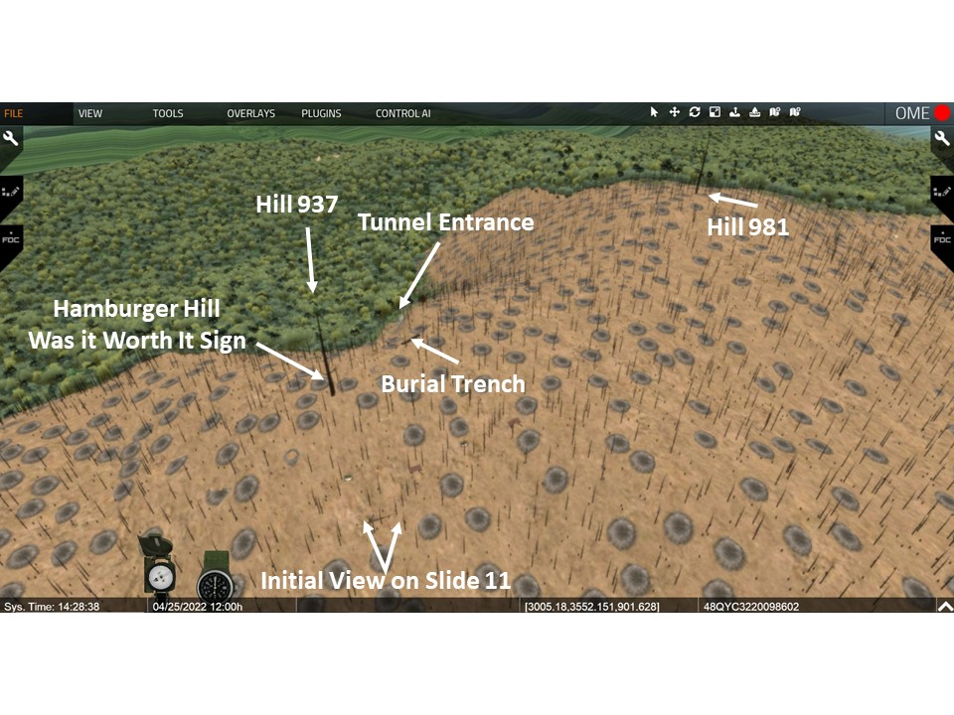

  - A burial trench with over a hundred bodies was discovered.

  - VSR: Move into the tunnel entrance - SSE of the burial trench. 3-187th discovered that the mountain was honeycombed with tunnels.
    - In one tunnel they discovered a room with 40 dead NVA stacked liked cord wood.
    - A functional hospital was discovered.
    - A storage room with 75,000 rounds of ammunition, thousands of mortar and RPGs, and over 10 tons of rice.

- VSR: Look SW down the draw. C5 - 1530: Enemy on the run - About 1530, 1-506th reported, “the enemy on the run… moving downhill… just fire for effect; they’re all over the place running… catch them in the open, they’re takin off for Laos.” (Boccia, 449).

- By 1655 - The fight was over.

ANALYSIS

- Evaluate LTC Honeycutt’s comment to his wounded Alpha commander, “If you can’t fight the company, then turn it over to someone who can.”

- What does SP 4 Johnny Jackson’s one man charge and SP 4 Michael Vallone call, “Follow-Me… Come on, everybody, follow me!” tell us about 3-187th IN and how do we (you) develop SP 4’s like Jackson and Vallone?

- Evaluate the collapse of the NVA defense of Dong Ap Bia. What factors other than the concentration of 4 infantry battalions against them contributed to the collapse?

STAND 11: WAS IT WORTH IT

VISUALS

11: Was it Worth It

ORIENTATION

Virtual View: Down slope (SSE) of the tree marking Hill 937 take up a view matching the base picture on Visual 11 [See the previous VSR View].

Orientation: Currently just to the west of the crest of Hill 397.
DESCRIPTION

VISUAL11: Was it Worth It [Unless otherwise stated – XXIV Corps Historical Summary.[The PPT builds on the visuals are noted as C1, C2, or C3 etc.]
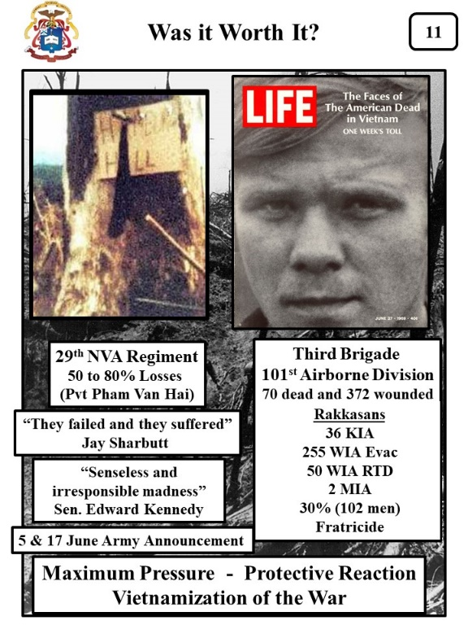
- At about 1700, the hill was secured.

- VSR: Move up to the hill circling slightly to the left left and take up a view of the north side of the large tree and Hamburger Hill sign. C1: Virtual Screen Shot of Sign - Soon after, rifleman Ed Henry (A/2-506) cut out the cardboard bottom of a C-ration box and printed “HAMBURger HILL[sic]” on it. (Willbanks, Hell on Hamburger Hill and https://www.vietnamjourneys.com/PL_HamHillSign.jpg and https://www.vietnamjourneys.com/Page_Diary_HH.html)

  - The sign was tacked to a charred tree trunk near the western edge of Hill 937.
  - Later, another soldier passing by scrawled underneath the question, “Was it worth it?”

- The question – “Was it worth it?” was already growing as a National debate throughout the press and within the government.

- C2: 29th NVA Regiment Casualties- The 7th and 8th Battalions of the 29th NVA Regiment along with other supporting units (Anti-aircraft, heavy weapons and engineer) had suffered grievous losses.

  - The 101st Airborne Division official count was the enemy suffered 50 to 80% losses with 630 enemy soldiers killed (The Headquarters 101st Airborne Division, Office of the Commanding General, Fact Sheet: Summary of Action and Results, 24 May 1969).

  - Much of this number was based upon the interrogation of NVA Pvt Pham Van Hai, who told them that before the final fight his 100 man company was down to only 20 men.

- C3: 3d Bde Casualties - The U.S. casualties were 70 dead and 372 wounded.(Zaffiri, 272).
  - C4: Rakkasans - Most of these casualties were in the Rakkasans who suffered 343 casualties (101st Fact Sheet).
    - 36 KIA
    - 255 WIA Evac
    - 50 WIA RTD
    - 2 MIA
  - 30% (102 men) were from fratricide incidents.
- The battle had been in the U.S. news since 14 May. However, the story captured little attention – just being another battle in Vietnam.

- C5: They failed and they suffered - The situation changed drastically on the morning of 19 May with Associated Press journalist Jay Sharbutt article “US Assault on Mountain Continues, Despite Heavy Toll.”

  - He had interviewed Gen Zais on the 16th. In the interview he questioned the soundness of the 101st tactics.

  - His article was one of the first to “portray the fight for Dong Ap Bia as an event in which individual men were fighting and dying.” (this and details below, Zaffiri, 274 and XXIV Corps Historical Summary).

    - “The paratroopers came down from the mountain, their green shirts darkened with sweat, their weapons gone, their bandages stained brown and red – with mud and blood.”
    - “Many cursed Lt. Col. Weldon Honeycutt, who sent three companies Sunday to take this 3000-foot mountain just a mile east of Laos and overlooking the shell-pocketed A Shau Valley.”
    - “They failed and they suffered. That damn Blackjack, won’t stop until he kills every one of us,” said one of the 40 to 50 101st Airborne troopers who was wounded.”
  - Follow on articles stated, “…many of the men in BRAVO Company were near the breaking point.”

- C6: Senseless and irresponsible -On 20 May, Senator Edward Kennedy stated to the Senate, “…senseless and irresponsible…madness… symptomatic of a mentality and policy that requires immediate attention. American boys are too valuable to be sacrificed for a false sense of military pride.”

- For weeks within the Congress, politicians debated tactics and questioned the tactical proficiency of Gen Zais.

- Dong Ap Bia became another rallying point for anti-war protestors and political platforms for politicians to argue against continued U.S. involvement. (Boian, MG n Zais and Hamburger Hill, 38)

- The Nixon administration worried that debate would further erode public support and shorten the time available to reach a negotiated end to the war in the Paris Peace Talks.

- C7: Army Announcement - On June 5 the Army expanded the debate when they withdrew the forces occupying the mountain. On 17 June, in the daily Vietnam War briefings, released intelligence that the NVA had reoccupied the mountain with possibly 1000 soldiers.

- C8: Life Magazine - The 27 June issue of Life Magazine heightened the debate with its cover story “The Faces of the Dead in Vietnam – One Week’s Toll.” (Zaffiri, 279 and https://www.life.com/history/faces-of-the-american-dead-in-vietnam-one-weeks-toll-june-1969/

  - They printed the photos of 242 men killed in Vietnam during the preceding week.
  - Only five of the soldiers shown died at Hamburger Hill.
  - However, the accompanying article included an excerpt of letter written by a soldiers that died at Hamburger Hill. It stated, “You may not be able to read this, I am writing in a hurry. I see death coming up the hill.”
  - The American public assumed that the 242 men died at Hamburger Hill.
  - Harry Summer, a military scholar, stated the “American public outrage over what appeared to be a senseless loss of life” was exacerbated by the faces of the 242 dead soldiers.

- C9: Max Pressure to Protect Reaction - Up until 27 June, American commanders in Vietnam had operated with the guidance to keep “maximum pressure” on the enemy while negotiations continued.

- The strategy was changed to “Protective Reaction.” US forces were to fight only when threatened by the enemy to hold down casualties.

  - President Nixon ordered the withdrawal of 25,000 troops by 8 July and another 35,000 by Early December- about 12% of the troops in Vietnam.
  - The new policy was “Vietnamization of the war.”
  - By 1971, the troop strength had been reduced from 475,000 to 157,000.

- Before Hamburger Hill, U.S. forces were seeking victory on the battlefield; after Hamburger Hill, the country’s civilian leadership was seeking a way out of the war. (Willbanks, Hell on Hamburger Hill)

ANALYSIS

The question – Was it worth it? – during the course of the discussion is the analysis for this stand.

West Point Center for Oral History [WPCFOH], Harkins Interview. http://www.westpointcoh.org/search?authenticity_token=nxQ5SiZtFUZn3dMNNpOvKbs9NxlCyqGalv3SeP4bM7E%3D&search=hamburger+hill&utf8=%E2%9C%9
West Point Center for Oral History [WPCFOH], Helms Interview. http://www.westpointcoh.org/search?authenticity_token=nxQ5SiZtFUZn3dMNNpOvKbs9NxlCyqGalv3SeP4bM7E%3D&search=hamburger+hill&utf8=%E2%9C%9
Excerpt from Wright, Apache Snow, 9.
http://www.westpointcoh.org/interviews/the-weight-of-the-world-was-on-my-shoulders-an-infantry-platoon-leader-at-hamburger-hill
Excerpt from Wright, Apache Snow, 10
Excerpt from Wright, Apache Snow, 12-13.
Excerpt from Wright, Apache Snow, 17.
Times from Wright, Apache Snow, 18)

